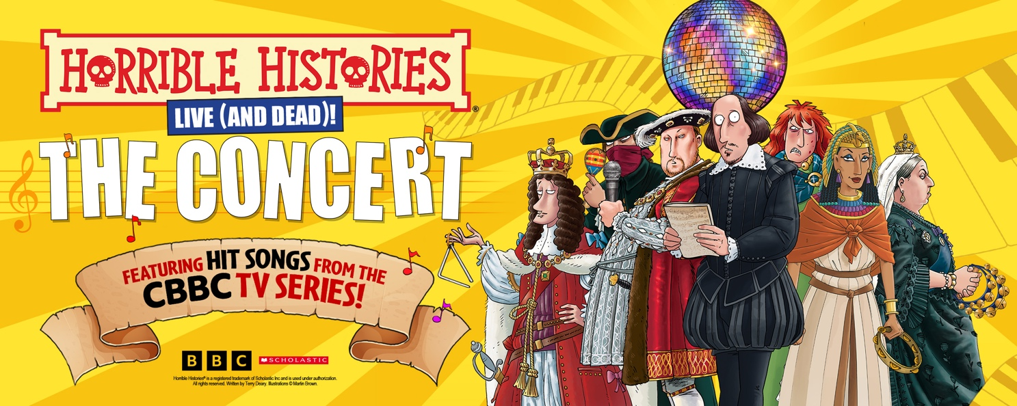

Media assets LINK HERE

HORRIBLE HISTORIES - THE CONCERT
Live (and dead) on stage!

TICKETS ONSALE 9AM, WEDNESDAY 9TH JULY
Prices from £18 (venue prices will vary) via birminghamstage.com

This year marks the 20th anniversary of Horrible Histories Live on Stage and to celebrate this theatrical milestone Birmingham Stage Company have teamed up with Lion Television to offer Horrible Histories fans a truly special production.

For the very first time, your favourite songs and characters from the BAFTA Award-winning BBC TV series will be appearing live (and dead!) on stage in a special show touring the UK from January!

This unique show is written by the TV series’ writers Ben Ward and Claire Wetton and will be led on stage by the Horrible Histories song master Richie Webb himself, who has written all the songs from the smash-hit BBC TV series.

When William Shakespeare is asked to create the greatest show on earth, he’s already facing a tough challenge (he knows he’s good but is he that good?!) but he’s no idea how much trouble he’ll get from monstrous monarchs like Henry VIII, Queen Victoria and Boudica! Things hot up when Death appears – and now Boudica, Napoleon and Cleopatra all want to take over! Can things get any worse? Of course they can - Loo Man’s in the building too!

Featuring a live band, with the sensational TV songs, including guest appearances from Charles II, Dick Turpin and a bunch of Vikings that we couldn’t stop barging through the stage door, this is one show you don’t want to miss! Bring your singing voices for what promises to be a truly Horrible show!

Horrible Histories - The Concert is written by Ben Ward & Claire Wetton, songs & music by Richie Webb, directed by Neal Foster, designed by Jackie Trousdale, with lighting by Jason Taylor, sound by Nick Sagar and choreography by Lucie Pankhurst. Executive Producers are Richard Bradley and Simon Welton, for Lion Television, an All3Media Company. The cast is to be announced shortly.

Horrible Histories shows are recommended for ages 5 to 105 (106-year-olds may not like them!).

Horrible Histories books launched in 1993 and are written by Terry Deary, illustrated by Martin Brown and published by Scholastic.

Twitter: @HHLiveOnStage / Facebook: birminghamstage / Instagram: @HHLiveOnStage

For all media enquiries contact Warren Higgins at Chuff Media
warren@chuffmedia.com / 07762 130510

DATES & TICKETS INFO
Tickets onsale 9am, Wednesday 9th July
Prices from £18 (venue prices will vary) via birminghamstage.com

Fri 23rd January Darlington Hippodrome
Sat 24th January Darlington Hippodrome
Fri 30th January Bristol Beacon
Sat 31st January Bristol Beacon
Sun 1st February Cardiff Wales Millenium Centre
Fri 6th February Manchester Opera House
Sat 7th February Manchester Opera House
Fri 13th February Liverpool Empire
Sat 14th February Liverpool Empire
Tues 17th February London Royal Festival Hall
Fri 20th February Birmingham Alexandra
Sat 21st February Birmingham Alexandra
Thur 26th February Milton Keynes Theatre
Fri 27th February Milton Keynes Theatre
Sat 28th February Milton Keynes Theatre
Sun 1st March Cambridge Corn Exchange
Sun 8th March Sheffield City Hall
Thur 12th March Edinburgh Festival Theatre
Fri 13th March Edinburgh Festival Theatre
Sat 14th March Edinburgh Festival Theatre
Sun 15th March Edinburgh Festival Theatre
Fri 20th March Glasgow Theatre Royal
Sat 21st March Glasgow Theatre Royal
Sun 29th March Nottingham Concert Hall
Thur 2nd April Southampton Mayflower
Fri 3rd April Southampton Mayflower
Sat 4th April Southampton Mayflower
Mon 6th April York Barbican
Tues 7th April York Barbican
Thur 9th Brighton Concert Hall
Fri 10th April Brighton Concert Hall
Sat 11th April Brighton Concert Hall
Fri 17th April Sunderland Empire
Sat 18th April Sunderland Empire

About Horrible Histories the TV series:
Horrible Histories has been delighting audiences on CBBC for 15 years. Now in its 11th series, the show has also seen two live productions as part of the BBC Proms, and continues to be one of the most popular brands for the channel. The show is made by Lion Television, an All3Media company, for CBBC, and Executive Produced by Richard Bradley and Simon Welton. Melissa Hardinge is the Senior Commissioning Editor for BBC Children’s and Education.

About Horrible Histories Live On Stage:
Based on the bestselling books by Terry Deary – the world’s top-selling non-fiction author for
children – Horrible Histories has sold over 36 million copies in 45 languages. Deary’s delightfully
dreadful stories have come alive on stage thanks to the Birmingham Stage Company, one of the
world’s top theatre companies for families. They have produced all the Horrible Histories live stage
shows since 2005. The BSC have also created the Olivier Award-nominated productions of David
Walliams’ Gangsta Granny and Billionaire Boy and adaptations of Roald Dahl stories including
George’s Marvellous Medicine and The Witches.

