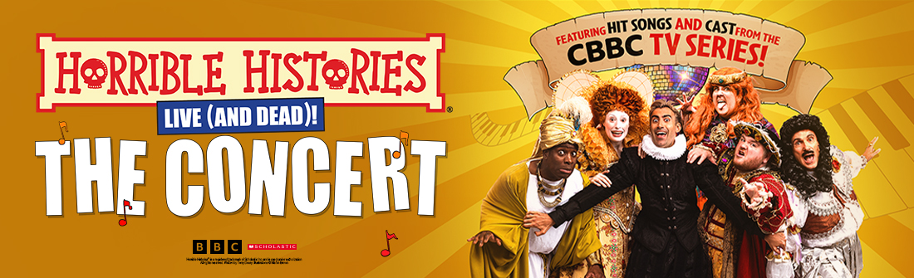

Media assets here

HORRIBLE HISTORIES - THE CONCERT
Live (and dead) on stage!

ANNOUNCES SENSATIONAL CAST FROM THE HIT TV SERIES & THEATRE SHOWS

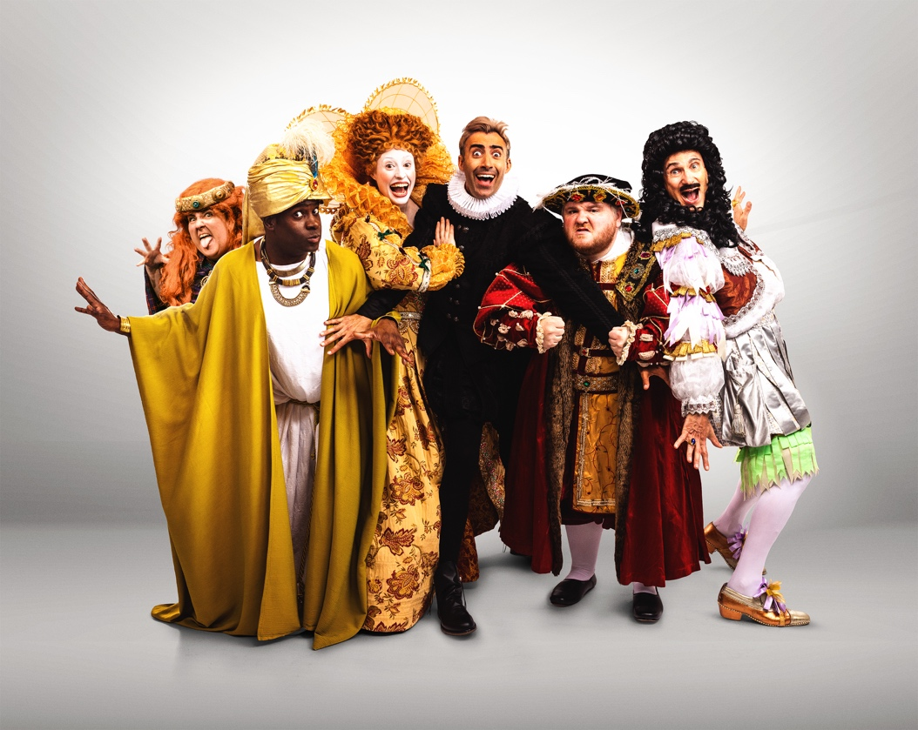

Tickets Onsale Via Birminghamstage.com

Following the exciting announcement of Horrible Histories – The Concert earlier this year, Birmingham Stage Company and Lion Television are thrilled to reveal the phenomenal cast bringing the BAFTA Award-winning TV show to life on stage.

For the very first time, Horrible Histories Live (and Dead!) on Stage will feature both the hit TV songs and stars of the beloved CBBC series, a unique combination never before seen on tour.

Leading the music is Richie Webb, the award-winning composer behind every unforgettable Horrible Histories TV song. From the iconic ‘The Monarchs' Song’ to the riotous anthems that have become fan favourites, Richie joins the cast as Musical Director, bringing his extraordinary catalogue to the stage with a live band.

Sharing the spotlight are some of the most recognisable current faces from the multi BAFTA-winning Horrible Histories and its spin-off Horrible Science:

- Richard David-Caine, one of the show’s longest-serving performers, also known for Class Dismissed and CBeebies’ Swashbuckle.
- Harrie Hayes, who has embodied history’s most iconic royals, from Elizabeth I to Marie Antoinette.
- Inel Tomlinson, A core cast member of both shows, from Histories’ Rameses to Science’s Big Danny.
- Ethan Lawrence, a Horrible Histories favourite and star of Ricky Gervais’ global Netflix hit After Life.

Joining them are two stalwarts of the 20-year stage phenomenon Horrible Histories Live on Stage:

- Alison Fitzjohn, an original cast member who has toured the world with Birmingham Stage Company.
- Neal Foster, the company’s Actor/Manager and creative force behind all the Horrible stage shows since 2005.

Together, this extraordinary company unites the best of the smash-hit TV series with the legendary stage productions, promising a once-in-a-lifetime experience for fans.

When William Shakespeare is asked to create the greatest show on earth, he knows it won’t be easy – but he has no idea how much trouble he’ll get from monstrous monarchs like King Henry VIII, Queen Elizabeth I and Queen Victoria! Things hot up when Death appears, and now Boudica and Cleopatra want to take over. Can things get any worse? Of course they can!

Featuring a live band led by Richie Webb performing his much-loved TV songs, with guest appearances from Charles II, Dick Turpin and a bunch of Vikings barging through the stage door, Horrible Histories – The Concert promises a truly Horrible night out. Bring your singing voices for a show that will make history come alive like never before!

Horrible Histories - The Concert is written by Ben Ward & Claire Wetton, songs & music by Richie Webb, directed by Neal Foster, designed by Jackie Trousdale, with lighting by Jason Taylor, sound by Nick Sagar and choreography by Lucie Pankhurst. Executive Producers are Richard Bradley and Simon Welton, for Lion Television, an All3Media Company.

Horrible Histories shows are recommended for ages 5 to 105 (106-year-olds may not like them!).

Horrible Histories books launched in 1993 and are written by Terry Deary, illustrated by Martin Brown and published by Scholastic.

Twitter: @HHLiveOnStage / Facebook: birminghamstage / Instagram: @HHLiveOnStage

For all media enquiries contact Warren Higgins at Chuff Media
warren@chuffmedia.com / 07762 130510

DATES & TICKETS INFO
Prices from £18 (venue prices will vary) via birminghamstage.com

Fri 23rd January Darlington Hippodrome
Sat 24th January Darlington Hippodrome
Fri 30th January Bristol Beacon
Sat 31st January Bristol Beacon
Sun 1st February Cardiff Wales Millennium Centre
Fri 6th February Manchester Opera House
Sat 7th February Manchester Opera House
Fri 13th February Liverpool Empire
Sat 14th February Liverpool Empire
Tues 17th February London Royal Festival Hall
Fri 20th February Birmingham Alexandra
Sat 21st February Birmingham Alexandra
Fri 27th February Milton Keynes Theatre
Sat 28th February Milton Keynes Theatre
Sun 1st March Cambridge Corn Exchange
Sun 8th March Sheffield City Hall
Fri 13th March Edinburgh Festival Theatre
Sat 14th March Edinburgh Festival Theatre
Sun 15th March Edinburgh Festival Theatre
Fri 20th March Glasgow Theatre Royal
Sat 21st March Glasgow Theatre Royal
Sun 29th March Nottingham Concert Hall
Thur 2nd April Southampton Mayflower Theatre
Fri 3rd April Southampton Mayflower Theatre
Sat 4th April Southampton Mayflower Theatre
Mon 6th April York Barbican
Tues 7th April York Barbican
Thur 9th Brighton Concert Hall
Fri 10th April Brighton Concert Hall
Sat 11th April Brighton Concert Hall
Fri 17th April Sunderland Empire
Sat 18th April Sunderland Empire

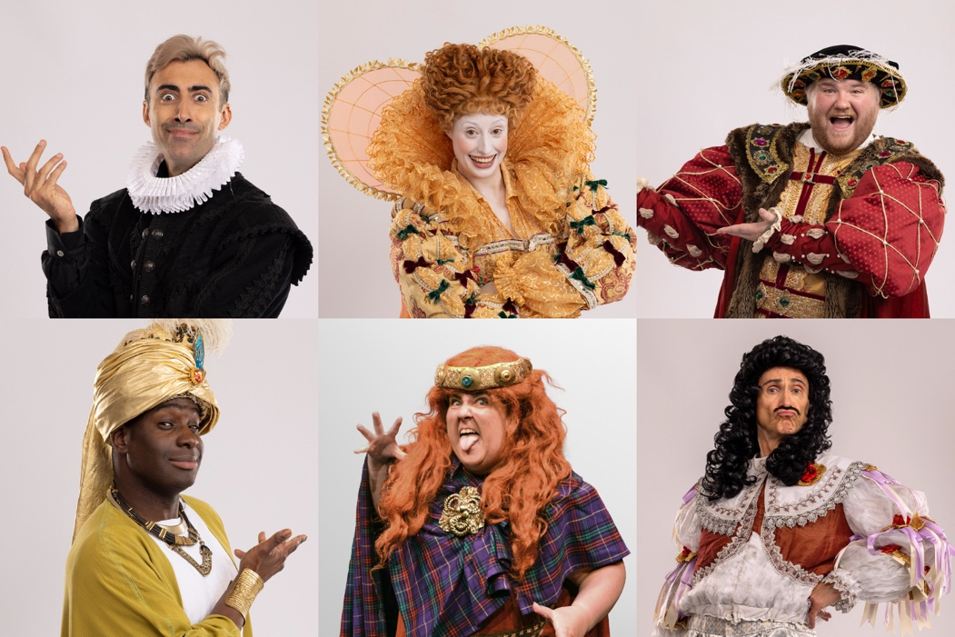
Top L-R: Richard David-Caine, Harrie Hayes & Ethan Lawrence
Bottom L-R: Inel Tomlinson, Alison Fitzjohn & Neal Foster

FULL CAST BIOGRAPHIES

Richard David-Caine
Richard David-Caine is one of the longest-serving cast members of CBBC’s BAFTA-winning Horrible Histories and its spin-off Horrible Science. He starred in the CBBC mockumentary Class Dismissed, twice nominated for an RTS Award for Best Comedy Performance, and created his own sketch show Big Fat Like. Richard is also well known as half of comedy duo Cook and Line in CBeebies’ Swashbuckle, appearing in several of its Christmas specials. Other screen credits include Better Things (FX), Avenue 5 (HBO), Midsomer Murders (ITV), Finding Alice (ITV) and People Just Do Nothing(BBC). Stage work includes The Witches (National Theatre) and his one-man show Tall, Dark and Anxious.

Harrie Hayes
Harrie Hayes is a cast member on CBBC’s BAFTA-winning Horrible Histories, where she has played iconic figures such as Elizabeth I, Anne Boleyn and Marie Antoinette, as well as appearing in Horrible Science. Her TV credits include Romantic Getaway (Sky), Red Rose (BBC/Netflix), King Gary (BBC), Wasted (E4) and Bloods (Sky). Film work includes My Cousin Rachel (Fox Searchlight), Three Houses and Upholstergeist. Harrie is also a filmmaker, having written, produced and starred in the short films Sole Heirs and Contemplating Motherhood, currently on the festival circuit. Stage credits include The Importance of Being Earnest (Mercury Theatre) and The Shape of Things (Arcola Theatre).

Ethan Lawrence
Ethan Lawrence has appeared in CBBC’s Horrible Histories and Horrible Science for three years, taking on dozens of memorable roles. He is best known as James in all three series of Ricky Gervais’ Netflix hit After Life, and as Joe in BBC Three’s Bad Education and its feature film. Other TV includes Boat Story (BBC), Murder, They Hope with Johnny Vegas, and Flat TV. His film work includes Magic Mike’s Last Dance and Alfonso Cuarón’s Disclaimer (Apple TV). Ethan is thrilled to join Horrible Histories: The Concert and looks forward to bringing his characters to the stage for audiences across the UK.

Inel Tomlinson
Inel Tomlinson is a multi award-nominated actor, comedian and presenter. He stars in CBBC’s Horrible Histories and Horrible Science, known for his high-energy, character-driven performances. His screen work includes Christmas on Mistletoe Farm (Netflix), The Joy of Missing Out (C4) and Bull (UKTV). As a voiceover artist, he has fronted major campaigns for Nintendo, Xbox and Bulldog Cosmetics. Inel also works as a popular host, presenting live events for BAFTA, Comic Con and Netflix. Renowned for his versatility across comedy, acting, voice and hosting, he continues to be one of the most dynamic performers in family and children’s entertainment.

Richie Webb
Richie Webb is an award-winning composer, writer, actor and radio producer, best known for his prolific comedy songwriting. From early work on Goodness Gracious Me and Dead Ringers to every song for the multiple award-winning Horrible Histories, his credits span two decades of iconic TV and radio comedy. He has written hundreds of songs for CBBC and CBeebies, from Andy and the Band to Mr Bloom and Teletubbies, with his Horrible Histories songs even featured at the BBC Proms. With collaborator Matt Katz, he has scored countless TV shows and films, while also creating acclaimed Radio 4 comedies.

Alison Fitzjohn
Alison Fitzjohn is an award-winning Welsh actor based in Bristol. Theatre highlights include Dixon and Daughters(National Theatre/Clean Break), Choir (Chichester Festival Theatre), The Little Mermaid (Bristol Old Vic), The Outrun(Edinburgh Lyceum/EIF), The Band Musical (West End/UK tour) and Typical Girls (Sheffield Crucible). As an original member of Horrible Histories Live on Stage, Alison has toured the UK and internationally with Birmingham Stage Company for two decades, performing in the West End, Asia, the Middle East and at Sydney Opera House. Screen credits include Horrible Histories: ‘Orrible Opera (BBC), Nova Jones (CBBC), The Crow Girl (Paramount+), and Channel 4’s TrueLove.

Neal Foster
Neal Foster is Actor/Manager of Birmingham Stage Company and has produced and performed in every Horrible Histories stage show since 2005. He has written and directed numerous productions, including Barmy Britain (with Terry Deary), which has played at the Garrick Theatre, Apollo Theatre and Sydney Opera House; Groovy Greeks and Incredible Invaders on UK tour; and Terrible Thames, the hit river tour co-created with Terry Deary. Neal also directed and performed as Verdi and Beethoven in ‘Orrible Opera for the BBC Proms at the Royal Albert Hall. He continues to lead Birmingham Stage Company’s acclaimed productions in the UK and worldwide.

About Horrible Histories the TV series:
Horrible Histories has been delighting audiences on CBBC for 15 years. Now in its 11th series, the show has also seen two live productions as part of the BBC Proms, and continues to be one of the most popular brands for the channel. The show is made by Lion Television, an All3Media company, for CBBC, and Executive Produced by Richard Bradley and Simon Welton. Melissa Hardinge is the Senior Commissioning Editor for BBC Children’s and Education.

About Horrible Histories Live On Stage:
Based on the bestselling books by Terry Deary – the world’s top-selling non-fiction author for
children – Horrible Histories has sold over 36 million copies in 45 languages. Deary’s delightfully
dreadful stories have come alive on stage thanks to the Birmingham Stage Company, one of the
world’s top theatre companies for families. They have produced all the Horrible Histories live stage
shows since 2005. The BSC have also created the Olivier Award-nominated productions of David
Walliams’ Gangsta Granny and Billionaire Boy and adaptations of Roald Dahl stories including
George’s Marvellous Medicine and The Witches.

