Grand Christmas Classics
with Alan Titchmarsh

LONDON, BIRMINGHAM AND MANCHESTER THIS DECEMBER

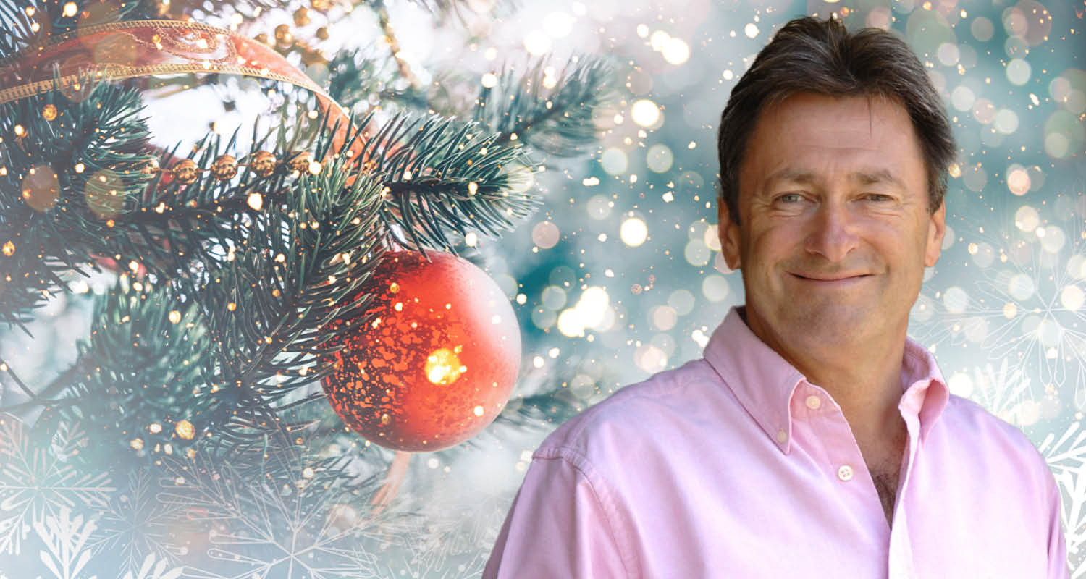

MEDIA ASSETS HERE

Are you looking for the perfect end-of-year festive outing? Make some space in your calendar to experience this exciting concert of festive classics, which features seasonal favourites such as White Christmas, Joy to the World and O Holy Night plus traditional carols such as Hark! The Herald Angels Sing, O Come, All Ye Faithful and The First Noel.

Join Alan Titchmarsh, one of the UK’s favourite personalities and broadcasters, as he leads you through this superb concert full of Christmas spirit and classics, accompanied by soloists and a full-orchestra live on stage!

The Philharmonia Orchestra will perform at the debut show at the Royal Festival Hall on the evening of the 9th December, with the Birmingham Symphony Hall concert on the 12th December set to feature amazing regional musicians and singers including The City of Birmingham Choir and the Quiristers of Winchester College. Joining Alan at Bridgewater Hall on 20th December will be the Manchester Concert Orchestra and Manchester Chorale.

Tickets can be purchased from www.raymondgubbay.co.uk or via the venue.

Grand Christmas Classics is appearing at venues around the country:

Thursday 9 December, 7.30pm - London, ROYAL FESTIVAL HALL*
https://www.southbankcentre.co.uk/whats-on/classical-music/grand-christmas-classics
http://www.raymondgubbay.co.uk/whats-on/grand-christmas-classics-rfh

Sunday 12 December, 3pm – Birmingham, SYMPHONY HALL
https://bmusic.co.uk/events/grand-christmas-classic-with-alan-titchmarsh
http://www.raymondgubbay.co.uk/whats-on/grand-christmas-classics-with-alan-titchmarsh-birmingham

Monday 20 December, 7.30pm - Manchester, THE BRIDGEWATER HALL
https://www.bridgewater-hall.co.uk/whats-on/christmas-with-alan-titchmarsh-201221/
http://www.raymondgubbay.co.uk/whats-on/grand-christmas-classics-with-alan-titchmarsh-manchester-2021

Wednesday 22 December at 7.30pm, London, BARBICAN HALL
https://www.barbican.org.uk/whats-on/2021/event/grand-christmas-classics-with-alan-titchmarsh
http://www.raymondgubbay.co.uk/whats-on/barbican-christmas-festival-2021/grand-christmas-classics-with-alan-titchmarsh-barbican-2021

*Alan Titchmarsh will not appear at the Royal Festival Hall.

For all media enquiries please contact
warren@chuffmedia.com or jenny@chuffmedia.com on 07762 130510

