**GOOD NEIGHBOURS**

**Release new single ‘Ripple’**

([LISTEN](https://goodneighbours.lnk.to/ripple)/[WATCH](https://goodneighbours.lnk.to/ripplevideo))

**Debut self-titled EP Out Now**

([LISTEN](https://goodneighbours.lnk.to/debutep))

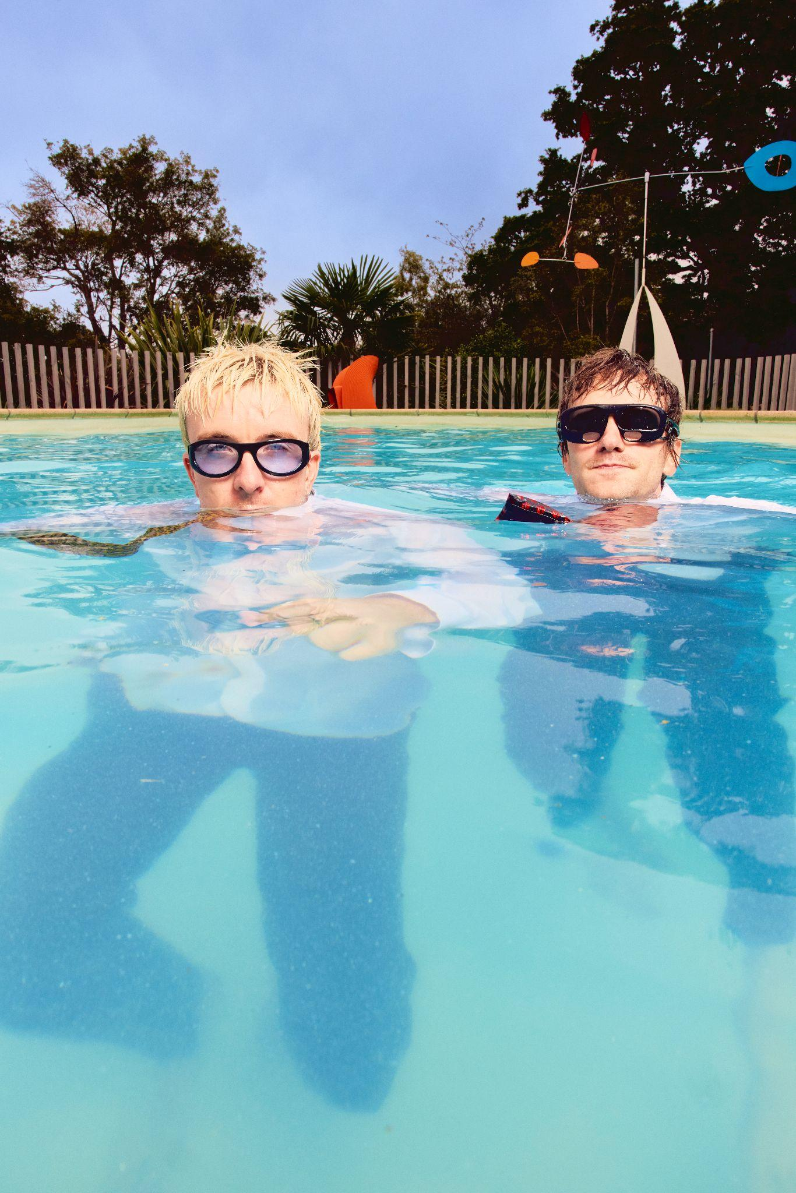

*Photographer Credit: Isaac Lamb (Download high-res version* [*HERE*](https://www.dropbox.com/scl/fi/m8qzvxvaq6adpeoqpjmw3/LEAD.jpeg?rlkey=pfqcnsk3gcdoggvjcp3so1bb6&st=57r620qt&dl=0)*)*

Following a blockbuster year in 2024, recently BRIT Rising Star-nominated **Good Neighbours** have returned to kick off 2025 with their latest offering ‘**Ripple**’. The song launched as Radio 1’s Hottest Record last night. Speaking on the track, the duo say *“Ripple was written about a close friend going through grief. They felt overwhelmed by the feeling and would sink into themselves. This song is about pulling your loved ones out of that deep place.”.*

The track is accompanied by the band’s first official music video, directed by **Alex Lockett** - watch **HERE**. The joyful and nostalgic video follows a pair of young boys during a milestone swimming lesson with friends. With the boys mimicking a young Oli and Scott, it captures a story of challenge, triumph and ultimately celebration, signifying the power of friendship above all. Overlaid by clips of the present day pair performing at the same swimming pool, the playful and carefree video is an ode to the feel-good essence that Good Neighbours have come to be known for. Speaking on the video, Lockett says “*The video explores the silent emotional battles men often face when submerged by grief or depression. The black brick and the diﬃculty young Oli faces reaching it, serve as a metaphor for the burdens we carry and the resistance we confront when bringing them to the surface. At its heart, it's really a celebration of resilience and the importance of connection. It’s about overcoming life’s challenges together, with the right support from those around us.”*

To say 2024 was something of a whirlwind for Good Neighbours might be an understatement.

‘**Home**’, their debut single released in January of last year, has now amassed half a billion global streams since January 2024, officiating it as the most streamed debut single globally from a new artist in 2024. The track entered the singles charts in 13 countries - securing 15 consecutive weeks in the UK Top 40, 11 weeks in the Billboard Hot 100, and nearly 40 weeks on the Billboard’s Hot Rock Songs chart. The single also recently went platinum in the US, making it the only Platinum certification for an Alternative debut single released & certified in 2024.

Latest single Ripple follows a sold-out UK and European tour with GRAMMY-nominated Benson Boone in December, a range of accolades including VEVO naming Good Neighbours one of their [VEVO DSCVR Artists To Watch for 2025](https://www.youtube.com/watch?v=8x30eCDNA0Q), a shortlisting for a [BRITS Rising Star](https://www.brits.co.uk/news/2025/brits-2025-rising-star-shortlist-revealed/), [MTV Push UK 2025](https://www.instagram.com/mtvuk/p/DC6PoizJNJ7/), and being added to [BBC Sound Of 2025](https://www.bbc.com/news/articles/ckgvpz0kry8o) longlist, as well as a Billboard Music Award nomination for Best Rock Duo/Group in the US. Most recently the duo have been honoured with a slew of picks as Ones To Watch in 2025, from the likes of Amazon Music, The Sunday Times, The Sunday Mirror, DIY Magazine, Dork Magazine, Clash Magazine, Sunday Express, Daily Mail, Daily Star and The Sun.

In addition, the band’s massive year included the release of their highly-anticipated, self-titled

debut EP, first US headline tour, during which time Good Neighbours made their television debut with a

lively performance of ‘Home’ on Jimmy Kimmel Live! ([WATCH](https://www.youtube.com/watch?v=kpIOLCUgyW0)), having their song ‘Daisies’ appear on

EA Sports’ FC 25 Soundtrack ([LISTEN](https://open.spotify.com/playlist/37i9dQZF1DX3wF1YbAXxkA)), the release of a special cover of Lana Del Rey’s hit 2012

single, ‘Video Games’, as part of the Spotify Singles program ([LISTEN](https://open.spotify.com/track/1C0KYMgW2BPDlKWW79cC9M?si=1725cc262b3c49cc&nd=1&dlsi=83e4a5702134448c)), among other

accomplishments.

The band are already set to keep up the momentum in 2025, as they set off in support of Foster The People on their North American tour, visiting over twenty cities. The tour kicks off January 25 in Seattle and concludes on March 6 in Dallas. For more information please visit: [www.wearegoodneighbours.com](http://www.wearegoodneighbours.com).



‘Ripple’ – Download High-Res Artwork [**HERE**](https://www.dropbox.com/scl/fi/g3yd4oncboucv1h1rdmvy/GOOD-NEIGHBOURS_RIPPLE-3000PX.jpg?rlkey=4e38zfhqtimg6dgxk402xr7gy&st=mdkb6j24&dl=0)

Optimism, positivity, and connection are the key ingredients of Good Neighbours - the duo of Scott Verrill and Oli Fox that have taken 2024 by the horns. What started off as one simple SoundCloud demo link emailed around to a few industry folk resulted in them having the most streamed debut single globally from a new artist this year, with 'Home'.

Good Neighbours' music is bursting with hope and joyous abandon and an amalgamation of their emotive indie influences of yesteryear such as MGMT, Passion Pit and Bleachers. They came together to create an indie-euphoric dreamscape of sound and vision for a subdued generation. Live, they bring the inclusive party to fans every time - racing through the London gig circuit and beyond. Scott and Oli have enjoyed a packed summer festival season playing key slots for the first time, including shows at All Points East, Latitude, Boardmasters, Reading and Leeds, and selling out their first world tour. Oli and Scott have also graced stages supporting Benson Boone, and will join Foster The People for a full spread of US dates in 2025.

**Follow Good Neighbours**

[TIKTOK](https://tiktok.com/@wearegoodneighbours) | [INSTAGRAM](https://instagram.com/wearegoodneighbours/) | [TWITTER/X](https://twitter.com/goodneighbourss) | [FACEBOOK](https://www.facebook.com/wearegoodneighbours) | [YOUTUBE](https://www.youtube.com/@wearegoodneighbours)

**For more information and press enquiries please contact**

**Jenny Entwistle**

[**Jenny@chuffmedia.com**](mailto:Jenny@chuffmedia.com)