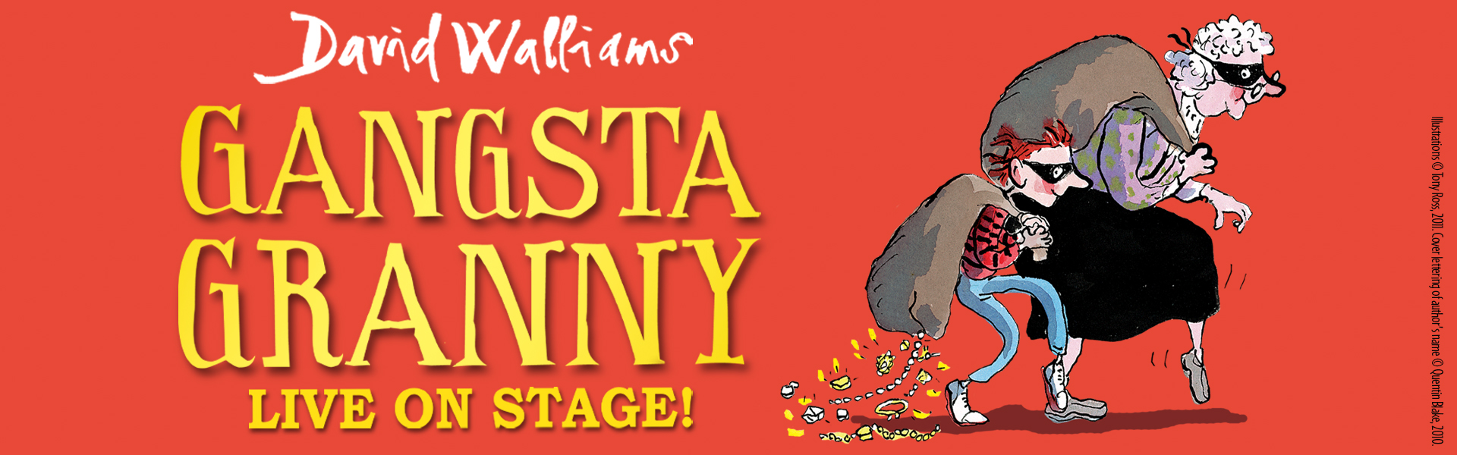

Birmingham Stage Company presents

David Walliams’
GANGSTA GRANNY

Adapted and directed by Neal Foster

Bloomsbury Theatre 9 December ‘21 – 9 January ‘22
Press performances: Saturday 11 & Sunday 12 December

“Brilliantly adapted and directed, this is a cracker of a show! Totally grantastic!” Mail on Sunday * * * *
“Kids loved this show. Every comic opportunity is grasped” The Daily Telegraph * * * *
“A fun-packed triumph - a must-see for all the family!” Sunday Express* * * *
“The brilliant Birmingham Stage Company have produced a fantastic show. It’s terrific. And so much better than the book!” David Walliams

Having been at the forefront of the West End revival this summer, entertaining families with two shows, Billionaire Boy and Horrible Histories - Barmy Britain Part Five, Birmingham Stage Company will be returning to London this Christmas with their Olivier Award nominated production of David Walliams’ GANGSTA GRANNY, arriving at the Bloomsbury Theatre from 9th December through to 9th January 2022.

When Friday night comes along, Ben knows it only means one thing – staying with Granny! There will be cabbage soup, cabbage pie and cabbage cake and Ben knows one thing for sure – it’s going to be sooooooooo boring! What he doesn’t know is that Granny has a secret, and Friday nights are about to get more exciting than he could ever imagine as he embarks on the adventure of a lifetime with his very own Gangsta Granny!

GANGSTA GRANNY is a must-see for all the family, as the show will be enjoyed by everyone from 5 to 105! It’s funny and thrilling, with important things to say about family relationships and the treatment of the elderly. The show originally premiered in 2015 and has since enjoyed two West End seasons, for which it was nominated for an Olivier Award in 2018.

David Walliams has revolutionised reading for children and has become one of the most influential children’s writers today. Since the publication of his ground-breaking first novel, The Boy in the Dress (2008), Walliams has seen unprecedented growth with global sales exceeding 44 million copies, and his books translated into 55 languages. The popularity of all his books, especially Gangsta Granny, looks set to continue for generations to come.

IT WILL BE A CRIME TO MISS IT IN LONDON THIS CHRISTMAS!

Listings info:

David Walliams’ Gangsta Granny
Bloomsbury Theatre
15 Gordon Street, London, WC1H 0AH

Tickets start from £22

Box Office: 020 3108 1000
https://www.thebloomsbury.com/event

9 December ’21 – 9 January ‘22

Press performances: Saturday 11 & Sunday 12 December
Running time: 2hrs 5mins with interval

Gangsta Granny is suitable for ages 5+

@BSCWalliams
GangstaGrannyWestEnd.com
www.birminghamstage.com

FOR MORE INFORMATION AND ALL MEDIA ENQUIRIES PLEASE CONTACT
Warren Higgins & Jenny Entwistle at Chuff Media
warren@chuffmedia.com / jenny@chuffmedia.com

***NOTES TO EDITORS***

DAVID WALLIAMS has become one of today’s most influential writers. Since the publication of his first novel, The Boy in the Dress (2008), illustrated by the iconic Sir Quentin Blake, David Walliams has celebrated more than ten years of writing success with global sales exceeding 40 million copies, and his books have been translated into fifty-three languages. David’s titles have spent 190 weeks (non-consecutive) at the top of the children’s charts – more than any other children’s author ever.

In addition to his fiction, David has worked with Tony Ross on five bestselling short-story collections, The World’s Worst Series as well as seven picture books. In 2020, David formed a new partnership with award-winning illustrator Adam Stower for his eighth picture book, Little Monsters.

BIRMINGHAM STAGE COMPANY since its foundation in 1992 has become one of the world’s leading producers of theatre for children and their families, including Horrible Histories Live on Stage for sixteen years in the UK, Dubai, Abu Dhabi, Qatar, Bahrain, Hong Kong, Singapore, New Zealand and Australia. They have originated three productions by David Walliams - Billionaire Boy, Awful Auntie and Gangsta Granny. The company are behind Car Park Party, which launched last summer, staging Horrible Histories - Barmy Britain and Horrible Christmas, playing to over 40,000 people. They have also launched a brand new boat tour of Horrible Histories - Terrible Thames.

