CRAWLERS SHARE NEW TRACK + VISUALISER
‘GOLDEN BRIDGE’

TAKEN FROM DEBUT ALBUM
‘THE MESS WE SEEM TO MAKE’
RELEASED 16th FEB

LISTEN HERE

Today (February 9th) CRAWLERS share their new song ‘Golden Bridge’ via Polydor Records. The track comes with a self-made visualiser shot by the band back at the Mersey in Liverpool. Watch it here.
‘Golden Bridge’ is the final new track to be shared ahead of the release of the Liverpool four-piece’s hotly anticipated debut album ‘The Mess We Seem To Make’ which arrives February 16th. The band recently announced they will perform on the main stage at Reading & Leeds festival this year, marking their second consecutive performance there.

Speaking about the track, singer Holly Minto says, “Writing Golden Bridge was the worst time in my life. At the time nothing amounted to anything, but I stood at the Mersey in Liverpool thinking about sinking or swimming and wrote down everything that makes life worth the hardships. We came back to that place where it was written - the same place where we spent our happy times after our first rehearsals as a band. Being back at the Mersey with the sunset bouncing off the water helped us to realise how things are now better than when we wrote the song.”

It follows a string of electrifying releases from CRAWLERS including debut album cuts ‘Call It Love’ and ‘Would You Come To My Funeral’, which launched as a Radio 1 Hottest Record in the World’ in September, and cements their reputation as one of the most exhilarating bands to come out of Liverpool in recent years. Recent single ‘Kills Me To Be Kind’ received significant support across a number of Radio 1 shows including plays from Clara Amfo and Jack Saunders.
Crawlers eagerly awaited debut album ‘The Mess You Seem To Make’ takes on a whole range of challenging topics; trauma, sexual politics, mental health, the general goings on in a young person’s life. Across the record, feelings of loneliness, insecurity and toxic forms of dependence are held up to the light and examined in close context.
It digs deeper into what fans already know and love about Crawlers’ eclectic alt-rock sound and builds on the relationship of trust they have with producer Pete Robertson and engineer Tom Roach at Liverpool’s Coastal Studios, crafting anthemic rock songs where each member's playing personality can truly thrive. Rather than forcing themselves in any one sonic direction, they maintained the free-wheeling spirit of 2022’s mixtape ‘Loud Without Noise’, producing a striking debut which cements their status as the UK’s next big crossover alternative act.
‘The Mess We Seem To Make’ features 12 tracks and will be available on various formats including Deluxe CD, white vinyl, blue splatter vinyl and silver glitter cassette.
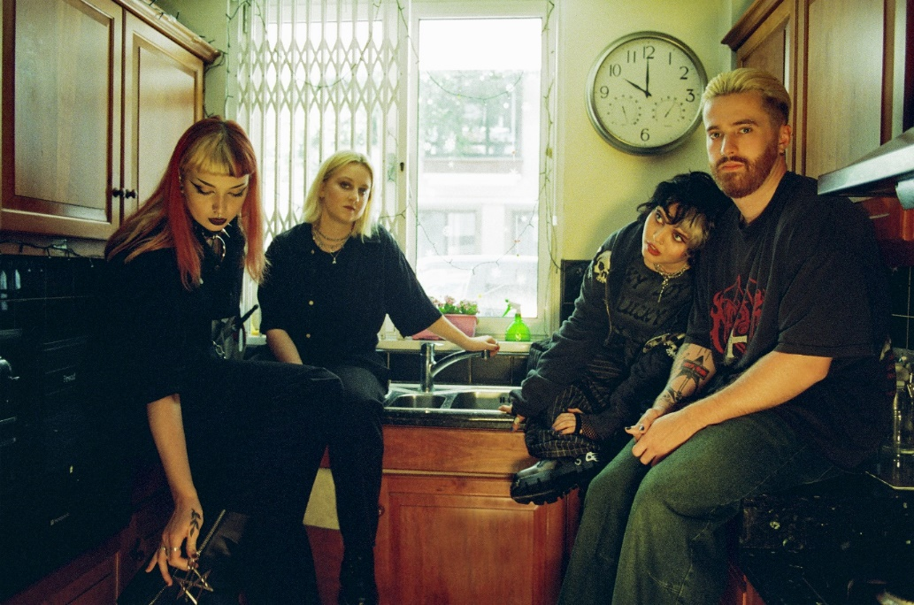
Photographer: Megan Doherty
ABOUT CRAWLERS
To become a great rock band, you often need to begin with a certain alchemy. There needs to be talent, determination, a solid friendship which can withstand the rigours of creative difference or public critique. But you also need a sizable dose of ambition, the kind of unapologetic belief that your voice is one which needs to be heard. Such was already the case for Crawlers way back in 2018, where Amy Woodall, Liv May and Holly Minto were at uni together in Liverpool. Having formed in 2018, the band spent their first few formative years gigging around the Liverpool scene. Amy, Holly and Liv were already polishing their grunge-rock sound when they recruited drummer Harry Breen. Newly solidified as a four, their formidable live reputation has already encouraged the kind of organic fanbase that will help them become the UK’s next big crossover alternative act. Over the years, each new release has sealed CRAWLERS reputation as one of the UK’s most exciting young bands, with last years’ debut mixtape “Loud Without Noise” cementing their global status through helping them to achieve a huge 80+million streams to date.
CRAWLERS are Holly Minto (she/they), Amy Woodall (she/her), Liv May (she/they) and Harry Breen (he/him).
Connect with CRAWLERS
INSTAGRAM | TWITTER | FACEBOOK

For more information and press enquiries please contact

Jenny Entwistle
Jenny@chuffmedia.com

