**GRACIE ABRAMS SOPHOMORE ALBUM**

***THE SECRET OF US* OUT NOW**

**LISTEN** [**HERE**](https://eur02.safelinks.protection.outlook.com/?url=http%3A%2F%2Fgracieabrams.lnk.to%2FTheSecretofUs&data=05%7C02%7Crachel.goldberg%40umusic.com%7C74df4636899a4b0c348608dc9163e77e%7Cbbcb6b2f8c7c4e2486e46c36fed00b78%7C1%7C0%7C638545105514240742%7CUnknown%7CTWFpbGZsb3d8eyJWIjoiMC4wLjAwMDAiLCJQIjoiV2luMzIiLCJBTiI6Ik1haWwiLCJXVCI6Mn0%3D%7C0%7C%7C%7C&sdata=m2fjzgqGemD55AKWKpUlAArxMqIhIrOw3QB1y3DQrxM%3D&reserved=0)

**ABRAMS MAKES BILLBOARD HOT 100 SOLO DEBUT WITH**

**“CLOSE TO YOU” THIS WEEK**

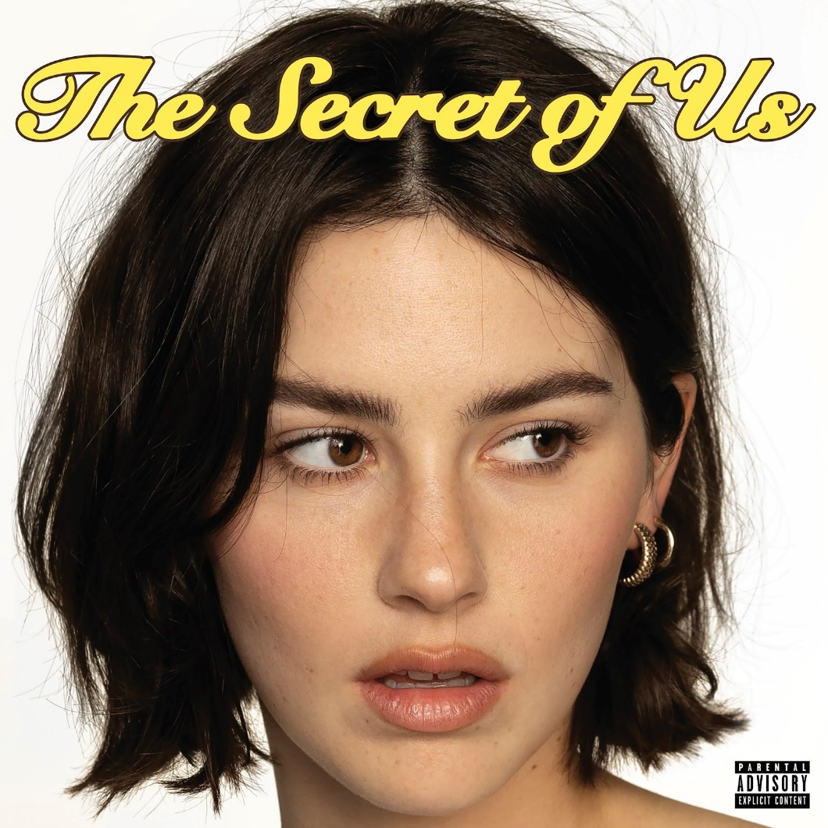

*Download hi-res art* [*here*](https://eur02.safelinks.protection.outlook.com/?url=https%3A%2F%2Fdrive.google.com%2Ffile%2Fd%2F1tP2lxXy1wpbUVuYkR8eauHt4FiUl34NP%2Fview%3Fusp%3Dsharing&data=05%7C02%7Crachel.goldberg%40umusic.com%7C74df4636899a4b0c348608dc9163e77e%7Cbbcb6b2f8c7c4e2486e46c36fed00b78%7C1%7C0%7C638545105514252938%7CUnknown%7CTWFpbGZsb3d8eyJWIjoiMC4wLjAwMDAiLCJQIjoiV2luMzIiLCJBTiI6Ik1haWwiLCJXVCI6Mn0%3D%7C0%7C%7C%7C&sdata=8gP472RSpzxuQ4LLQb6CS8%2BDGo1gjGPp3U1HErYJtJg%3D&reserved=0)

**LOS ANGELES (June 21, 2024)** - Today, GRAMMY®-nominated singer-songwriter, Gracie Abrams releases her highly anticipated sophomore album, *The Secret of Us* - listen [HERE](https://eur02.safelinks.protection.outlook.com/?url=https%3A%2F%2Fgracieabrams.lnk.to%2FTheSecretofUs&data=05%7C02%7Crachel.goldberg%40umusic.com%7C74df4636899a4b0c348608dc9163e77e%7Cbbcb6b2f8c7c4e2486e46c36fed00b78%7C1%7C0%7C638545105514260693%7CUnknown%7CTWFpbGZsb3d8eyJWIjoiMC4wLjAwMDAiLCJQIjoiV2luMzIiLCJBTiI6Ik1haWwiLCJXVCI6Mn0%3D%7C0%7C%7C%7C&sdata=iTM24WiOdo7f9e2mKlDoSKWJCtMRoyGAbSxNEgFgTBE%3D&reserved=0). *The Secret of Us* brings a bold new spirit to her songwriting and embodies all the breathless urgency of spilling your heart out to your closest friend at the end of a whirlwind night. The album was co-produced by her friend and frequent collaborator Aaron Dessner, and this project marks the first time Gracie herself took a hands-on role in the production process. Abrams also enlisted longtime friend Audrey Hobert to co-write much of the album. See tracklist below.

*The Secret of Us* features Gracie’s long-awaited new single “Close To You,” which she released earlier this month. Earlier this week, Gracie achieved another career milestone as she made her solo debut on the Billboard Hot 100 with “Close To You” entering the chart at #49. Originally teased a few years ago, “Close To You” has quickly become her best performing single upon release with three million streams in one day on Spotify alone. This single is Gracie’s first time entering the Spotify Global Chart and is currently Top 20 on the platform. Last night, Gracie  gave a show stopping performance of “Close To You” on Jimmy Kimmel Live! on the outdoor  stage. The new album also includes “Us,” Gracie’s highly anticipated collaboration with Taylor Swift, as well as lead single “Risk,” which Abrams released last month along with the official video - watch [HERE](https://eur02.safelinks.protection.outlook.com/?url=https%3A%2F%2Fyoutu.be%2FTiMuT2BhwO0%3Fsi%3DvkeAty328asBYVys&data=05%7C02%7Crachel.goldberg%40umusic.com%7C74df4636899a4b0c348608dc9163e77e%7Cbbcb6b2f8c7c4e2486e46c36fed00b78%7C1%7C0%7C638545105514266172%7CUnknown%7CTWFpbGZsb3d8eyJWIjoiMC4wLjAwMDAiLCJQIjoiV2luMzIiLCJBTiI6Ik1haWwiLCJXVCI6Mn0%3D%7C0%7C%7C%7C&sdata=nRMoZUKnPDKckVcAEFV5jWGqj8F00EP0vwVi9SWnicA%3D&reserved=0). “Risk” garnered an impressive one million streams on Spotify in less than 10 hours after the release and currently has over 62M streams to date.

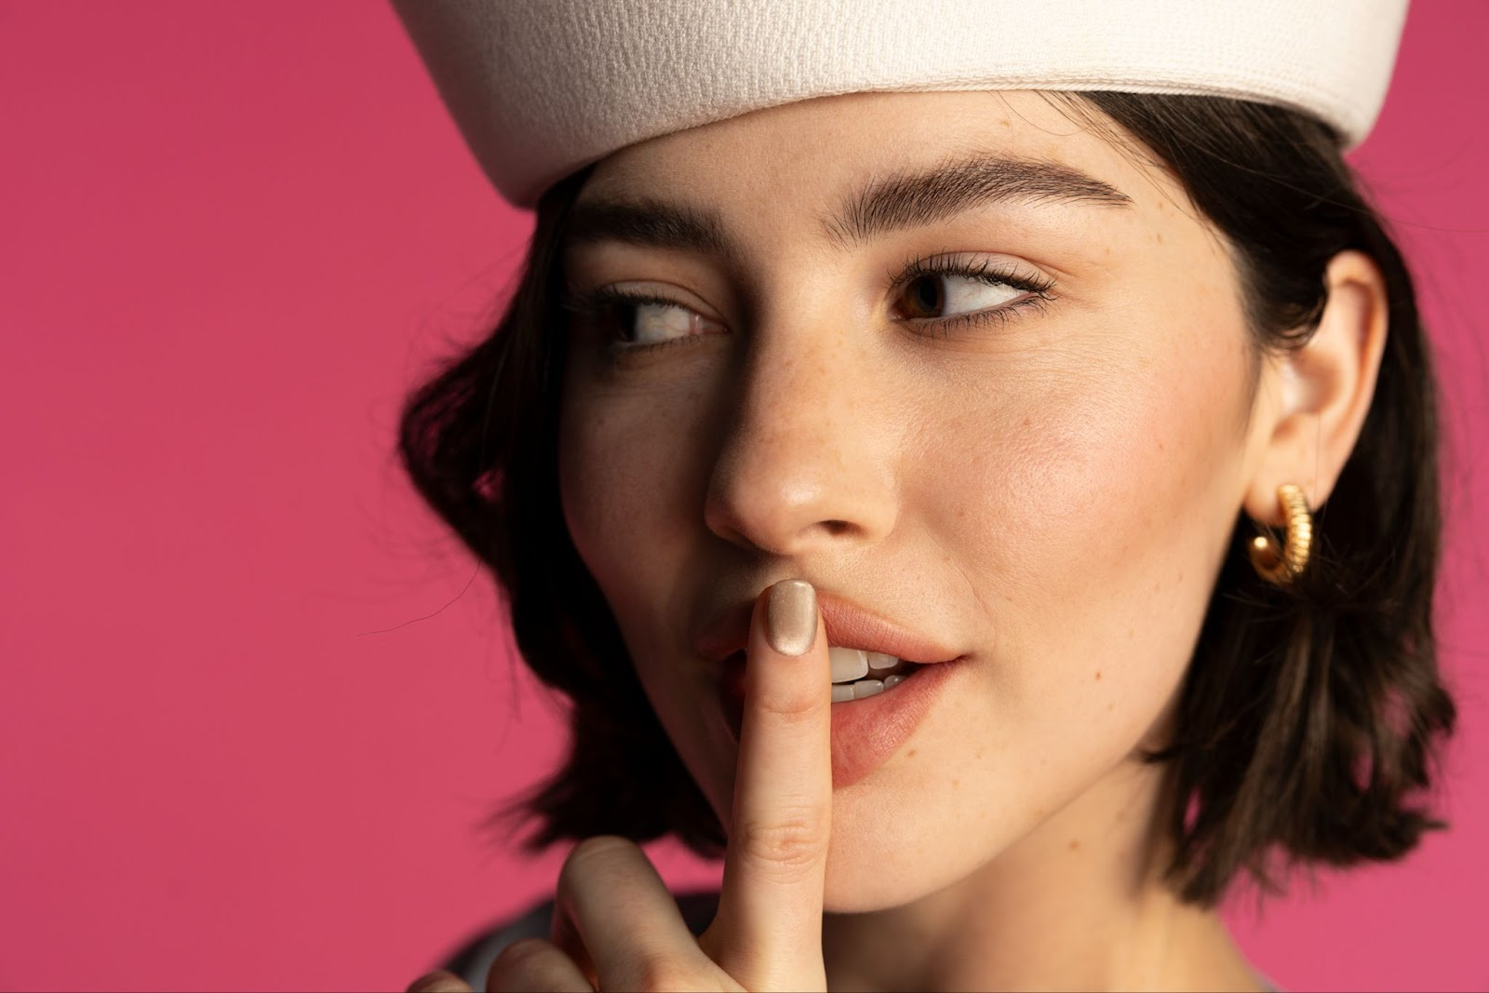

*Download hi-res press photo* [*here*](https://eur02.safelinks.protection.outlook.com/?url=https%3A%2F%2Fumusic.ent.box.com%2Fs%2Fnbk7e3usa535ahgi8728c19sr7fkgqj8%2Ffile%2F1563046350926&data=05%7C02%7Crachel.goldberg%40umusic.com%7C74df4636899a4b0c348608dc9163e77e%7Cbbcb6b2f8c7c4e2486e46c36fed00b78%7C1%7C0%7C638545105514271503%7CUnknown%7CTWFpbGZsb3d8eyJWIjoiMC4wLjAwMDAiLCJQIjoiV2luMzIiLCJBTiI6Ik1haWwiLCJXVCI6Mn0%3D%7C0%7C%7C%7C&sdata=LozqMw%2FtQuQv%2FV74aLi6pGo6zcWt3ahFfnNpvn8Qypc%3D&reserved=0)

*Photo Credit: Abby Waisler*

***The Secret of Us* Tracklist**

1. Felt Good About You
2. Risk
3. Blowing Smoke
4. I Love You, I’m Sorry
5. us. (feat. Taylor Swift)
6. Let It Happen
7. Tough Love
8. I Knew It, I Know You
9. Gave You I Gave You I
10. Normal Thing
11. Good Luck Charlie
12. Free Now
13. Close To You

**ABOUT GRACIE ABRAMS**

Since making her debut in 2019, Gracie Abrams has emerged as one of the most compelling singer-songwriters of her generation, earning the admiration of such like minded artists as Taylor Swift, Lorde, Billie Eilish, and Olivia Rodrigo and most recently, she earned the highly coveted nomination for Best New Artist for the 66th Annual GRAMMY Awards.  A consummate songwriter who names Joni Mitchell as her most formative influence, she penned her first song at age eight, then went on to amass a devoted following on the strength of her emotionally intimate lyrics and DIY sensibilities. As her profile rose, Abrams was named an artist to watch by taste making outlets like Pigeons & Planes, Fader, and i-D, in addition to being crowned one of seven breakout female musicians by Vogue UK. With the arrival of her debut project *minor* in summer 2020, she received glowing reviews from the likes of NME, who praised her “painfully honest tales of heartbreak draped in delicate melodies that carry much more intrigue than the usual run-of-the-mill singer-songwriter.” Executive-produced by Blake Slatkin — and also made with leading producers like Joel Little and benny blanco – the seven-song effort features her beloved singles “21,” “I miss you, I’m sorry,” and “Long Sleeves.” In November 2021, Abrams returned with *This Is What It Feels Like*, a 12-track project exploring such complex emotional experiences as self-betrayal, insecurity, and failed attempts at connection. Soon after completing her sold-out North American headline tour for *This Is What It Feels Like*, she set to work on her debut album. Abrams kicked off 2022 with a headline tour of North America followed by a support slot on Olivia Rodrigo’s tour and reconnected with Dessner to release two songs “Block me out” and “Difficult.” In 2023, Abrams released her highly anticipated debut album, *Good Riddance*, on February 24, followed by a North American headline tour that sold out in under one hour. Gracie toured with Taylor Swift as the opening on select dates of her blockbuster Eras Tour and will continue as direct support when the Eras Tour returns to North America later this year.

**Keep up with Gracie Abrams:**

[instagram](https://eur02.safelinks.protection.outlook.com/?url=https%3A%2F%2Fwww.instagram.com%2Fgracieabrams%2F&data=05%7C02%7Crachel.goldberg%40umusic.com%7C74df4636899a4b0c348608dc9163e77e%7Cbbcb6b2f8c7c4e2486e46c36fed00b78%7C1%7C0%7C638545105514276899%7CUnknown%7CTWFpbGZsb3d8eyJWIjoiMC4wLjAwMDAiLCJQIjoiV2luMzIiLCJBTiI6Ik1haWwiLCJXVCI6Mn0%3D%7C0%7C%7C%7C&sdata=cYw8xhxJoJN%2Bl7KEwfi50UQHIXpQ0p6cxKQJ7d%2Biz%2F0%3D&reserved=0)

[twitter](https://eur02.safelinks.protection.outlook.com/?url=https%3A%2F%2Ftwitter.com%2Fgracieabrams%3Flang%3Den&data=05%7C02%7Crachel.goldberg%40umusic.com%7C74df4636899a4b0c348608dc9163e77e%7Cbbcb6b2f8c7c4e2486e46c36fed00b78%7C1%7C0%7C638545105514282621%7CUnknown%7CTWFpbGZsb3d8eyJWIjoiMC4wLjAwMDAiLCJQIjoiV2luMzIiLCJBTiI6Ik1haWwiLCJXVCI6Mn0%3D%7C0%7C%7C%7C&sdata=zsrcqHj10EU4r5Vu5D2uLkIPofQHJhvb8DgGTwzgG6E%3D&reserved=0)

[youtube](https://eur02.safelinks.protection.outlook.com/?url=https%3A%2F%2Fwww.youtube.com%2Fchannel%2FUCwXDwwxNVRXPcPk7ABkakdA&data=05%7C02%7Crachel.goldberg%40umusic.com%7C74df4636899a4b0c348608dc9163e77e%7Cbbcb6b2f8c7c4e2486e46c36fed00b78%7C1%7C0%7C638545105514289611%7CUnknown%7CTWFpbGZsb3d8eyJWIjoiMC4wLjAwMDAiLCJQIjoiV2luMzIiLCJBTiI6Ik1haWwiLCJXVCI6Mn0%3D%7C0%7C%7C%7C&sdata=kW43FrVubQmDt9QuJ%2BFWqFKjppjdF8i4k4nZq%2FH3Q0U%3D&reserved=0)

**For more information and press enquiries please contact**

**Jenny Entwistle**

[**Jenny@chuffmedia.com**](mailto:Jenny@chuffmedia.com)