FLORENTENES

RISING ROCK FORCE ANNOUNCE
‘BREAKING NEWS’ EP FOR 13th MAY

RELEASE NEW SINGLE
‘UNDISCOVERED COLOURS’ ON MARCH 25TH

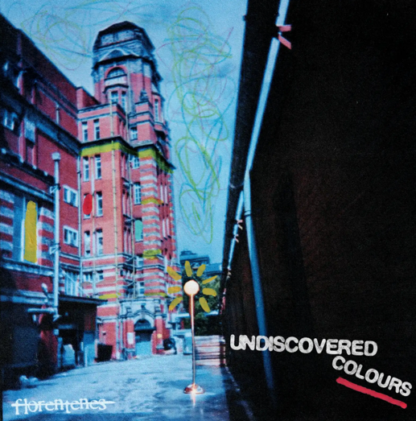
Download Images HERE

LISTEN TO/ SHARE “UNDISCOVERED COLOURS” HERE
WATCH/ SHARE THE VISUALISER FOR “UNDISCOVERED COLOURS” HERE

One of the UK’s most exciting rising guitar bands Florentenes continue their rapid ascent with the announcement of their 3rd EP ‘Breaking News', set for release May 13TH, alongside the release of their new single ‘Undiscovered Colours’ March 25th.

Marking a defining moment for the Bolton four piece, the ‘Breaking News EP’ is the 3rd installment in a trilogy of EPs from a band who have built their reputation through relentless touring across the UK which has earnt them a growing loyal fanbase that proves they can’t be ignored.

New single ‘Undiscovered Colours’ showcases a different side to the band’s sound. Opening as a Bowie / Lennon-inspired ballad, the track gradually expands into Florentines’ signature intensity. The accompanying video mirrors this evolution, beginning in stark black and white before bursting into colour, as the music swells.

“We wrote ‘Undiscovered Colours’ when I was 17, it’s about how harsh the world can be, especially to good people, and those feelings you can’t even put into words. The idea of an ‘undiscovered colour’ is something impossible to describe, like a certain kind of ache. It also nods to our early days and that fear the fire might not last, but hopefully it never burns out.”

With momentum building at pace, Florentenes head into a summer of festivals and live shows, including a full support run with rising Liverpool band Kairos, and a standout slot at Mad Cool Festival in Spain, as they take their explosive live energy to bigger stages and wider audiences. Rooted firmly in the North’s rich tradition of storytelling and live music culture, Florentenes have quickly built a reputation at the forefront of a new wave of modern indie rock bands known for their razor-sharp songwriting, fully live, tight musicianship and performances that connect instinctively with real audiences. Fronted by songwriter William Train Smith, alongside Luke Holding (guitar), Harry Stubbs (bass) and Liam Fiddy (drums), the band’s chemistry is unmistakable, and their songs have earned them high profile airplay and on air praise from Radio X’s John Kennedy & BBC 6 Music’s Chris Hawkins.

Recorded with legendary producer Dave Eringa (Manic Street Preachers, Jamie Webster, The Who), ‘Breaking News EP’ is another step forward for a band still barely a year out of school and already helping to define a new era of northern guitar music.

Their rise has been fuelled not by trends, but by word of mouth, sweat-soaked gigs, and songs that resonate. It’s this foundation that makes Breaking News EP unignorable.

Live Dates

Crystal Tides Support
March 27, Manchester, Gorilla

The Kairos Support
March 28, Leeds, Key Club
April 2, Bristol, The Exchange
April 3, Sheffield, Sidney & Matilda
April 4, Glasgow, Stereo
April 9, Brighton, Patterns
April 10, Birmingham, O2 Institute 3
April 11, Southampton, Heartbreakers
April 17, Nottingham, The Bodega
April 23, London, Colours
April 24, Newcastle, Reds Bar
April 25, Liverpool, Invisible Wind Factory

About Florentenes

Florentenes are in a rush.

With youth on their side and sharply written songs that could soundtrack a generation, the Bolton-based four-piece match the eloquent urgency of early Arctic Monkeys with the guitar rush of The Strokes and the classic rock power of The Who. They have the songs, the attitude, and that indefinable extra that has seen them pack out venues and forge a tight bond with an ever-growing audience.

Forged in the North and steeped in its storytelling tradition, Florentenes are a band who are part of a new wave of creativity rising from the grassroots. With frontman and songwriter William Train Smith, Luke Holding (guitar), Harry Stubbs (bass), and Liam Fiddy (drums), the band’s chemistry is palpable, four schoolmates turned sonic force, mixing jagged riffs, melodic basslines, and hooks that stay lodged in your head for days.

Their recent work with legendary producer Dave Eringa (Manic Street Preachers, Jamie Webster, The Who) captures their live spark and intent, raw, real, and free of gimmicks. As Eringa put it: “This is the band the UK music industry has been waiting for, insanely talented, insanely young, and cool as! No clicks, no autotune, no nonsense, just massive songs recorded live and allowed to breathe like the records of old, but sounding like the records of tomorrow.”

Following recent and forthcoming support with Kairos, The Ks, Arkayla, The Royston Club, and The Wombats, Florentenes are firmly setting their sights on making 2026 their breakthrough year, as they prepare to release their third body of work. The band were recently invited to join Justin Hawkins on stage at his Rides Again tour - a testament to their musicianship and songwriting skills

Florentenes somehow make guitars feel urgent again, a new generation of northern voices with something to say, something to prove, and the songs to back it up.

For further information about Florentenes:
INSTAGRAM | FACEBOOK | TIKTOK | WEBSITE | YOUTUBE | SPOTIFY

For more information and press enquiries please contact

Warren Higgins
warren@chuffmedia.com/ 07762 130510

