FISH
PHENOMENAL RESPONSE TO
THE FAREWELL TOUR

TWO FURTHER FINAL UK DATES ADDED TO ‘ROAD TO THE ISLES 2025’

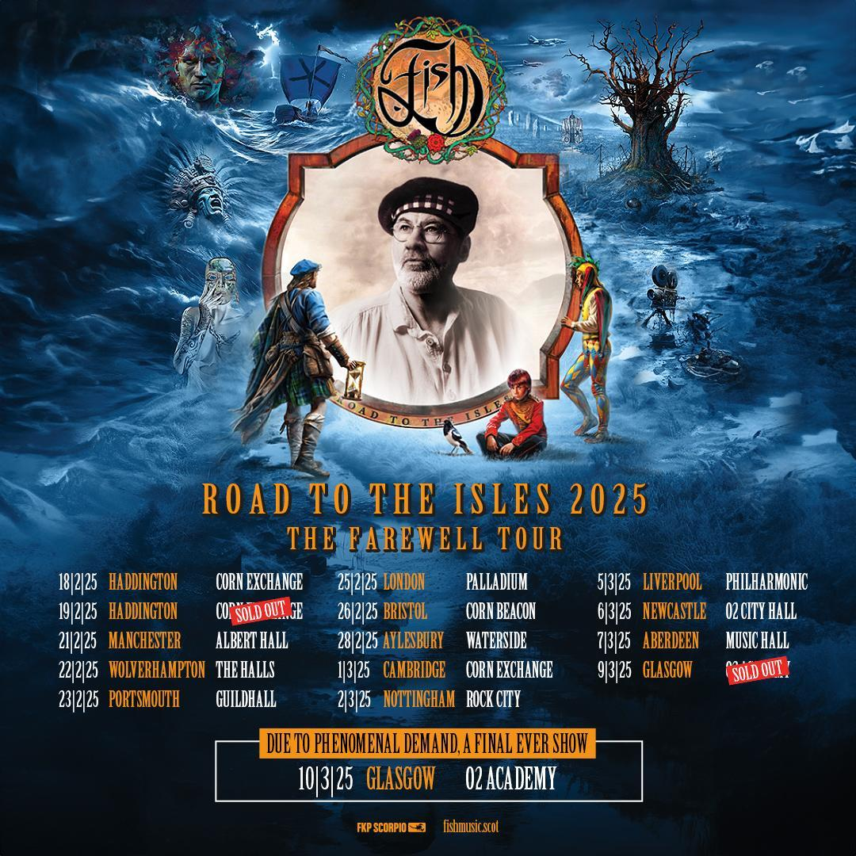
TUES 5th MARCH: Last week FISH announced the UK dates for his final ever tour, and demand for tickets has been phenomenal, replicating the huge sales across Europe where nine further shows needed to be added, to cope with the overwhelming response.

As a result of UK tickets also being snapped up within hours, FISH has decided to add TWO more final shows in Scotland, to ensure he opens and closes his farewell tour in his beloved home country. He will now play two nights at the Haddington Corn Exchange, kicking off the UK tour there on 18th February 2025, and closing the tour with a second night at Glasgow O2 Academy on March 10th.

FISH comments; “Shortly after announcing the general sale of tickets for the 2025 tour I was taken aback by the reaction and demand, none more so than with the show at the O2 in Glasgow which sold out in less than 48 hours. Glasgow has always been one of the most popular shows on any of my tours but on this 'Farewell' tour the demand was amplified and as the nominated last show there were a lot of tickets sold internationally. This meant that a lot of Scottish fans lost out so I felt I should add another show in both Haddington and Glasgow to cater for that demand in my home country.

“I had originally wanted to play different setlists in venues across two nights but due to a number of factors this wasn’t possible. However, as we will be performing a rotating setlist across the entire European and British tour I'll now be able to perform all the songs we will have rehearsed and played on the tour over the two nights in both Haddington and Glasgow. It may not placate people who already bought tickets for the 9th and who wanted to be able to say they were at the 'final show' but after weighing it up and taking everything into consideration the promoters and myself agreed to add another show on the 10th to accommodate the demand.

“I can assure the fans who bought tickets for the 9th that the two shows will be different and equally emotional as I perform songs for them for the very last time. Ultimately every venue I perform in across Europe and in Britain is my 'final' show in that city. After the 10th March in Glasgow there will be no more shows. The 10th is the final gig before I retire and head to “the islands”.

However I would like to add that I may be finishing touring in this format but in the words of the great Terry Gilliam "I'm not quite dead yet!! ;-)”

Bidding a final goodbye to the music industry after four decades of hits, memories and touring, these fifteen celebratory shows across England and Scotland, including a landmark show at London’s Palladium Theatre, will conclude FISH’s extraordinary career as a live performer.

UK DATES 2025
Tues Feb 18th 2025 Corn Exchange, HADDINGTON, SCO *
Wed Feb 19th 2025 Corn Exchange, HADDINGTON, SCO (SOLD OUT)
Fri Feb 21st 2025 Albert Hall, MANCHESTER, UK
Sat Feb 22nd 2025 The Halls, WOLVERHAMPTON, UK
Sun Feb 23rd 2025 Guildhall, PORTSMOUTH, UK
Tues Feb 25th 2025 The Palladium, LONDON UK
Wed Feb 26th 2025 Beacon, BRISTOL UK
Fri Feb 28th 2025 Waterside, AYLESBURY, UK
Sat Mar 1st 2025 Corn Exchange, CAMBRIDGE, UK
Sun Mar 2nd 2025 Rock City, NOTTINGHAM, UK
Wed Mar 5th 2025 Philharmonic, LIVERPOOL, UK
Thurs Mar 6th 2025 O2 City Hall, NEWCASTLE, UK
Fri Mar 7th 2025 Music Hall, ABERDEEN, SCO
Sun Mar 9th 2025 O2 Academy, GLASGOW, SCO (SOLD OUT)
Mon Mar 10th 2025 O2 Academy, GLASGOW, SCO *

* - new show added
Tickets for first night in Haddington HERE
Tickets for last night in Glasgow HERE

ALL TICKETS https://www.fishmusic.scot

The ‘Road to the Isles’ tour is inspired by the fact that Fish and his wife Simone are retiring to a croft they have taken over on an island in the Outer Hebrides. They are permanently moving to the Western Isles at the end of this year and Fish is selling the former recording studio and house in Haddington, East Lothian in May after living there since he left Marillion in 1988.

‘ROAD TO THE ISLES’ EUROPEAN TOUR DATES

Wed Oct 2nd 2024 Centre Culturel Opderschmelz, DUDELANGE, LUX (SOLD OUT)
Fri Oct 4th 2024 Muziekgieterij, MAASTRICHT, NL (SOLD OUT)
Sat Oct 5th 2024 Muziekcentrum, ENSCHEDE, NL (SOLD OUT)
Sun Oct 6th 2024 Oosterpoort, GRONINGEN, NL (SOLD OUT)
Tues Oct 8th 2024 Tivoli Vrendenburg, UTRECHT, NL (SOLD OUT)
Wed Oct 9th 2024 Tivoli Vrendenburg, UTRECHT, NL (SOLD OUT)
Thurs Oct 10th 2024 Grosse Freiheit 36, HAMBURG, DE
Fri Oct 11th 2024 Carlswerk Viktoria, COLOGNE, DE (SOLD OUT)
Sun Oct 13th 2024 Im Wisemaan, STUTTGART, DE
Tues Oct 15th 2024 Volkhaus, ZURICH, CH
Wed Oct 16th 2024 Muffathalle, MUNICH, DE
Thurs Oct 17th 2024 Arena, WIEN, AU
Sat Oct 19th 2024 A2, WROCLAW, PL
Sun Oct 20th 2024 Progeresjam, WARSAW, PL
Mon Oct 21st 2024 Studio, KRAKOW, PL
Tues Oct 22nd 2024 Srtary Manez, GDANSK, PL
Thurs Oct 24th 2024 Rockefeller, OSLO, NOR
Sat Oct 26th 2024 Byscenen, TRONDHEIM, NOR
Mon Oct 28th 2024 Pustervik, GOTHENBURG, SW
Tues Oct 29th 2024 Berns, STOCKHOLM, SW
Wed Oct 30th 2024 Amager Bio, COPENHAGEN, DK
Fri Nov 1st 2024 Alter Schlachtof, DRESDEN, DE
Sat Nov 2nd 2024 Tollhaus, KARLSRUHE, DE
Sun Nov 3rd 2024 Metropol, BERLIN, DE

9 NEW EUROPEAN SHOWS ADDED DUE TO PHENOMENAL DEMAND
Tues Nov 5th 2024 La Madeleine, BRUSSELS, BL
Wed Nov 6th 2024 Trix, ANTWERP, BL
Thurs Nov 7th 2024 Philharmonie, HAARLEM, NL
Sat Nov 9th 2024 Muziekgebouw, EINDHOVEN, NL (SOLD OUT)
Sun Nov 10th 2024 Muziekgieterij, MAASTRICHT, NL
Tues Nov 12th 2024 Capital, HANNOVER, DE
Wed Nov 13th 2024 Batschkapp, FRANKFURT, DE
Fri Nov 15th 2024 FZW, DORTMUND, DE
Sat Nov 16th 2024 Centre Culturel Opderschmelz, DUDELANGE, LUX (SOLD OUT)

ALL TICKETS www.fishmusic.scot

VIGIL IN A WILDERNESS OF MIRRORS AND INTERNAL EXILE – DELUXE EDITIONS

Vigil in a Wilderness of Mirrors and Internal Exile both remixed by Calum Malcolm in 2024, will be available in a 4 audio CD and a BluRay disc set containing Dolby Atmos and 5.1 mixes, documentaries and full concerts from 90-91 all in a 100 page hardback book, in a slipcase featuring extensive sleeve notes by Fish, artwork by Mark Wilkinson and photos and images from the periods. Sleeve designs are by Steve Vantsis .The deluxe versions will be exclusively available on fishmusic.scot and fishmusic.eu from April 2024 together with special vinyl editions of both the albums mastered at half speed by Barry Grint at Air studios and manufactured by Seabass vinyl in Scotland.

Currently available: the deluxe triple vinyl box sets of Feast of Consequences and 13th Star featuring 3 x 180gm vinyl discs and 12 inch full colour booklets and inserts in an engineered cardboard box and the deluxe CD/Blu Ray version of 13th Star with a 2023 remix by Calum Malcolm , 3 CD's featuring the remix/original demos and live tracks together with a Blu ray disc with Dolby Atmos and 5.1 mixes , documentaries and other bonus material all in a hardback book with slipcase featuring extensive sleeve notes by Fish, artwork by Mark Wilkinson and previously unseen photos and images. Sleeve Designs by Steve Vantsis.

More information including track lists on the above titles can be found at www. fishmusic.scot and www.fishmusic.eu

For more info contact Warren warren@chuffmedia.com

