HOLLY HUMBERSTONE RELEASES
CAN YOU AFFORD TO LOSE ME?

AN EXTENDED COLLECTION OF SONGS SPANNING HER MUSICAL JOURNEY TO-DATE, LED BY THE BRAND NEW TRACK “CAN YOU AFFORD TO LOSE ME?”

LISTEN NOW & WATCH THE OFFICIAL MUSIC VIDEO

BIGGEST UK HEADLINE TOUR TO DATE THIS WINTER WITH O2 ACADEMY BRIXTON ON 1 DECEMBER

Download Claryn Chong image here

Closing the beginning chapter on one of music’s most exciting stories in recent memory, Holly Humberstone has released Can You Afford To Lose Me? today: the title track from an extended collection of songs tracing her sensational musical journey to-date, out on 28th October. The project is led by the brand new title track – a devastating slowburn carried by a piano-driven heartbeat and swelling choir vocals. Seared with the type of lyrical authenticity that’s been a staple in Holly’s songwriting since day one, the track is a heartbreaking ode to a relationship hurtling toward it’s conclusion as she sings “you were my home planet / you were my stars, my holy place / but you took me for granted, right from the start now didn't you babe.” From her first-ever single “Deep End” to tracks from her stunning debut EP Falling Asleep At The Wheel and acclaimed second EP The Walls Are Way Too Thin, the eleven-song collection is not only a reflection on Holly’s origins, but her evolution from an unknown artist hailing from the small countryside town of Grantham, to emerging as one of the biggest breakout talents of the past two years.

Can You Afford To Lose Me? offers fans a culmination of the singer-songwriter’s past and present as she looks ahead to 2023 and the impending release of her highly anticipated debut album. Listen to the project in its entirety now.

“The past couple of years have been a whirlwind and I rarely get the chance to reflect on everything that’s happened. Over the past few months I’ve been looking back; at the music I’ve made, the people I’ve met, the incredible experiences we’ve shared together and where I’m heading on a personal level. Playing my songs on tour, seeing them out in the world, and how they’ve affected people differently has made me want to give them another life so much I’ve put them together in the order I would listen to them in now - a fresh evolution of my first two EPs. I’ve also added a brand new song called Can You Afford To Lose Me? which is probably one of my favorite songs I’ve ever written. I feel like I've changed quite a lot since releasing some of my tracks, so I decided not to include a couple of them - while I’ll always love those songs, I wanted to highlight the ones that resonate the most with where I'm at in my life in this moment. I hope you guys can listen to these songs in new ways, just like I have.

I guess this is me closing the chapter on the first part of my journey. I’m writing my debut album as we speak and it’s going to come next year. It's my most personal music yet and I hope I can continue to document my experiences for them to become yours. lots & lots of love, HH xx"

LISTEN TO CAN YOU AFFORD TO LOSE ME?

CAN YOU AFFORD TO LOSE ME? TRACKLIST
- Can You Afford To Lose Me?
- Overkill
- Scarlett
- Please Don't Leave Just Yet
- Deep End
- Haunted House
- Thursday
- Vanilla
- The Walls Are Way Too Thin
- Falling Asleep At The Wheel
- Friendly Fire
ARTWORK:
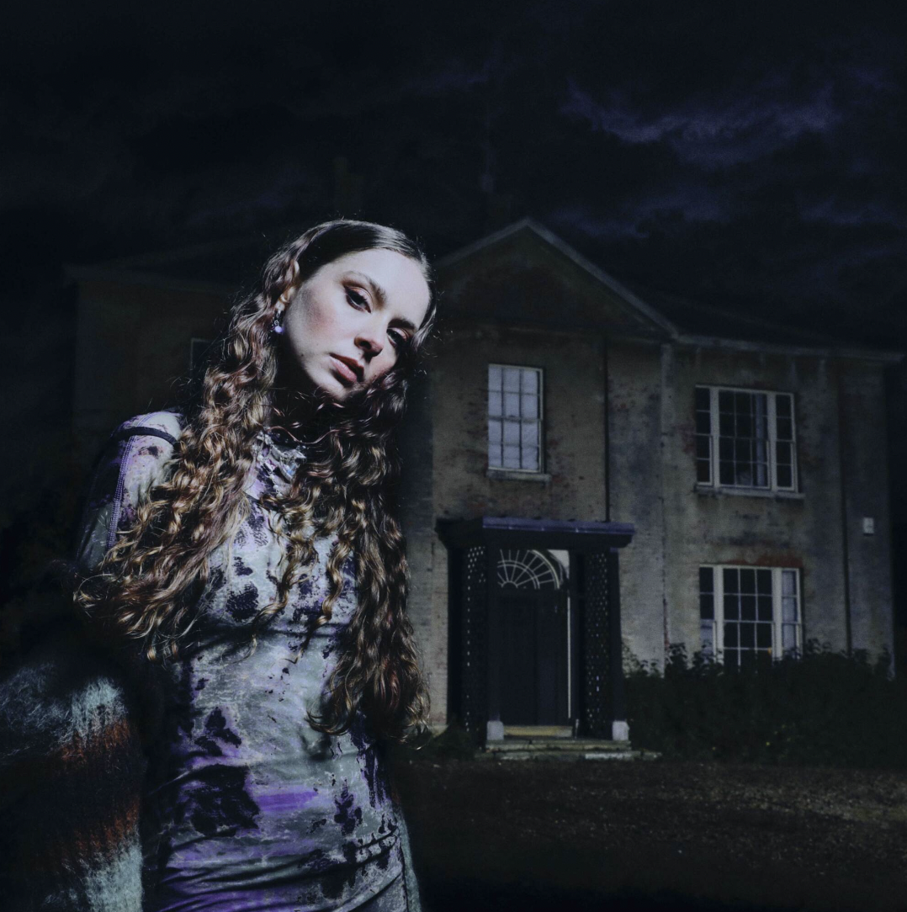

At the core of the BRIT Rising Star, NME Award winner and Ivor Novello nominated singer songwriter is her love of the craft and art of storytelling. Through her breakthrough debut EP “Falling Asleep At The Wheel” released in 2020, to critically revered “The Walls Are Way Too Thin” released last year, and sublime singles singles “London Is Lonely” and “Sleep Tight”, Holly captures the universal feeling of anxiety when you leave home, move to a new city and feel lost and displaced, to finally having a small place of your own. Audiences have grown up with Holly, and have streamed her music over 260 Million times, and earlier this year the star collaborated with YouTube for a short film “A Handbook To Growing Up Too Fast”, which carefully captured her growth as a young woman finding her voice.

WATCH A HANDBOOK TO GROWING UP TOO FAST

Now taking to countless stages with just her guitar and keys, the 22-year-old Grantham born breakthrough artist has become one of the most critically praised and sought after touring artists in just two years since she was catapulted into the public arena. Having spent three months on the road in the North America with GRAMMY winning pop star Olivia Rodrigo and Girl In Red, playing to thousands at sold-out venues every night and captivating fans for her raw lyricism and soaring, complex guitar riffs and melodies, Holly will be touring the UK this winter, with shows at O2 Academy Leeds, Manchester Academy 1, Rock City and O2 Academy Brixton on 1st December. Being named the star who conquered the world from her bedroom to becoming a British voice on the world stage, earlier this year Holly released the blistering single “Sleep Tight”, written with longtime collaborator Rob Milton and 1975’s Matty Healy - the second collaboration with Matty, following ‘Please Don’t Leave Just Yet’.

WATCH OFFICIAL SLEEP TIGHT VIDEO HERE

Winning the prestigious BRITs Rising Star earlier this year, Holly gave a captivating performance of the heartbreak ballad “London Is Lonely” live at the awards show, which was the very first time she has ever stepped foot into the O2 Arena. Following in the footsteps of global superstars including Adele, Florence + The Machine, Sam Fender and Griff, Holly’s Rising Star win marks the start of a colossal year for the 22-year-old. Having been nominated for Best Song Musically and Lyrically at this year’s Ivor Novello’s for ‘Haunted House’, alongside Adele, Ed Sheeran and Dave, and winning the NME Awards for “Best Mixtape” for “The Walls Are Way Too Thin”, Holly is a songwriter and artist whose lyrics and melodies transform painful human experience into collective joy.

WATCH OFFICIAL LONDON IS LONELY VIDEO

WATCH HOLLY’S ‘LONDON IS LONELY’ BRITS PERFORMANCE

It is the honest storytelling at the heart of Holly’s craft that has captured the hearts and minds of fans globally, with “tattoo lyrics” that are specific to her life, from her sisters' struggles with mental health to growing apart from her friends, where within the particular lives the universal. Having released her critically acclaimed second EP The Walls Are Way Too Thin last year, about being lost and questioning where you belong last year, Holly has become the UK’s next great songwriting talent, with over 260M global streams. The EP features Holly’s “favourite” BBC A-listed ‘Scarlett’, the cinematic masterpiece title-track The Walls Are Way Too Thin, the immaculately beautiful ‘Haunted House’, and ‘Friendly Fire’, which was performed with Bombay Bicycle Club’s Jack Steadman at her O2 Shepherd’s Bush Empire headline, and ‘Thursday’, which sits at the poignant heart of the body of work. Holly has also leant her inimitable vocals to BRIT Winner Sam Fender’s smash hit ‘Seventeen Going Under’, with the star surprising Holly live on air when he presented her with the BRIT Rising Star Award, whilst Holly’s cover of Doja Cat’s “Kiss Me More” for BBC Radio 1’s Live Lounge and cover of Prince’s legendary ‘I Would Die 4 U’, shows her incredible ability to reimagine and redefine.

As she turns the page to her next chapter, Holly’s journey is destined to be among the most captivating of 2023 and beyond.

UK WINTER HEADLINE TOUR

22 Nov O2 Academy Bristol (SOLD OUT)
23 Nov O2 Academy Leeds
24 Nov O2 Academy 1 Liverpool
26 Nov O2 Institute Birmingham
27 Nov NX Newcastle
29 Nov SWG3 Galvanizers
30 Nov Manchester Academy 1
01 Dec O2 Academy Brixton
03 Dec The LCR, UEA
04 Dec Rock City, Nottingham

Follow Holly Humberstone:
YouTube/ Instagram / Twitter / Facebook / Spotify /
Apple/ / TikTok

