BOYGENIUS ANNOUNCE NEW EP
the rest
OUT OCTOBER 13TH VIA INTERSCOPE

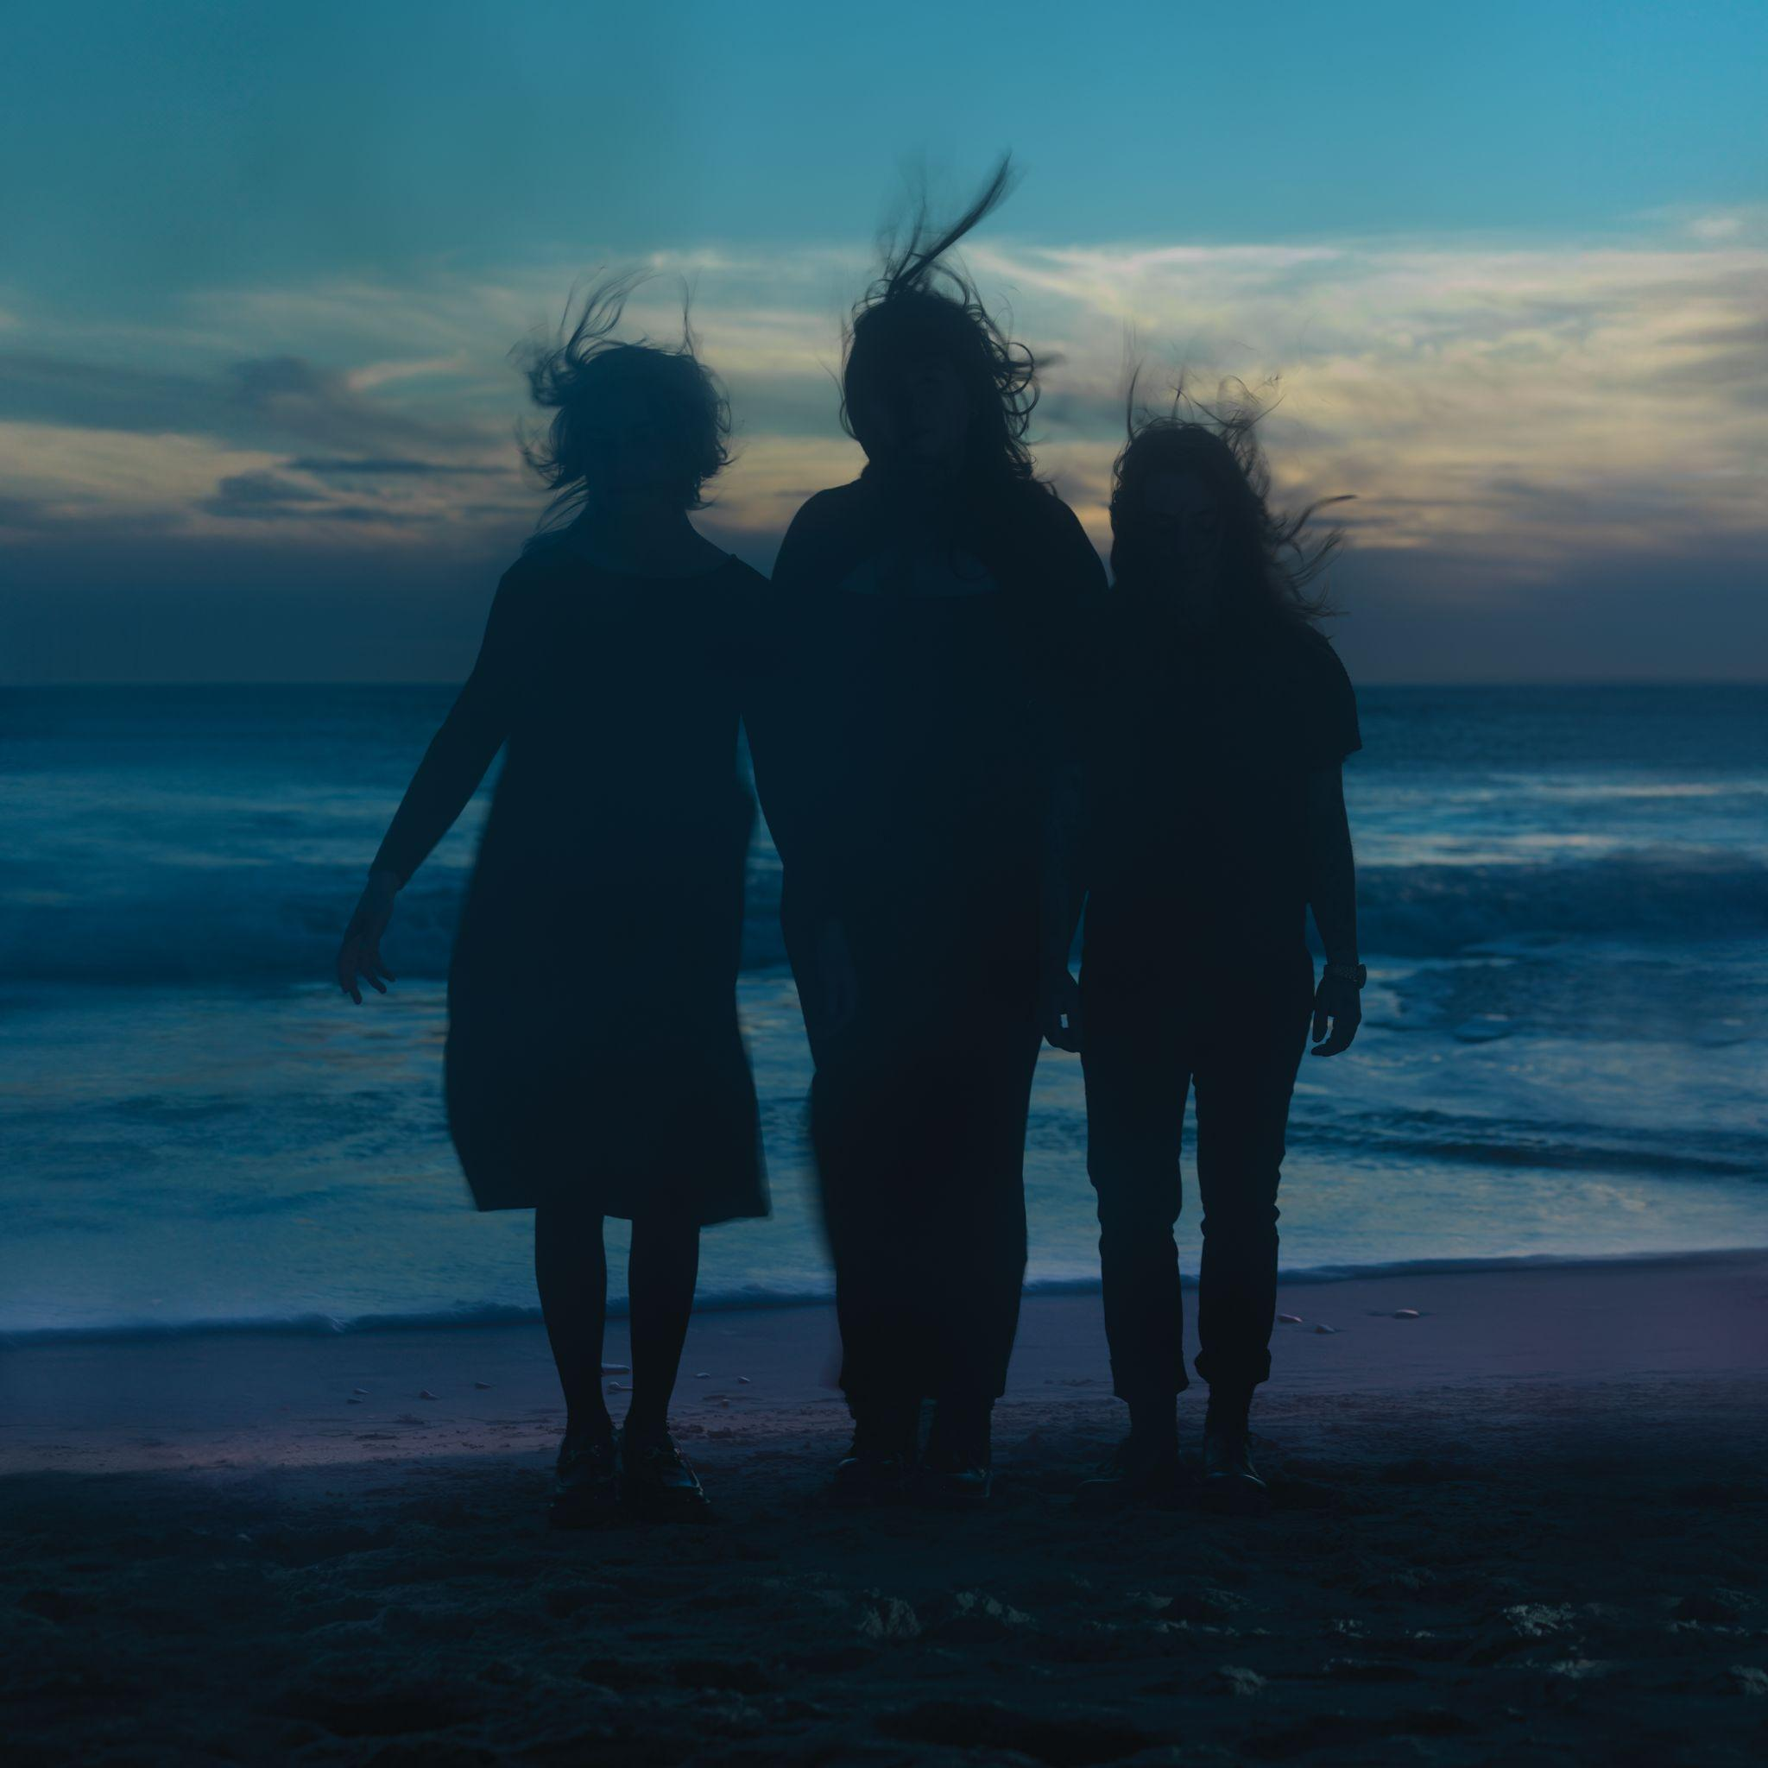
(EP artwork, download HERE)

boygenius (Julien Baker, Phoebe Bridgers and Lucy Dacus) have announced a surprise EP, the rest. News of the brand new music comes shortly after performing the first track “Black Hole” at their sold-out Boston show earlier this evening. To be released on October 13 via Interscope, the four-track EP is an expansion of their critically acclaimed debut full-length the record. Produced by boygenius, Tony Berg, Jake Finch, Ethan Gruska, Calvin Lauber, Collin Pastore and Marshall Vore, the rest continues to showcase the band’s songwriting prowess and distinct sound.

PRE-ORDER “the rest” HERE
The band kicked off the fall leg of their tour this evening with the first of two shows in Boston (MGM Music Hall at Fenway), and will make stops in New Haven (Westville Music Bowl) and Philadelphia (TD Pavilion at The Mann) before their Madison Square Garden debut on October 2nd and special Halloween event at Hollywood Bowl on October 31st. Special guests include MUNA, Samia and Palehound plus a unique Halloween event with 100 gecs and special guest Sloppy Jane.

TOUR DATES
September 26 - Boston, MA @ MGM Music Hall ! SOLD-OUT
September 28 - New Haven, CT @ Westville Music Bowl !
September 30 - Philadelphia, PA @ TD Pavilion at The Mann ~ SOLD-OUT
October 2 - New York, NY @ Madison Square Garden = SOLD-OUT
October 31 - Los Angeles, CA @ Hollywood Bowl * SOLD-OUT

! with special guest Palehound
~ with special guest Samia
= with special guest MUNA
* with 100 gecs and special guest Sloppy Jane

KEEP UP WITH BOYGENIUS:
Web / Instagram / Twitter

For more information and press enquiries please contact

Jenny Entwistle
Jenny@chuffmedia.com

