Fletchr Fletchr Announce Debut EP, We All Feel the Same

Released Friday 28th November

- Share New Single ‘Limitations’

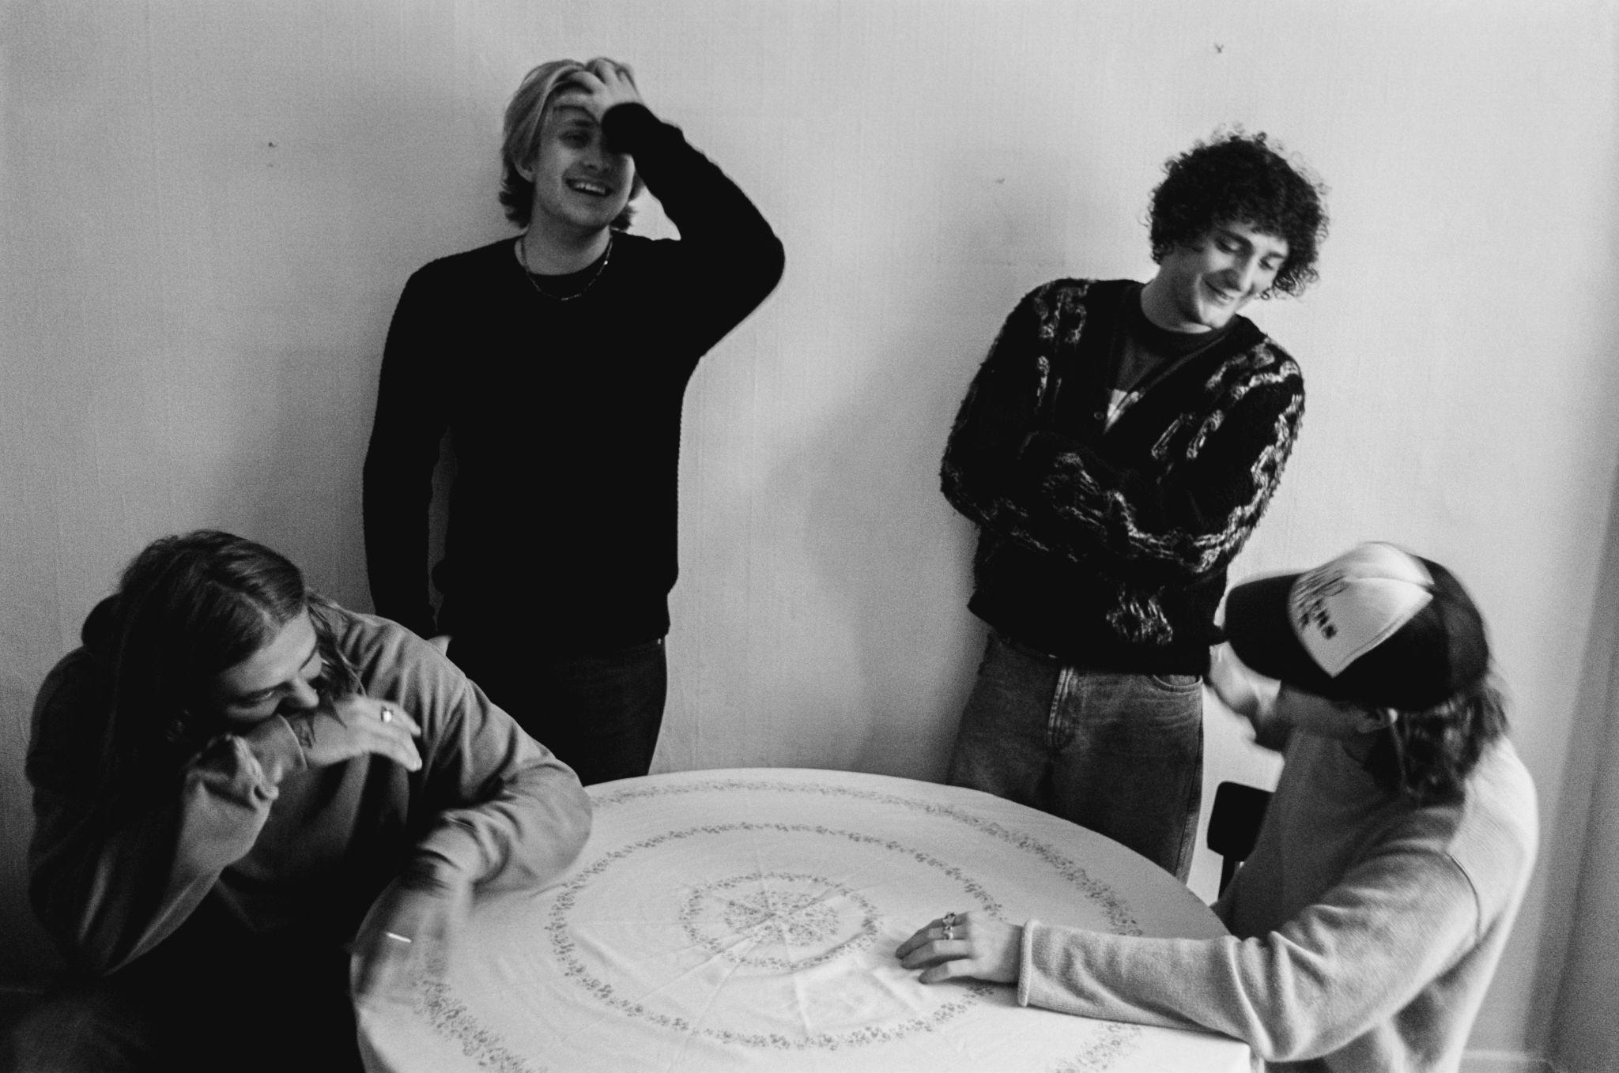
Credit: Charlie Harris

“With a thrilling sound and lofty ambitions, Fletchr Fletchr are on the path to the big time” - Rolling Stone UK

Fletchr Fletchr are excited to announce their debut EP, We All Feel the Same, which will be released on Friday 28th November.

Alongside this, they share their latest single, ‘Limitations’. Listen HERE.

Limitations is the fast-rising British indie-rock band’s most expansive track to date, with its tender, intimate opening making way for a raucous cacophony of sound. Its lyrics search longingly for feeling amidst the mundane, and ultimately find resilience through strain.

Vocalist Rohan Fletcher explains: “You can find yourself looking for excuses in relationships when sometimes it’s best to accept that good things come to an end.

When looking back on the relationship, you realise where the problems were, and how for a time you were seeing through rose tinted glasses.

We wrote this song through a break up, and it was the song that really started Fletchr Fletchr for what it is now."

‘Limitations’ is the third track to be taken from Fletchr Fletchr’s forthcoming debut EP. It follows previous singles ‘Feel the Same’, a klaxon call to chatting through problems, and their ferocious opening statement of intent, ‘Jet Black’.

After a run of sell-out shows across London grassroots venues in recent weeks, the band will also embark on their first UK/EU headline tour next month.

The four-piece were formed by three schoolfriends (vocalist/guitarist Rohan Fletcher, lead guitarist (and producer of the band’s debut EP) Adam Sanders, and drummer Oli Williams who Fletcher and Sanders nabbed from another school band). The trio all chose to study at the same university where they plotted the plight of their new band together. Bassist George Green arrived when Fletchr Fletchr were already almost fully formed, ushered on stage for a show merely days after joining.

Naming your band after the vocalist follows a curious lineage (Van Halen, Florence & The Machine, Mumford & Sons, Ben Folds Five to name but a few), yet the actual reasoning is somewhat sweeter. Firstly, it’s in tribute to Rohan’s father, who passed away as the band’s biggest fan and source of encouragement. And secondly, when Adam moved into Rohan’s family home, working at their pub alongside Rohan, it was commented by friends that the pair had become almost inseparable, with Adam welcomed as a genuine part of the family Fletchr – and thus Fletchr Fletchr were born.

The very adult but relatable emotions of anxiety, love, and grief are already at the heart of what the band are writing their nascent songs about, and are quickly finding a kinship with their young fanbase by tapping into those themes. None of it goes hidden, instead rocketed out verbatim in these dizzying guitar songs.

Fletchr Fletchr’s first headline tour kicks off at Green Door Store in Brighton on 11th November, stretching to 26th November at Downstairs at The Dome in London’s Tufnell Park. Full dates are listed below.

Remaining tickets can be found via the band’s website (www.fletchrfletchr.com).

Pre-order We All Feel the Same

Fletchr Fletchr Live:

31st October – London Calling, Amsterdam
11th November – Green Door Store, Brighton
14th November – Academy 2, Dublin
15th November – Live at Leeds in the City
17th November – Cabaret Voltaire, Edinburgh
18th November – The Deaf Institute The Lodge, Manchester
20th November – O2 Institute 3, Birmingham
21st November – Dead Famous, Newquay
24th November – Louisiana, Bristol
26th November – Downstairs at The Dome, London

Fletchr Fletchr are:

Rohan Fletcher - Guitars / vocals
Adam Sanders – Guitars
George Green - Bass
Oli Williams - Drums

For more information, please contact jenny@chuffmedia.com

