Westside Cowboy

Release second EP So Much Country ‘Till We Get There via Island Records imprint Adventure Recordings

Headline tour in January ‘26 ft. London’s iconic Scala | March 2026 UK/EU tour support with Geese

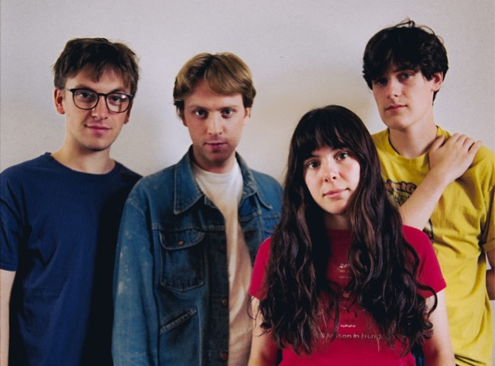
Photo Credit: Charlie Barclay Harris

Select Acclaim for Westside Cowboy:

“Thrilling - marked by a mood of ramshackle invention at odds with the studied, polished air of a lot of current alt-rock” Alexis Petridis - The Guardian

“Come for the urgent, wistful guitars, and stay for the heart-wrenching harmonies”- Stereogum

“Rapidly climbing the rungs and notching up the wins, Westside Cowboy are the buzzy Britainicana newcomers determined to let down the ladder behind them” - DIY

“So Much Country… is an EP, but if it doesn’t set up Westside Cowboy for a very big 2026 I’ll eat my laptop” - Loud & Quiet

“One of the new acts heralding a gloriously ramshackle new era of ’90s-styled slacker rock” - NME

“Music for the ancillary moments of everyday life that make everything else real” - So Young

“The future of British rock? Undoubtedly.” - Wonderland
–
Westside Cowboy today release their second EP So Much Country ‘Till We Get There via Island Records imprint Adventure Recordings.

Alongside the EP release comes a music video for bouncy long-standing live favourite ‘The Wahs’ - directed by Liam Barton, and featuring a cameo from Horsegirl’s Nora Cheng.

The EP was recorded with esteemed producer Loren Humphrey in New York, who brought the same studio magic to the quartet’s self-styled ‘Britainicana’ sound as he has for Cameron Winter’s acclaimed Heavy Metal LP (alongside credits for Arctic Monkeys, Lana Del Rey, Wunderhorse and more).

To support the EP the band continue their biggest headlined shows to date in January and February (all dates now sold out), and follow it up with a mammoth UK and European tour supporting indie titans Geese in March. This comes off the back of being tipped for success by DIY, DORK, Rolling Stone (UK) and many more in their 2026 previews, as well as their debut sell-out US headline shows.

These live highlights speak to the fact that much of the group’s reputation as leaders of a vital new wave of UK bands has come from a scintillating live set - which is already establishing an immersive mythos, replete with ‘I was there’ credentials, and if-you-know-you-know moments. Packed out stages at Glastonbury, Green Man, End of The Road and more during the summer months is evidence of an outfit striking at the core of the scene.

The show has been taken on the road in support of Black Country, New Road across mainland Europe throughout last October, prior to what is already set to be a momentous 2026 festival season.

Kinetic college-rock sprint ‘Can’t See’ and the nostalgia-tinged ‘Don’t Throw Rocks’ were compelling pre-release singles, and both found their way onto the BBC 6 Music Playlist. Detailing the full collection, the band say:

“We like the idea that music has the ability to capture the moment in time in which it was made, for good and for bad. For us, we think this EP sounds like us figuring it out, and we find that really appealing at the moment. We can’t sit here and say that we know what we’re doing yet because we really don’t, but that’s how it should be at this stage, because everything feels so new much of the time. This year has been one of great change for the band, and we feel like So Much Country reflects this. We’re not there yet, but we’re cycling down the Oxford Road towards it, whatever ‘it’ is in this case.”

Around the release of debut EP This Better Be Something Great, the band earned no shortage of admirers – personal invites to support English Teacher, Ezra Furman, Mary in the junkyard, and Blondshell matched with early press praise from the likes of The Guardian, Stereogum, Uncut, NME, DIY, DORK, So Young, The Line Of Best Fit, Clash, Rolling Stone UK, Rough Trade and Paste.

The four-piece have also landed primary support from Huw Stephens, Steve Lamacq, Nick Grimshaw, Lauren Laverne, Craig Charles, Deb Grant, Nathan Shepherd, Emily Pilbeam (BBC 6 Music) and Sian Eleri and Alyx Holcombe (BBC Radio 1), Jo Whiley (BBC Radio 2), Matt Wilkinson (Apple Music), KEXP and John Kennedy (Radio X).

Westside Cowboy’s second EP So Much Country ‘Till We Get There is out now via Adventure Recordings.

Westside Cowboy is Reuben Haycocks (guitar, vocals), James (Jimmy) Bradbury (guitar, vocals), Aoife Anson O’Connell (bass guitar, vocals), and Paddy Murphy (drums, vocals)

Westside Cowboy Online
Instagram / X / TikTok / YouTube / Website

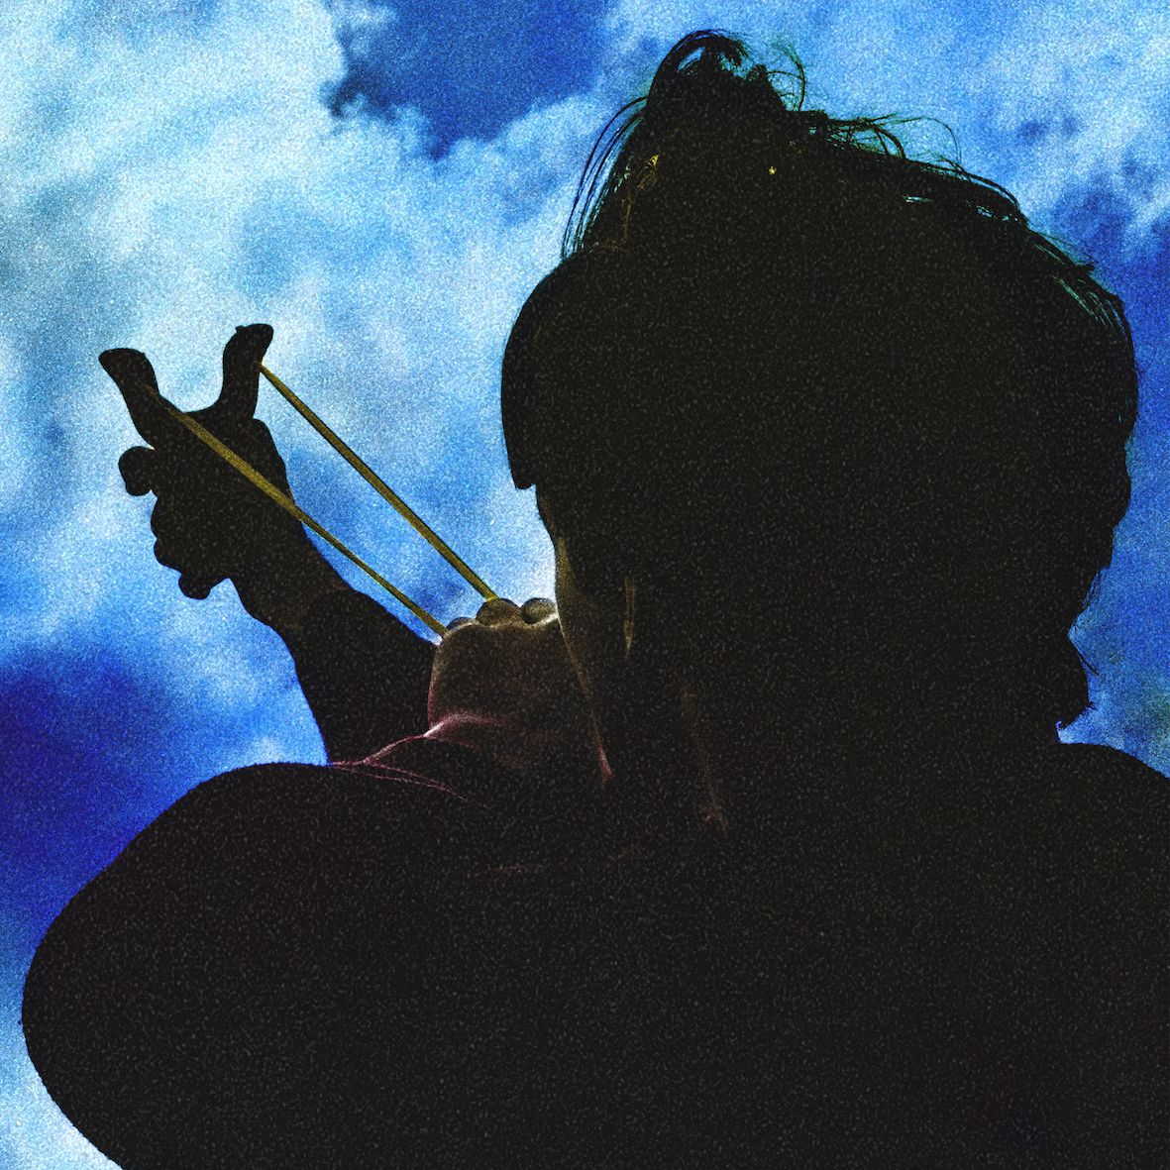
So Much Country ‘Till We Get There EP Artwork

Track-Listing

1. Strange Taxidermy
2. Can’t See
3. Don’t Throw Rocks
4. The Wahs
5. In The Morning

Live Dates

28 Jan - London, Scala
29 Jan - Manchester, Gorilla
31 Jan - Dublin, Grand Social
2 Feb - Glasgow, King Tuts
3 Feb - Leeds, Brudenell Social Club
4 Feb - Nottingham, Bodega
6 Feb - Bristol, The Exchange
7 Feb - Brighton, The Hope and Ruin
8 Feb - Oxford, The Bullingdon
20 Mar - Bristol, The Prospect Building *
21 Mar - Glasgow, SWG3 *
22 Mar - Leeds, O2 Academy *
24 Mar - Manchester, O2 Victoria Warehouse *
25 Mar - London, Eventim Apollo *
2-3 May - Liverpool Sound City
14 May - Brighton, The Great Escape
22 May - Bearded Theory, Derbyshire
24 May - Warrington, Neighbourhood Weekender
21 June - Glasgow, TRNSMT
24 July - Tramlines, Sheffield
25 July - Latitude Festival, Suffolk
26 July - TRUCK, Oxfordshire

*supporting Geese

For more information and press enquiries please contact

Warren & Harry
@chuffmedia.com

