Jacob Alon Shares ‘the alon salon’ Live EP – Streaming Now

Five-Track EP Recorded Live at Edinburgh’s Mash House Featuring String Section

+ Wins BBC Introducing Artist of the Year

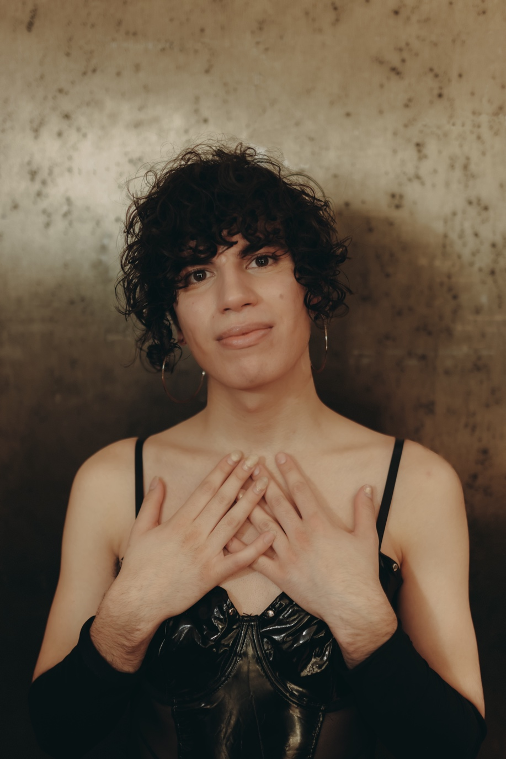
Credit: Jessie Morgan

Jacob Alon is pleased to share ‘the alon salon’ a five-track live EP recorded at Edinburgh’s intimate Mash House venue and featuring a live string section.

The EP features five live recordings from Jacob’s Mercury Prize nominated debut album “In Limerence”, released earlier this year.

It’s been a fantastic 2025 for Jacob with the release of the peerless debut album In Limerence to near unequivocal critical acclaim, whilst touring the UK, Europe and debut shows in the US to ever-increasing stages and rooms. It’s reaped the Scottish contemporary folk musician not only a prestigious Mercury Prize nomination (and a show-stealing performance on the night), but also nominations at the Rolling Stone UK Awards, the Scottish Album of the Year award, a BBC 6Music Artist of the Year, and just this week Jacob was unveiled as the BBC Introducing Artist of the Year – the first time that it’s been awarded to an artist north of the border.

With the alon salon EP, Jacob breaks these bittersweet songs down to their very skeletal frame of vocals, guitar, and strings, and rarely have they sounded quite so beautifully heartbraking.

Tracklisting for the alon salon ep:

I couldn’t feed her - live
don’t fall asleep - live
confession - live
liquid gold 25 - live
august moon - live

Jacob concludes their support tour with Kae Tempest this week in Edinburgh and Dublin, before three headline shows in Glasgow and London next month.

Jacob Alon Live:
12th November – Corn Exchange, Edinburgh (w/ Kae Tempest)
13th November – Vicar Street, Dublin (w/ Kae Tempest)
5th December – The Mackintosh Church, Glasgow SOLD OUT
6th December - The Mackintosh Church, Glasgow SOLD OUT
8th November – KOKO, London

https://www.jacobalon.scot/

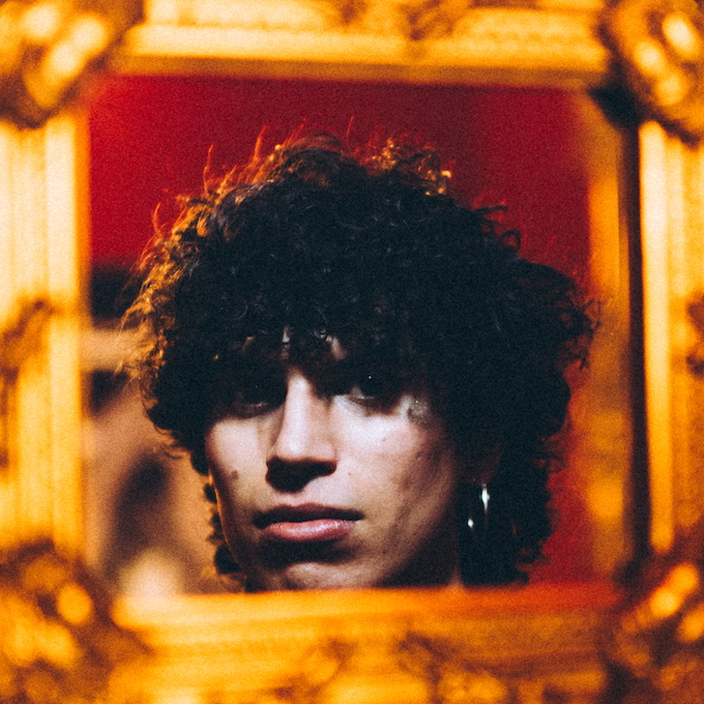
the alon salon artwork (credit: Rosie Sco)

For more on info contact warren@chuffmedia.com 07762 130510

