CAITY BASER ANNOUNCES BRAND NEW 6-TRACK EP
HER ‘THANKS FOR NOTHING, SEE YOU NEVER’ EP IS OUT FEB 17TH
NEW TRACK ‘2020S’ OUT NOW
TICKETS FOR HER FORTHCOMING TOUR AVAILABLE NOW, WITH LANDMARK AFFORDABLE TICKET PRICING
“Caity Baser is fast becoming pop’s wittiest new songwriter” – NME
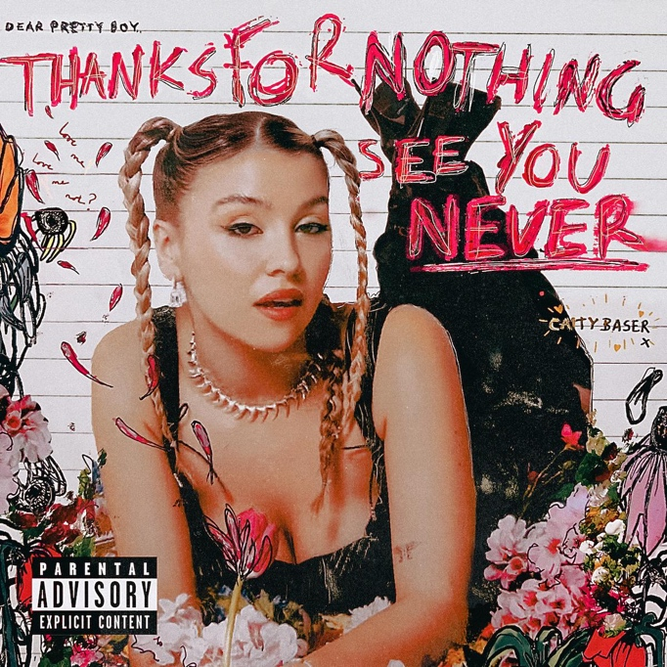
EP cover art for Caity Baser’s ‘Thanks For Nothing, See You Never’ EP. Full press assets available here
Listen to Caity Baser - ‘2020s’ HERE
Caity Baser has announced her new EP today. The ‘Thanks For Nothing, See You Never’ EP will feature six tracks including ‘X&Y’ and ‘Kiss You’ - and will be released 17th February via EMI Records/Chosen Music.
To celebrate the announcement, Caity has today released a brand new track - taken from the forthcoming EP. ‘2020s’ is available to stream and download now here.
Tracklisting for Caity Baser’s ‘Thanks For Nothing, See You Never’ EP is as follows:
1. Pretty Boys
2. X&Y
3. Kiss You
4. Feel More Okay
5. That’s What Friends Are For 6. 2020s
Of the EP, Caity says: “I am SO FRICKN HAPPY I can finally tell you all about my new EP. It's full of absolute bangers...some you know some you don't. But I love them all and I hope you do too xx"
Tickets for Caity’s anticipated ‘Thanks For Nothing, See You Never’ UK tour are also available today. It was announced earlier this week that tickets for all the shows have been capped at affordable prices, a decision made by Caity herself to ensure tickets to her shows are affordable and accessible to all.
The ‘Thanks For Nothing, See You Never’ tour will take place throughout April and May, including a performance at London’s O2 Forum Kentish Town - Caity’s biggest show to date.
Dates for Caity’s ‘Thanks For Nothing, See You Never’ tour are as follows:
Friday 7th April - Komedia, Brighton
Saturday 8th April - SWX, Bristol
Monday 10th April - O2 Institute2, Birmingham
Tuesday 11th April - Academy 2, Manchester
Thursday 13th April - SWG3 Studio Warehouse, Glasgow
Friday 14th April - Northumbria Uni, Newcastle
Sunday 16th April - Green Room, Dublin
Monday 17th April - Stylus, Leeds
Wednesday 19th April - Engine Rooms, Southampton
Thursday 20th April - O2 Forum Kentish Town, London

About Caity Baser
Hailed as a one to watch by many including Rolling Stone UK, The Independent, NME and more, 20-year-old pop singer Caity Baser has seen her enormous fanbase explode in a matter of months.
Her viral hit singles ‘Friendly Sex’ and ‘X&Y’ both helped the Southampton-born singer become the name on everyone’s lips last summer, but it was her live performances at Reading & Leeds festivals - just before two sold-out shows at London’s XOYO - which captured the attention of the UK and beyond. Her shows were met with packed-out crowds screaming every lyric of her songs back at her, with fans clearly closely identifying with Caity and her no-holds-barred, no filter approach to her music and her personality.
Now signed to EMI Records, she recently released her new single ‘Kiss You’ amidst a flurry of national press and radio coverage by the likes of The Guardian, Rolling Stone UK, CLASH, The Independent, BBC Radio 1, BBC Introducing, Capital FM and more. NME recently selected her as one of their NME 100 - a handpicked selection of acts who will change the face of music in 2023. Caity was also the digital cover star of The Line Of Best Fit, who proclaimed: “Caity Baser is having her main character moment”, stating that she is “here to start a new pop revolution built on sincerity and zero bullshit”. Record Of The Day said “Friendly Sex is the fun and outspoken pop track you need to hear. One to watch”, while Notion Magazine praised that Caity “brings a fresh sound that is wholly her own...furious, fuck-you energy”.
Caity Baser’s EP ‘Thanks For Nothing, See You Never’ will be released 17th February via EMI Records/Chosen Music. Her tour of the same name will take place throughout April 2023. Her new track ‘2020s’ is out now.
For more on Caity Baser:
TikTok | Website | Facebook | Twitter | Instagram | Spotify | Apple Music | Amazon
For more info contact warren@chuffmedia.com

