TOM A. SMITH
RELEASES NEW EP
‘PUT ON A RECORD TOMMY’

TODAY AVAILABLE ACROSS ALL DIGITAL PLATFORMS
LISTEN HERE

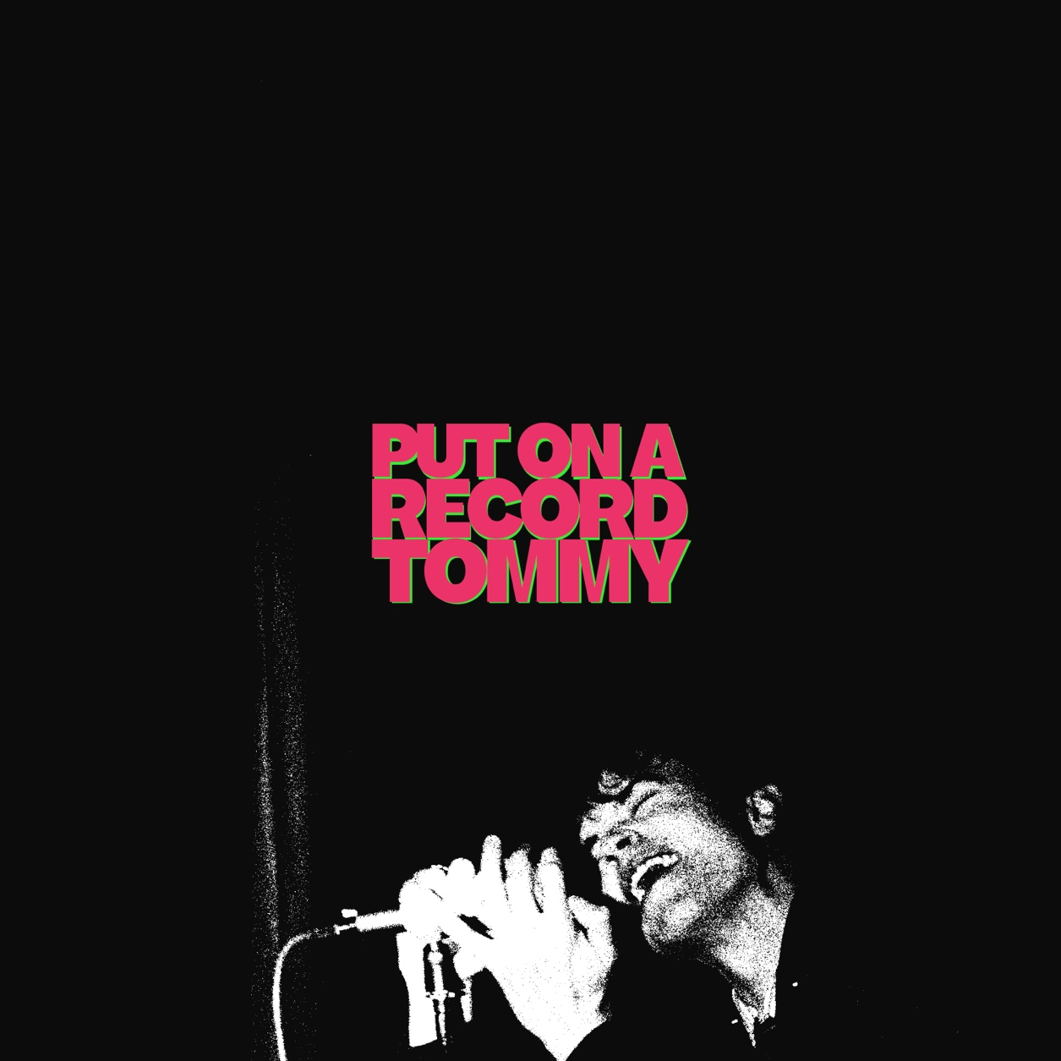

VINYL RELEASE JUNE 12TH
PRE-ORDER HERE

Rising North East star Tom A. Smith today releases his highly anticipated new EP ‘Put On A Record Tommy’, out now via Fiction Records and available digitally on all streaming platforms. Marking a bold and confident new chapter, the six-track project arrives alongside its centrepiece and focus track, the electrifying title song “Put On A Record Tommy.” A limited black vinyl LP edition will be released on June 12th and is available to pre-order now.

Framed around the idea of escapism and identity, the title-track brings the EP’s conceptual world into sharp focus. With driving rhythms, infectious hooks and a theatrical edge, it introduces listeners to “Tommy’s Dance Place”, a space that feels as euphoric as it does uncertain.

“Tommy’s dance place is officially open,” Tom explains. “Put on a record Tommy is a party and everyone is invited. But it’s not all it seems. Where do I go from here?”

Blending indie energy with emotional candour, the EP sees Tom continue to evolve both sonically and thematically. Opening track “SFX”, which recently earned BBC Radio 1’s Introducing ‘Tune of the Week’ with plays across shows including Greg James’ Breakfast and Future Artists with Sian Eleri, sets the tone for a release that balances confidence with vulnerability. Across the EP, tracks like “Our Song” and “The Only One” lean into heartfelt immediacy, while “No Matter What” and “The Band” round out the collection with a sense of reflection, ambition and forward momentum.

At just 22, Tom A. Smith continues to build a formidable reputation as one of the UK’s most exciting emerging voices. With major national radio support, a rapidly growing fanbase, a relentless touring schedule which includes a recent packed run of UK headline dates and an appearance at SXSW Austin and an upcoming jam-packed festival season which kicks off at The Great Escape and sees him hit the stage again for BBC Radio 1’s Big Weekend in his hometown of Sunderland, Isle of Wight Festival, Truck Festival and The Eden sessions with The Maccabees by personal invite from the band, this EP lands at a pivotal moment in his ascent.

‘Put On A Record Tommy’ captures an artist stepping further into his own identity, offering a snapshot of where he is now, and hinting at where he’s heading next.

‘PUT ON A RECORD TOMMY’ TRACKLIST:
SIDE A
SFX
Our Song
The Only One

SIDE B
Put On A Record Tommy (feat. Rowetta)
No Matter What
The Band

UPCOMING LIVE DATES & FESTIVALS

13 May – Hastings, White Rock Theatre (with The Lottery Winners)
15 May – The Great Escape, Brighton (Third Man Records at DUST)
16 May – London, The Forum (with The Lottery Winners)
21 May – Paris, Oberkampf Festival
23 May – BBC Radio 1’s Big Weekend, Sunderland
19 Jun – Stockton Globe (with Amy MacDonald)
20 Jun – Isle of Wight Festival
27 Jun – Sheffield Steelyard (with The Sherlocks)
10 Jul – Plymouth Sound Factory Festival
11 Jul – Eden Sessions, Cornwall (with The Maccabees)
24 Jul – Together Again Festival, Chester
25 Jul – Fulford Arms, York
26 Jul – Truck Festival, Oxford
09 Aug – Boardmasters Festival, Cornwall
20 Aug – 110 Above Festival, Leicestershire
21 Aug – Lemon Street Social Club, Tyldesley
22 Aug - RNRC Roll Circus, Norwich w/ The Kooks

At just 21 years old, Tom A. Smith has already built an impressive résumé; from playing open mic nights as a young teen in the North East with Sam Fender, festival performances at Glastonbury, Leeds and BBC Radio 1’s Big Weekend, to support slots with Gang of Youths, DMA’s, Catfish and the Bottlemen, Miles Kane, and Elton John, who personally selected him to perform at Hyde Park during the legendary Farewell Yellow Brick Road shows. He’s also been announced to play Dave Stewart (Eurythmics) in an upcoming musical memoir film, Ebony McQueen.

Raised in Houghton-le-Spring just outside Sunderland, Tom first picked up a guitar aged four and hasn’t stopped since. With his bold songwriting, undeniable charisma, and a relentless drive to push forward, “SFX” marks yet another thrilling step in what promises to be a huge year ahead.

DISCOVER TOM A. SMITH
Website | Facebook | Instagram | YouTube | Spotify



For more information and press enquiries please contact

Warren Higgins
warren@chuffmedia.com

