Liverpool band STONE release new EP Punkadonk
Out now on Polydor Records

Listen to new single ‘Moto’

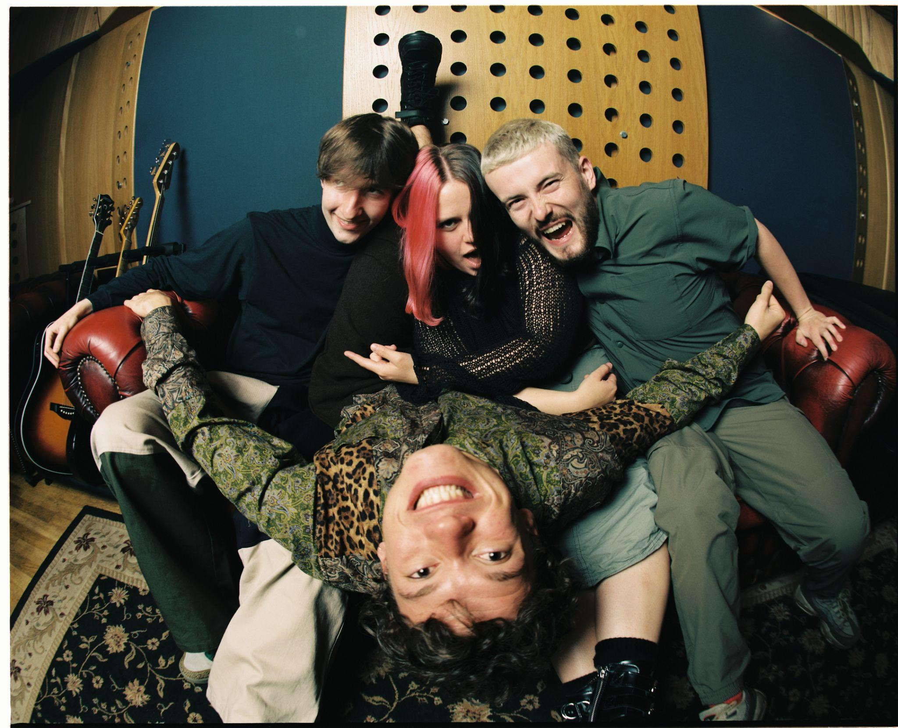
Photo Credit: Isaac Lamb | Download High Res

"Bruising post-punk full of Scouse spirit and soul"
NME

“STONE are the post-punks with a reputation for mosh-pit starting licks and the snarling delivery of frontman Fin Power”
Rolling Stone UK

“Full throttle and immediate but undeniably powerful – from a band that must be seen live to be truly believed. Expect venues around the country to be shaking in anticipation."
Dork

Liverpool four-piece STONE release their debut EP Punkadonk today, out now via Polydor Records. The EP arrives with new single ‘Moto’, a live staple and fan-favourite, now finally captured in the studio. The new single joins recent BBC Radio 1 ‘Tune of the Week’ ‘Money’ Hope Ain’t Gone’ as well as earlier cut ‘Waste’ on the five-track EP. Across a breakout 12 months, STONE’s formidable live presence has seen them sell-out multiple headline shows, foster a burgeoning fanbase, and pique the interest of some of music’s biggest names. The band have toured with YungBlud and Inhaler, performed at Sam Fender’s Finsbury Park show, and headed to Malaga for Louis Tomlinson’s ‘Away from Home’ festival between blistering sets at Reading and Leeds Festivals. The band have also shared details of their own UK headline tour for April 2023, with an extra show now added for London due to demand, full dates below and tickets here.

Where ‘Money (Hope Ain’t Gone)’ touches on the collective uncertainty of coming of age in a politically fraught time, ‘Moto’ is a carefree account of frontperson Fin Power’s unwavering loyalty to his cheap replacement Motorola phone. On the track, STONE comment; “‘Moto’ was written about when Fin (lead singer) kept losing his iPhone. He got so sick of it he eventually just went into Tesco and asked for the cheapest phone, and it was a Motorola. He eventually loved the Motorola and had the ringtone stuck in his head with a drum beat behind it.”

With their debut offering Punkadonk, STONE hope to solidify their ethos - one which encapsulates the scope of their influences, joyfully and urgently refusing to be boxed in, delivered via the instantly discernible vocals Fin Power. This intention is made clear with the track ‘Disruptor’, a surprising electronic-flecked track which nods endearingly towards the late 90s and early noughties soundscapes present in their early childhood years. Tracks like ‘Moto’ and continue this lightheartedness, as does ‘Radio Ready’ - a good-humoured jab at the pressure to create music for mass appeal. On the other side of the coin is STONE’s fundamental desire to create catharsis. This manifests itself in their blend of thrilling, frenetic rock’n’roll with more intimate exploration of the Gen-Z experience, most pertinent on the EP in tracks like ‘Money (Hope Ain’t Gone)’ and ‘Waste.’ The latter is a candid exploration of the debilitating effect that feeling misjudged has had on Fin’s mental health, a clear example of their ability to craft songs which are as rewarding to mosh to as they are to emotionally absorb. Lead guitarist Elliot Gill reflects; “Our music is just a conduit to all the emotion that we all feel. We're living in this scary sensational world of social media, where everything is overexposed and overwhelming. But we're all in it as a generation. Me and Fin have our own struggles with mental health, and I think that’s why we do what we do with such an intensity; we put up that part of ourselves onstage just to give kids an opportunity to connect with something.”

Alongside Fin Power and Elliot Gill, STONE are completed by Sarah Surrage (bass), and Alex Smith (drums).​ The band were named as part of the NME 100 for 2022, and have been championed by the likes Jack Saunders and Clara Amfo on BBC Radio1 and Steve Lamacq on BBC 6 Music. Originally forming in lockdown, the band quickly became frontrunners in the new-era Liverpool scene, releasing a string of dynamic early singles including ‘Stupid’ and ‘Let’s Dance To The Real Thing’ - which recently soundtracked the new Liverpool FC home kit reveal, see here. Now joining forces with Polydor, it’s clear that the stage is set for STONE to continue to rise as one of the UK’s most exhilarating young acts.

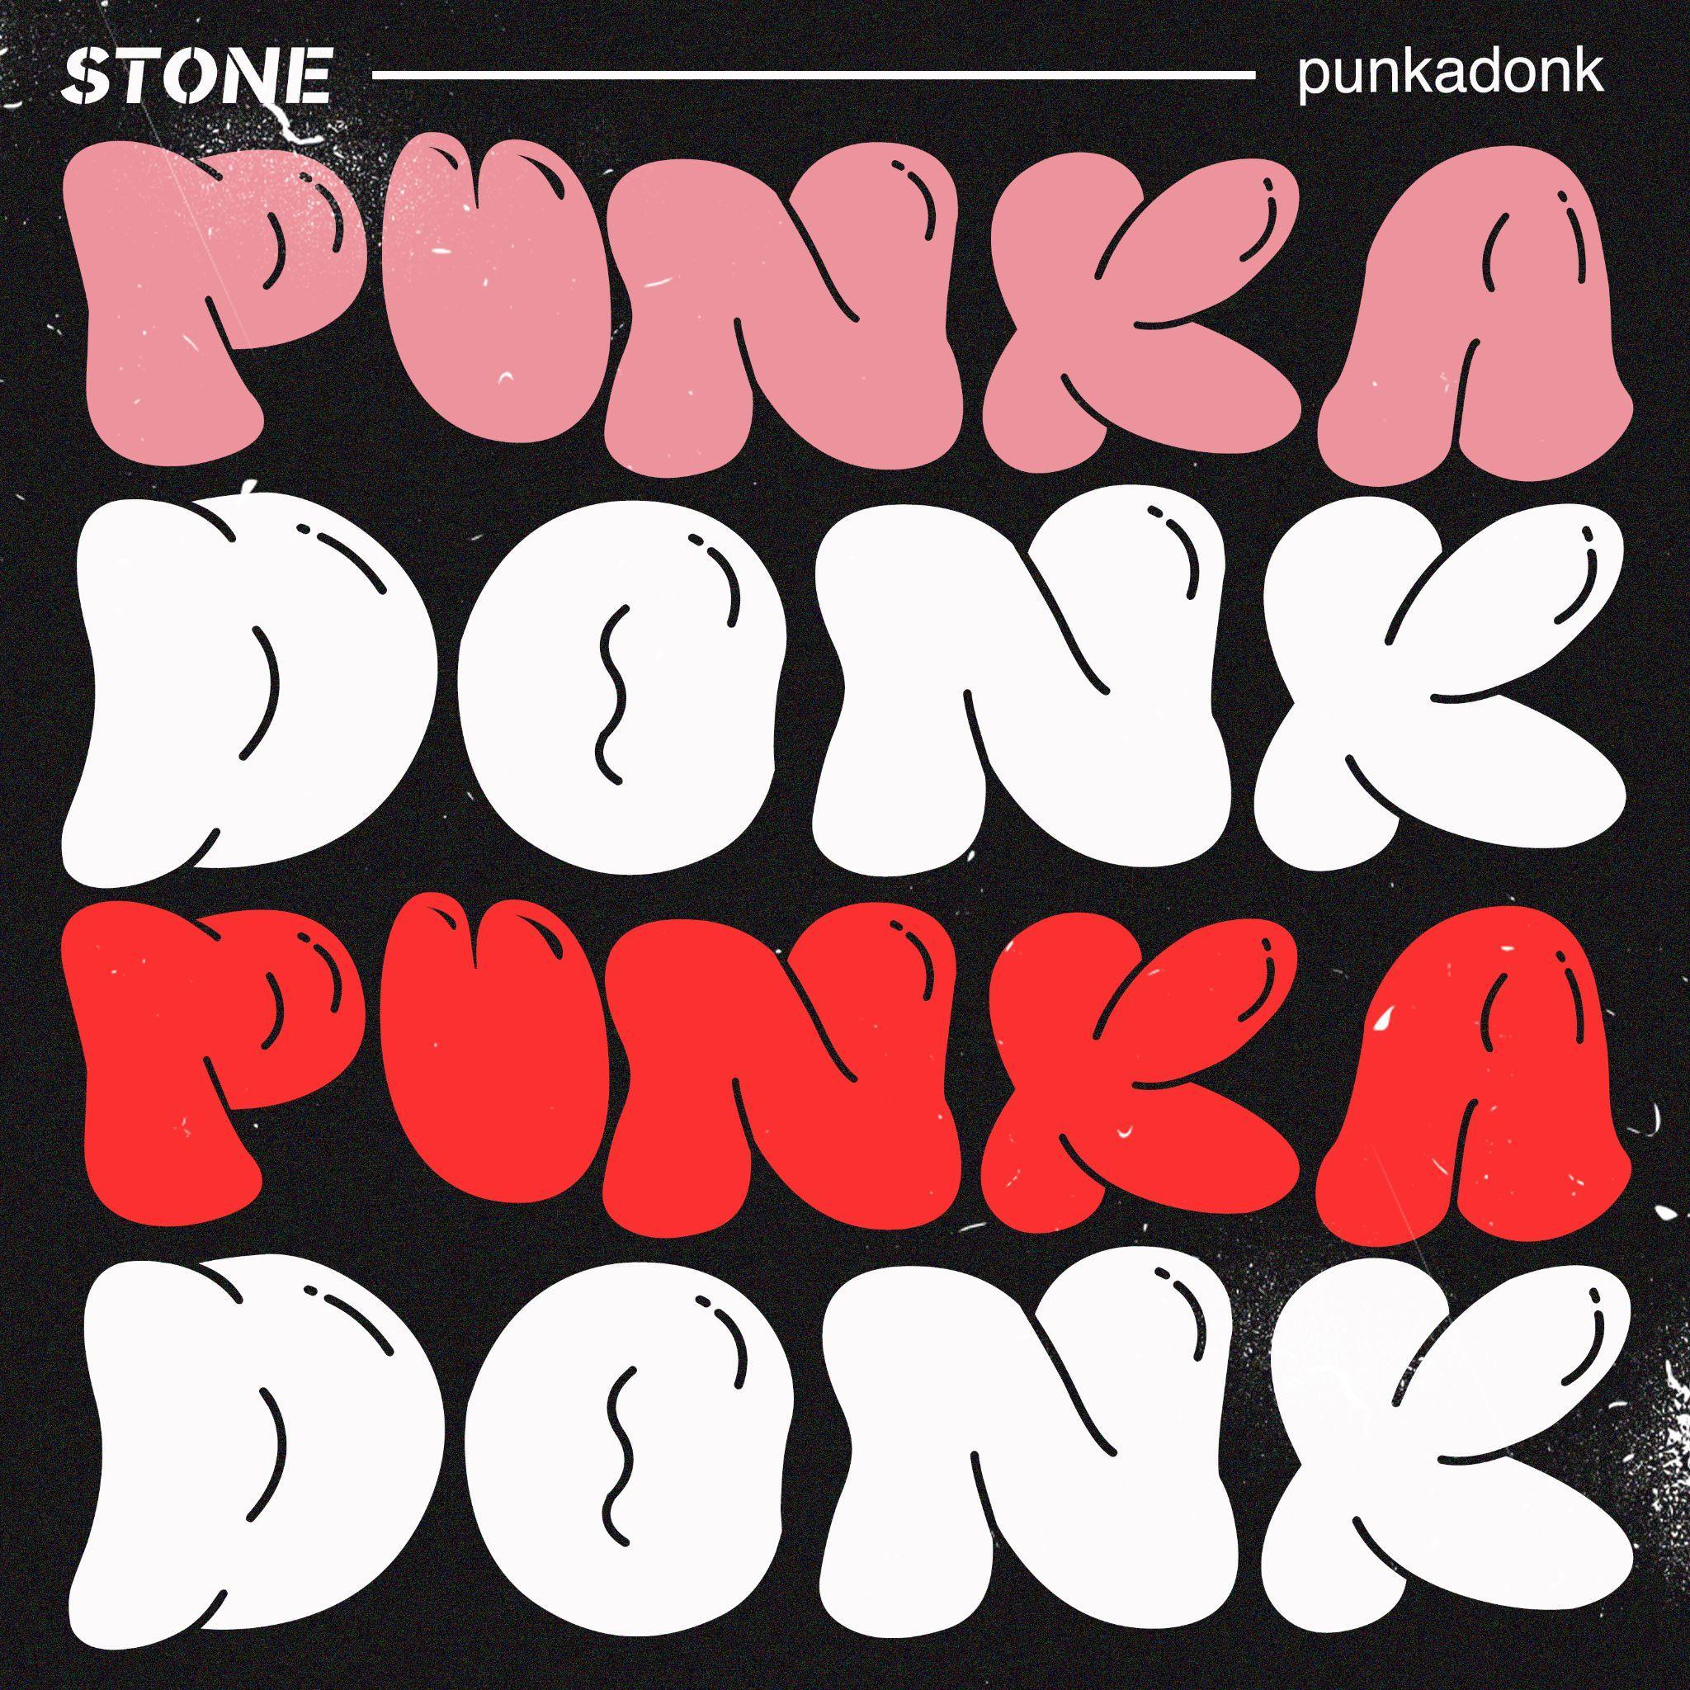
Punkadonk EP artwork | Download high res

2022 Live Dates:

18 November | Preston | The Ferret
26 November | Sheffield | Foundry

2023 UK Headline Tour:
Tickets here

10 April | London | Omeara
11 April | London | Omeara *SOLD OUT*
13 April | Newcastle | Cluny
14 April | Glasgow | SWG3 Warehouse
15 April | Cambridge | Junction 2
18 April | Birmingham | The Castle & The Falcon
19 April | Leeds | Wardrobe
21 April | Nottingham | Metronome
22 April | Liverpool | O2 Academy
23 April | Bristol | Thekla
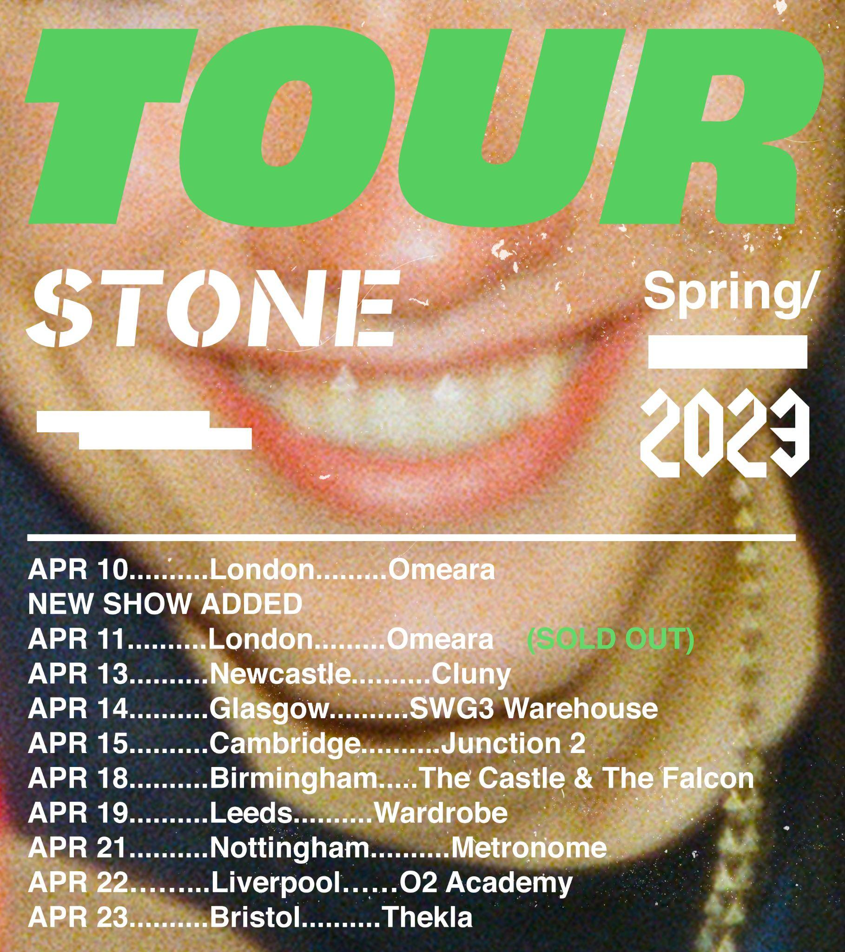

Follow STONE:
Instagram | Facebook | Youtube | TikTok | Spotify

For more information please contact
Warren@chuffmedia.com on 07762 130 510

