​​PALACE
ANNOUNCE NEW EP OUT JULY 18TH
“PART I – WHEN EVERYTHING WAS LOST”
RELEASE NEW SINGLE “WHEN EVERYTHING WAS LOST”
CURRENTLY ON BIGGEST NORTH AMERICAN TOUR TO DATE
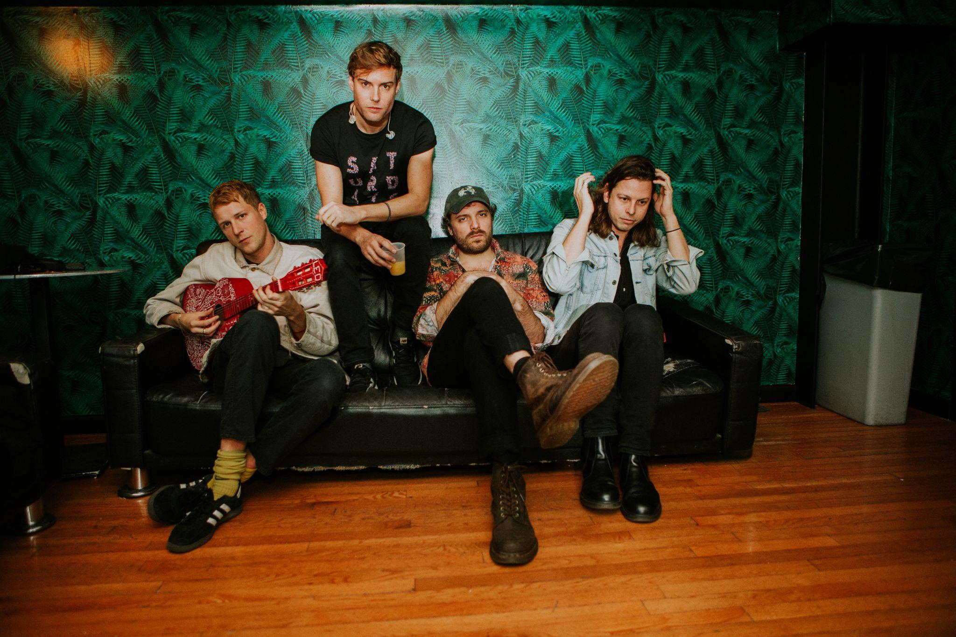
Credit – Joe Gonzalez

London band Palace today release a brand new single “When Everything Was Lost”, the title track from their upcoming four track EP “Part I - When Everything Was Lost”, out July 18th via Fiction. The new EP introduces rich, deep strings to Palace’s sonic arsenal, building on their now-trademark warmly melodic yet melancholic sound.

LISTEN TO “WHEN EVERYTHING WAS LOST” HERE

“The EP is about the journey of growing older with someone, and trying to move and mould to the things along the way that you don’t ever imagine or plan.” explains frontman Leo Wyndham; “The things that floor you, but will eventually bind you together. Intertwined. Inseparable.”

“'When Everything Was Lost’ is about the immense strength and power of female energy and feeling a profound and overwhelming sense of awe in that. It’s about looking at someone you love from a distance going through something hugely significant, and seeing them handle it in a way a man never could."

The EP announcement and new single follows the release of “How Far We’ve Come” and “All We’ve Ever Wanted”, their first new music since their acclaimed 2022 album ‘Shoals’, and arrives in the midst of the band’s biggest North American tour to date - tickets are on sale now. The landmark dates continue the band’s explosive growth in the US and Canada, and follow a debut Australian tour in December 2022 and a huge spring ‘22 UK tour that included their biggest show to date at O2 Academy Brixton. The band will play their debut shows in New Zealand and return to Australia for a string of dates in July including Splendour In The Grass.

2022’s ‘Shoals’ is a profound and pensive album, boldly exploring some of life’s greatest questions over its 12 mesmerising tracks. The album deftly explores the interplay of three central existential dilemmas against a broader backdrop of wonder at the vastness and power of the ocean, concluding its arc with the stunning opus ‘Where Sky Becomes Sea’. Through diving into themes of the subconscious, dreams and existentialism, ‘Shoals’ is a record about living with and processing fear.

Leo Wyndham, Matt Hodges and Rupert Turner released their acclaimed debut EP ‘Lost In The Night’ in 2014, followed by the ‘Chase The Light’ EP the following year, their debut album ‘So Long Forever’ in 2016 and sophomore album ‘Life After’ in 2019.

PRE-SAVE THE EP HERE
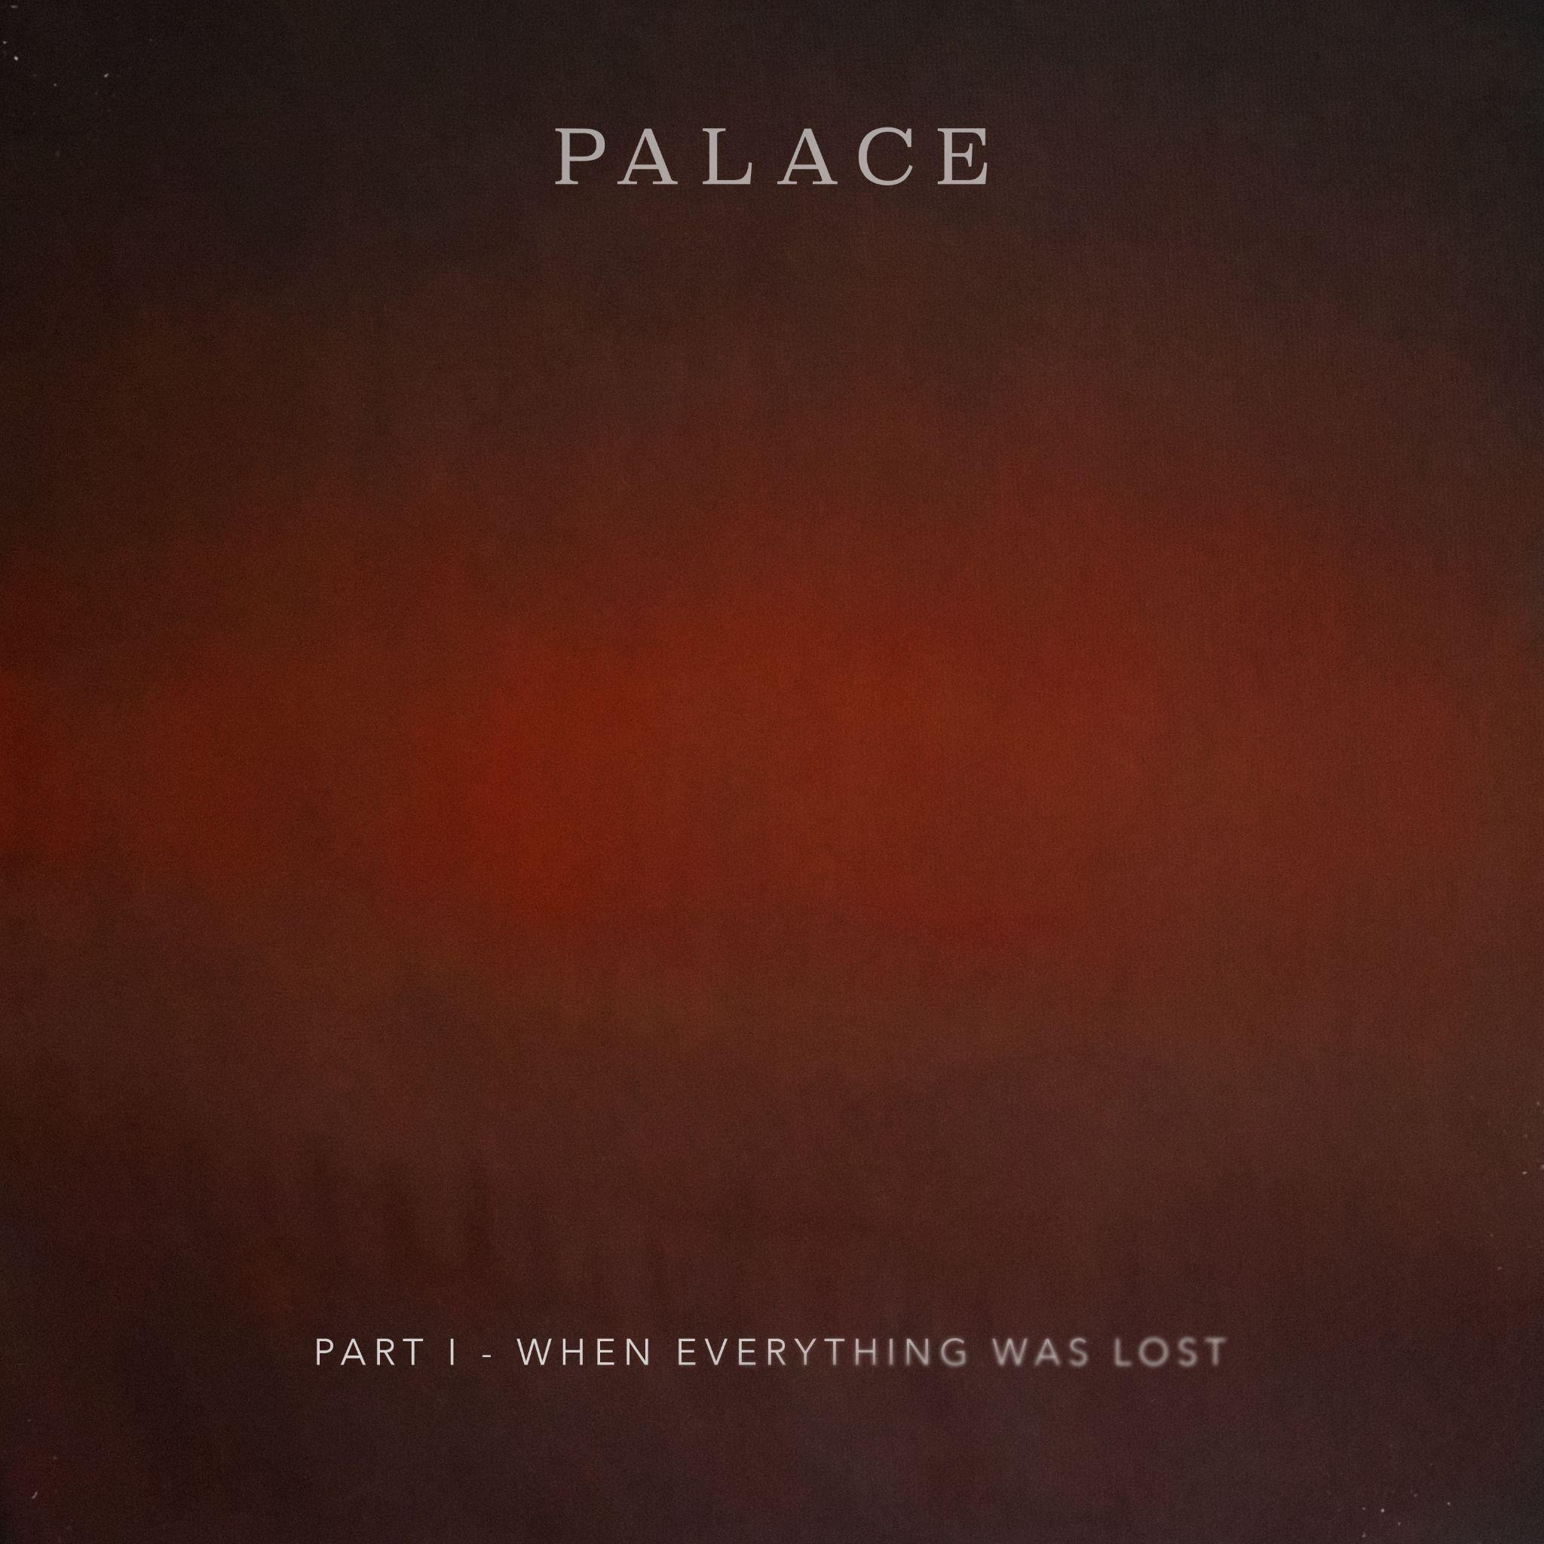
EP Artwork

EP TRACKLISTING:

- All We’ve Ever Wanted
- How Far We’ve Come
- When Everything Was Lost
- Inside My Chest

REMAINING USA TOUR DATES

Tues June 20, Denver, CO - Ogden Theatre
Weds June 21, Salt Lake City, UT - Rockwell @ Complex
Fri June 23, Los Angeles, CA - Wiltern
Sat June 24, San Francisco, CA - Fox Theatre

AUSTRALIA + NZ

Tues July 18, San Fran, Wellington, NZ
Weds July 19, The Powerstation, Auckland, NZ
Fri July 21, Splendour in the Grass, North Byron Parklands, Australia
Sun July 23, Astor Theatre, Perth, Australia

Critical praise for ‘Shoals’
“If Shoals is anything to go by, Palace will be filling stadiums before too long” – The Line Of Best Fit 8/10
MOJO ****
“‘Shoals’ manages to offer consolation and tranquillity from beginning to end.” – Dork Magazine ****
“a more pure and intense sound” – DIY Magazine 3.5*
“equal parts moving as it is captivating” – Gigwise 7/10
“Not many bands do better emotionally literate, melancholic indie at the moment” – The Observer
“A band of emotional extremes and that is what for me makes them so exciting” - Jack Saunders, BBC Radio 1 “Expansive and emotive” - Stereogum
Instagram | Facebook | Twitter | Website

For more information & media enquiries, please contact

Warren Higgins
warren@chuffmedia.com

