SKYLAR SOARS INTO THE NEW YEAR WITH AN ODE
“TO THE GIRL THAT GETS HIM NEXT”

LISTEN TO THE NEW SINGLE HERE

DEBUT EP “I’D STEP ON LEGO FOR YOU” OUT 20/01/23

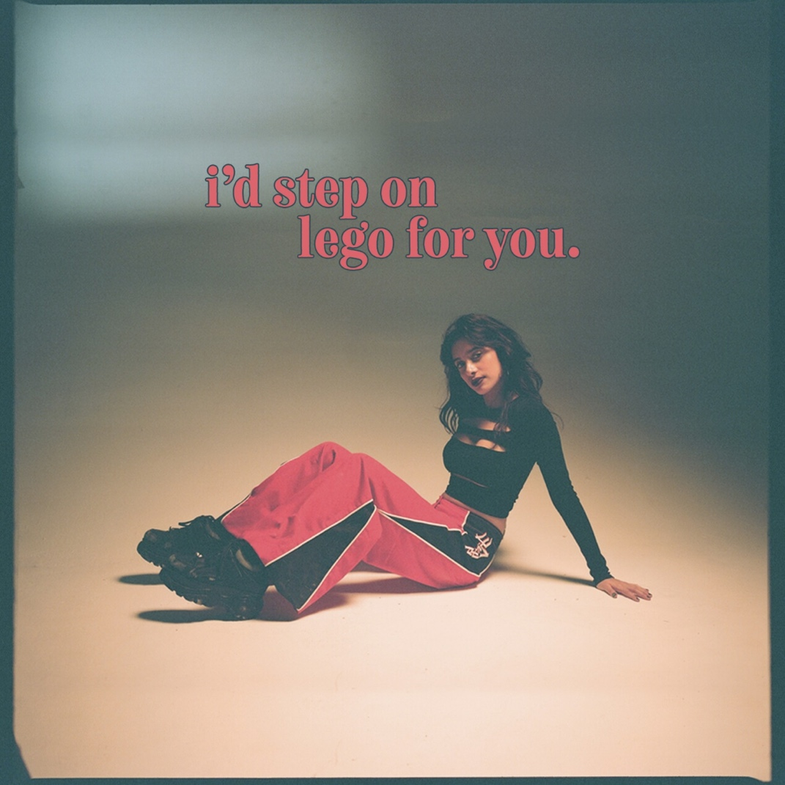

DOWNLOAD HI-RES ARTWORK HERE
DOWNLOAD HI-RES PRESS SHOTS HERE

Entering the new year with a bold sonic statement, newcomer Skylar affirms that it’s’ truly ‘out with the old and in with the new’, with the release of her uplifting pop soliloquy “To The Girl That Gets Him Next”. Arriving on the cusp of the release of Skylar’s debut EP via Polydor, “I’d Step On Lego For You”, the new single outlines Skylar’s desire to continue on creating a musical lane for herself in which she can explore the limits of fun-loving yet introspective pop records fashioned for an internet generation.

“It’s basically an excuse for me to chat sh*t with a touch of melody” cracks pop newcomer Skylar with regards to the messaging behind her debut EP, “I’d Step On Lego For You”. Continuing on her rise to stardom with a collection of feel-good coming-of-age anthems, Skylar is starting the new year strong with a five-track-wide offering which highlights past hits such as “Hair Tie” and “Double Denim”, whilst signalling her clear elevation of sound with new music.
On “To The Girl That Gets Him Next”, to the tune of a grandiose string arrangement cleverly bolstered by an infectious drumline, Skylar ponders on the future suitor to her ex-lover, as she deconstructs the remnants of a relationship she feels that she “should have left sooner”. “It’s almost a big sister diary which takes you on a journey through all the times of a relationship gone wrong” says Skylar of her motivations behind writing the track. “It’s genuinely a fun, ‘warning’ song addressed to the unlucky girl who gets my ex next!” she exclaims.

Always candid in her approach to songwriting, “I’d Step On Lego For You” encompasses Skylar’s sonic idiosyncrasies, and showcases the singers’ intrepid proficiencies for illuminating all the emotions associated with growing pains through her bold use of metaphor and satire. In attempting to encompassingly answer her own questions on “how to tell someone you love them” without the inherent awkwardness of actually having to say those “[cringey] three words” across the EP, Skylar has fashioned a body of work that sums up the solution perfectly within the title and tracks included on “I’d Step On Lego For You”. “Works like a charm” Skylar confirms, “you can find all that in my EP that’s for sure!” she says.

ABOUT SKYLAR
Describing her sound as “quintessentially British,” 19-year-old London singer-songwriter, and internet sensation Skylar – born Skylar Sanyal, is paving her own way in the world of music. As part of the social media generation, Skylar’s effortless aesthetic has made her a viral sensation on TikTok, where she’s found the perfect outlet for her own brand of creativity.
Cementing her own success on the app with her nostalgic Brit-pop musical expression has led to the singer amassing a monumental 5.5M likes and 396.9K followers in no time at all. Having extended her reach on TikTok out to her extended community of ‘internet friends’, Sanyal has also gained over 34.8k Instagram followers and 10K YouTube subscribers; who have all contributed to her whirlwind achievement of over 8 million combined streams across all releases to date.

“I’D STEP ON LEGO FOR YOU”

OUT FRI 20th JAN 2023

(TRACKLIST)

1.Hair Tie
2.Double Denim
3.To The Girl That Gets Him Next
4.Naked Poetry
5.Afterlife

Follow SKYLAR Online

SPOTIFY | INSTAGRAM | YOUTUBE | TIKTOK

For more information & enquiries please contact warren@chuffmedia.com

