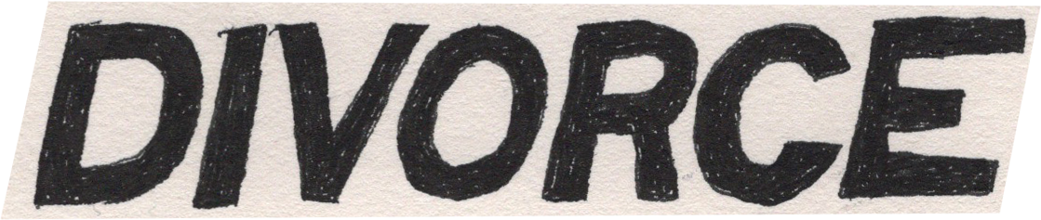

**Divorce** release[**‘Heady Metal’ (EP)**](https://divorce.lnk.to/HeadyMetal), out **today (November 17th)** via **Gravity/EMI Records**

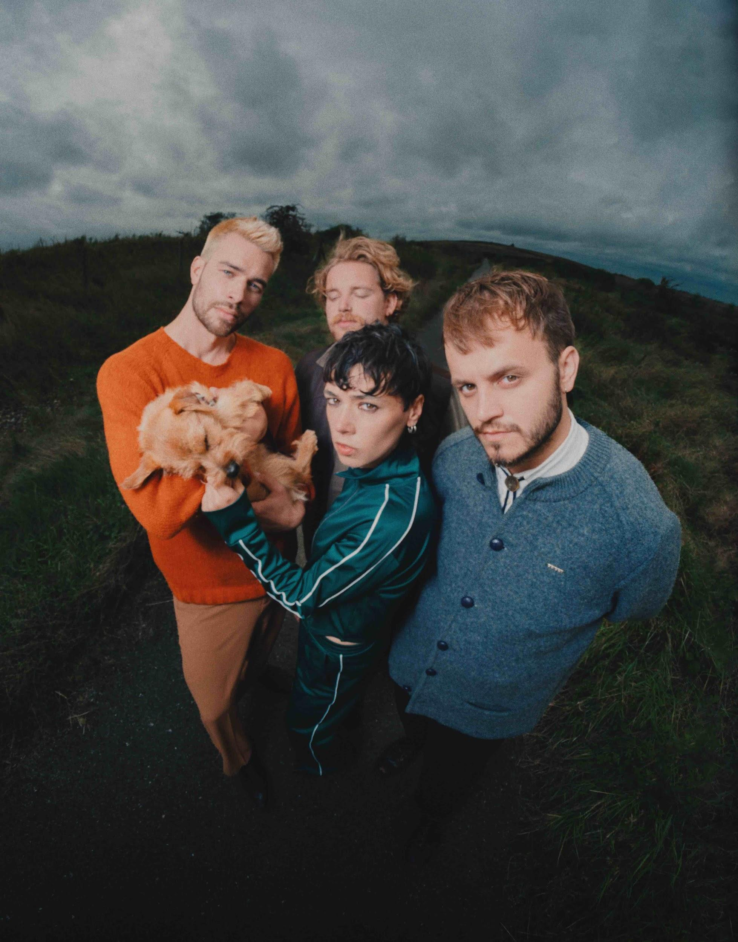

**Photo Credit:** Alex Evans

*“An indie-rock delight”* **The Times**

*“A patchwork sound that folds in The Beatles, The Carpenters and Fiona Apple"***The Independent**

*“Divorce are bringing the fun back to scuzzy guitar music”***The I Paper**

*“New genre-crossing sound”* **The Line Of Best Fit**

*“Intricate harmonies, folk-tinged guitars, and live shows imbued with humour and heart”* **DIY**

*“Anthemic indie rock”* **Brooklyn Vegan**

*“Engaging and catchy”* **Clash**

*“Playground-sing-song grunge”* **So Young Magazine**

Nottinghamindie sensations **Divorce** release second [**EP** **‘Heady Metal’**](https://divorce.lnk.to/HeadyMetal), out **today (November 17th)** via **Gravity/EMI Records.** Newly-confirmed to support **The Vaccines** on their mammoth spring 2024 UK tour, the alt-country figureheads’ thrilling ascent continues to show no signs of slowing, with the first singles from their extended release (**‘Birds’** and **‘Scratch Your Metal’**) landing on the **BBC 6 Music playlist**, and current single **‘Eat My Words’** already becoming a fixture on the airwaves.

Spearheaded by enigmatic songwriting duo **Tiger Cohen-Towell** and **Felix Mackenzie-Barrow**, ‘Heady Metal’ signals a closer collaboration than ever between the two bandmates, providing a striking portrayal of insecurity and questioning whether to trust oneself or your new surroundings. The character studies of **debut EP ‘Get Mean’** are gone; in their place more vulnerable narratives about grappling with identity amid the new pressures they were experiencing following their phenomenal rise.

Lead single **‘Birds’** for example, addresses the pressure of people taking interest after years of obscurity, whilst **‘Right on Time’** was written by Tiger about their first experience of queer relationships, having shied away from their identity as a teenager. Despite these anxieties however, their musical confidence has grown hugely; showcased in **‘Sex and the Millennium Bridge’**, a brooding effort that steadily gathers its mettle, whilst **‘Heaven Is A Long Way’** finds Felix reflecting on hazy childhood memories and delves deeper into the band’s vivid and varied songwriting..

With a **full UK tour** lined up to coincide with their EP release, preceded by a run of support dates alongside **Willie J Healey**, the thriving four-piece’s budding live reputation has certainly attracted considerable fanfare over the twelve months. With full-capacity shows at this year’s **The Great Escape** as well as playing the main stage at **End Of The Road** and acclaimed live shows with the likes of **Self Esteem** at **BBC Proms**, Divorce have also graced the stage alongside appearances with **86TV’s, Lime Garden** and **Pip Blom** amongst others.

In addition, widespread plaudits across the press landscape **(The Times, The Independent, The I Paper, DIY, Dork, So Young, The Line Of Best Fit, Clash, Consequence of Sound, NPR, Brooklyn Vegan, The Needle Drop, CMU, Rough Trade)** and radio airwaves **(BBC Radio 1’s Gemma Bradley & BBC 6 Music’s Steve Lamacq, Lauren Laverne, Craig Charles)** alike has certainly amplified the spotlight surrounding the emerging quartet.

Speaking ahead of their EP release, **co-vocalist/bassist** **Tiger Cohen-Towell** and **co-vocalist/guitarist Felix Mackenzie-Barrow** explained: “The title, ‘Heady Metal’ reflects the tongue-in-cheek nature of much of our songwriting. The EP is a patchwork of different streams of consciousness, often exploring the extremes of our instincts or how far you can push a feeling. As dual songwriters there is always a duality to what we do, and we played a lot with those contrasts in these songs.”

Produced by **Matt Peel (Dream Wife, Eagulls, Pulled Apart By Horses)**, and mixed by **Grammy-nominated** producer **Catherine Marks (boygenius, Wolf Alice, St. Vincent)**,Divorce’s **’Heady Metal (EP)’** is out now via **Gravity/EMI** and available on all digital platforms.

*Divorce are Tiger Cohen-Towell (Vocals, Bass), Felix Mackenzie-Barrow (Vocals, Electric Guitar), Adam Peter Smith (Electric Guitar) and Kasper Sandstrøm (Drums)*

**‘Heady Metal’ (EP) Tracklist**

01 - Sex & The Millennium Bridge

02 - Birds

03 - Right On Time

04 - Eat My Words

05 - Scratch Your Metal

06 - Heaven Is A Long Way

**Divorce Online**

[Instagram](https://www.instagram.com/divorcehq) / [Facebook](https://www.facebook.com/divorcehq/) / [Twitter](https://twitter.com/divorce_hq) / [YouTube](https://www.youtube.com/channel/UCippMqd8-uSF8OnKsTO9HaQ)/ [TikTok](https://www.tiktok.com/@divorcehq) / [Website](http://www.divorcehq.co.uk)

**Live Dates**

21st Nov - Rough Trade, Bristol – SOLD OUT

22nd Nov - The Social, London – SOLD OUT

23rd Nov - Sunflower Lounge, Birmingham

25th Nov - Nice N Sleazy, Glasgow

26th Nov - Headrow House, Leeds

27th Nov - YES (Basement), Manchester – SOLD OUT

16th Dec - Rescue Rooms, Nottingham

Feb 5th - O2 Institute, Birmingham^

Feb 6th - Manchester Academy, Manchester^

Feb 7th - Rock City, Nottingham^

Feb 10th - Troxy, London^

Feb 11th - Dreamland, Margate^

Feb 13th - Leas Cliff Hall, Folkestone^

Feb 14th - O2 Guildhall, Southampton^

Feb 15th - O2 Academy, Bristol^

Feb 17th - O2 Academy, Oxford^

Feb 18th - Brighton Dome, Brighton^

Feb 19th - O2 Academy, Sheffield^

Feb 21st - O2 Academy, Leeds^

Feb 22nd - Barrowland Ballroom, Glasgow^

Feb 23rd - NX, Newcastle^

*supporting Willie J Healey

^supporting The Vaccines

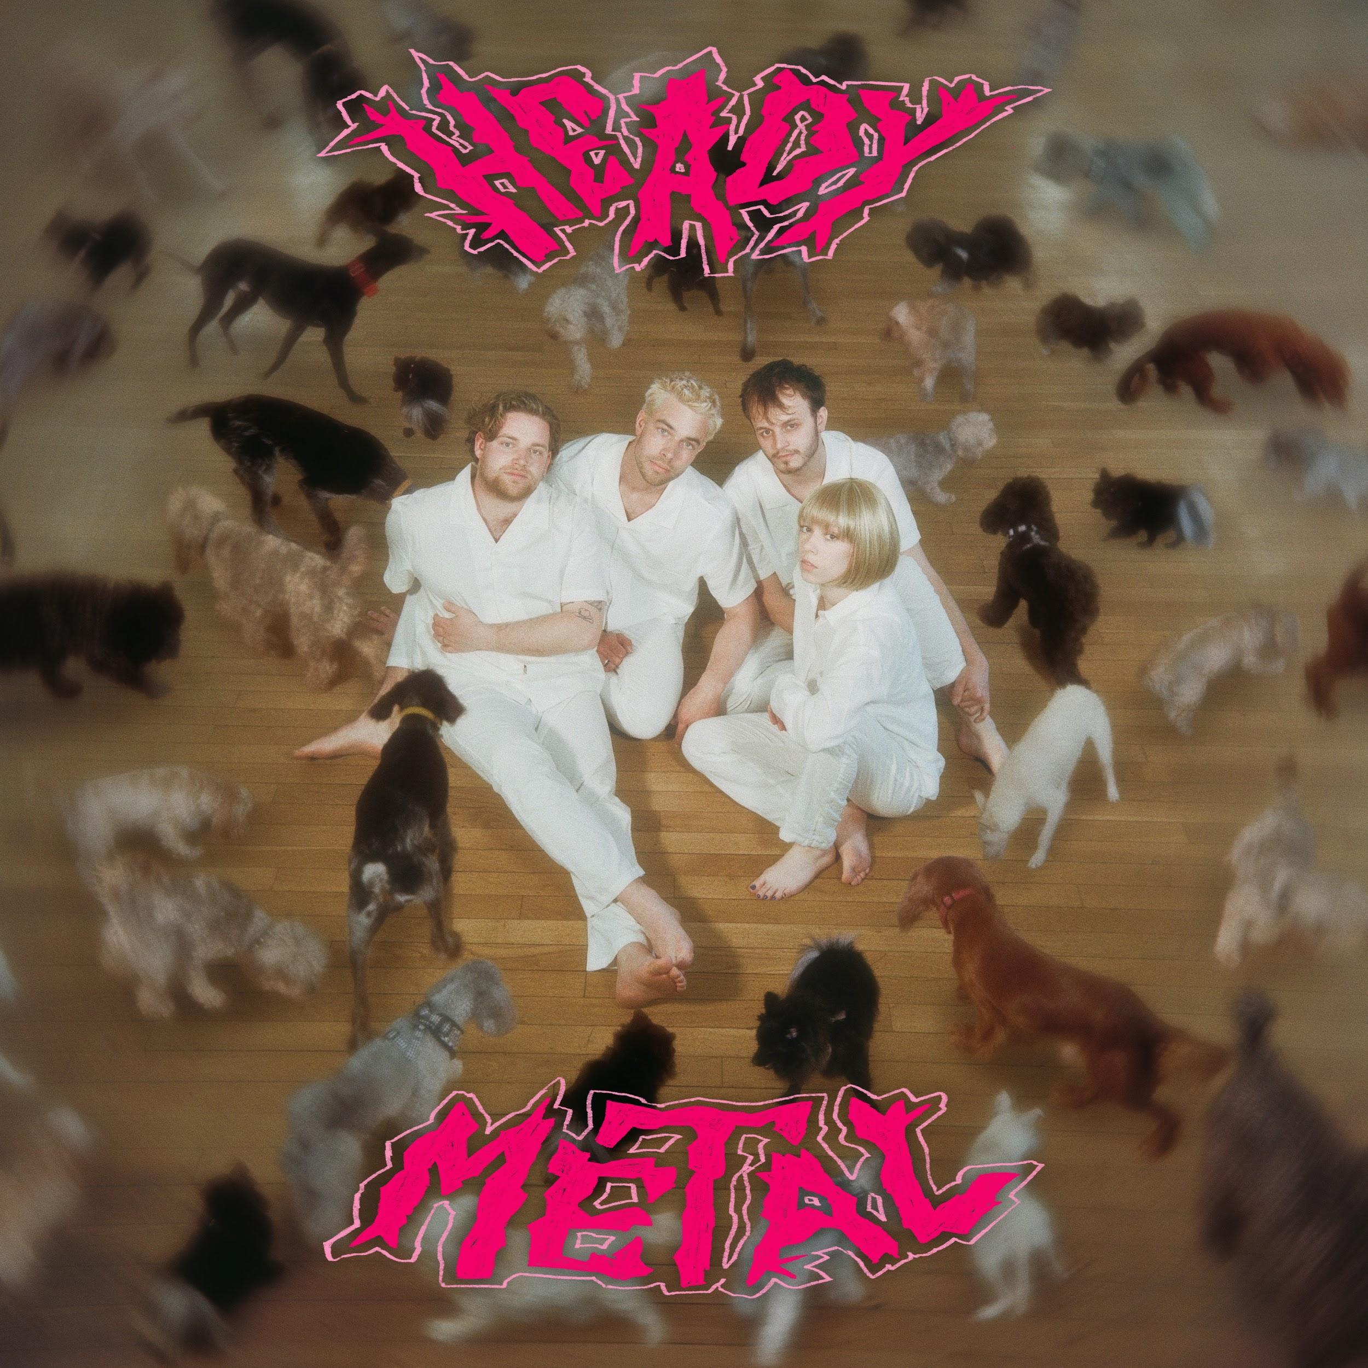

**For more on info contact** [**warren@chuffmedia.com**](mailto:warren@chuffmedia.com)