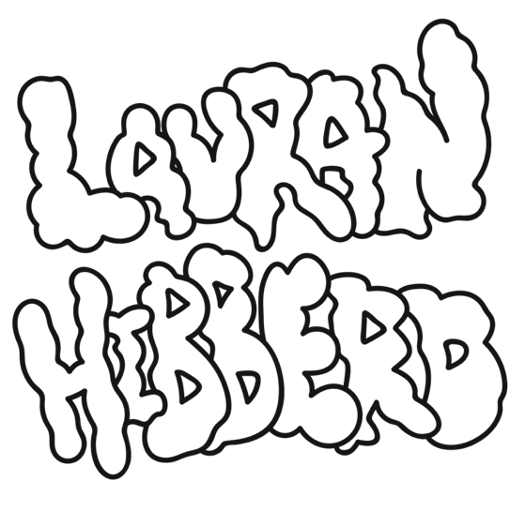
Slacker-pop sensation Lauran Hibberd shares satire-fuelled, anthem-stacked ‘Goober’ EP, set for release July 30th

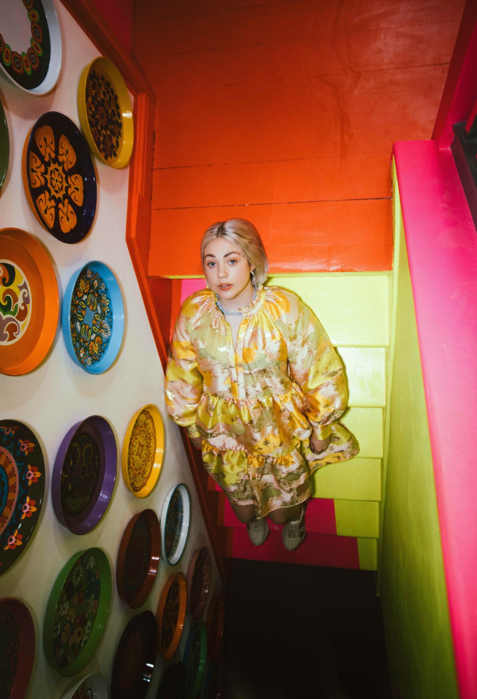
Photo Credit: Rebecca Need-Menear

“Lauran Hibberd is back with a new slacker-pop bop to prove just why she’s being hailed as the next hottest thing” DIY

“A firecracker of a track” Billboard

“Tongue-in-cheek slacker-pop” NME

“Garage rock tunes...huge pop hooks” NYLON

“Grunge-inflected, punky bubblegum pop…she continues on her upward trajectory in explosively exciting fashion” The Line Of Best Fit

"Queen of slacker pop…her witty and irreverent take on slacker-pop can brighten up even the bleakest of days" Dork

"Each song from the rising talent feels immaculately well packaged…cool-as-heck indie rock" Clash

"If you’re a fan of excellent indie then keep your eyes on Lauran Hibberd. We’re certain she won’t disappoint you" Gigwise

“Fizzy indie rock bangers” Music Week

“Slacker pop has a new frontrunner …every single one of Lauran Hibberd’s tracks is 10/10 great” Upset
Fast becoming a key figure within the emerging indie elite, slacker-pop sensation Lauran Hibberd shares her satire-fuelled, anthem-stacked ‘Goober’ EP, set to arrive July 30th.

“‘Goober’ has been a long time in the making”, explains the enigmatic figure. “It’s survived a global pandemic and many mood swings from me. These tracks all summarise what I’ve been thinking over the last twelve months. I hope for your sake, you can’t relate haha!”

Showcasing several explosive additions to an ever-growing back catalogue, the EP sees Hibberd partner with esteemed producer Suzy Shinn (Weezer, Panic! At The Disco, Fall Out Boy, Dua Lipa) for recent cuts ‘How Am I Still Alive?’ (with The Regrettes’ Lydia Night) and ‘Bleugh’, in addition to pop-rock belter ‘Boy Bye’, as she aims to capitalise on the huge wave of momentum generated over the last twelve months.

With glittering acclaim circulating throughout the tastemaker community (NME, The Line Of Best Fit, Dork, DIY, Billboard, NYLON, Clash, Gigwise, Upset), and significant praise across the BBC Radio 1 airwaves (Annie Mac, Jack Saunders, Gemma Bradley), Hibberd’s status continues to grow ahead of the record’s release, and with multiple festival dates and an autumn UK headline tour to come, she’s certainly primed to take full advantage.

Lauran Hibberd’s ‘Goober’ (EP) is out July 30th via eOne and will be available on all digital platforms (with a physical release to follow).

Lauran Hibberd Online
Facebook / Twitter / Instagram / Website / Spotify

‘Goober’ Tracklist
01 - Bleugh
02 - Old Nudes
03 - How Am I Still Alive?
04 - Boy Bye
05 - Crush
06 - You Never Looked So Cool

TOURING *w/The Vamps
24th: Tramlines (Mainstage)
25th: Standon Calling
30th: Ynot Festival (Mainstage)
31st: Weekend In The Park Festival
1st Aug: Kendal Calling
7th: Bath Festival
13th: 110 Above Festival
5th Sep: Neighbourhood Festival
6th Sep: O2 Academy, Newcastle*
8th Sep: O2 Academy, Birmingham*
9th Sep: Academy, Manchester*
12th Sep: O2 Academy, Glasgow*
14th Sep: O2 Academy, Liverpool*
15th Sep: O2 Academy, Leeds*
16th Sep: Urban Outfitters, Camden (In-store)
17th Sep: Eventim Apollo, London*
18th Sep: O2 Academy, Bournemouth*
20th Sep: O2 Academy, Sheffield*
22-25th: Reeperbahn Festival (Hamburg)
6th Oct: Deaf Institute, Manchester
7th: The Key Club, Leeds
8th: The Attic, Glasgow
9th: Twisterella Festival
10th: The Exchange, Bristol
12th: Joiners, Southampton
13th: Omeara, London
23rd: Hit The North Festival

For more information please contact warren@chuffmedia.com on 07762 130510

