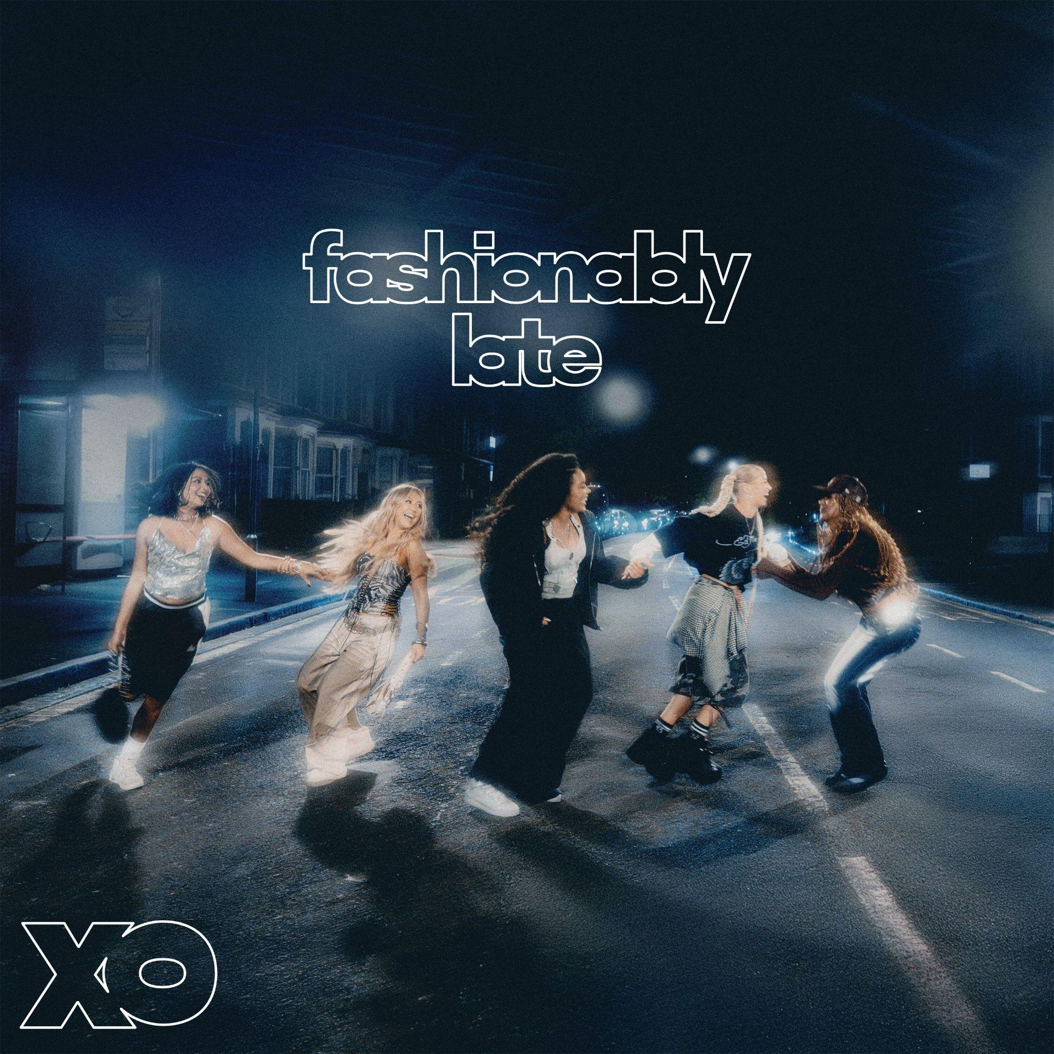

XO announce debut EP, Fashionably Late
Sold-out headline tour also confirmed
New track/video, ‘Real Friends’, available now

“A titanic debut…breaking through pop boundaries, XO are doing it their way” - CLASH
“Bolshy Y2K production…pop girlies, assemble” - Sunday Times Style
“Electrifying…XO’s unapologetic take on girl power, and it lands with impact” - Wonderland
“You’re gonna want to keep an eye on this lot” - Official Charts

Pre-Save Fashionably Late: XO.lnk.to/fashionablylate
Listen/Watch ‘Real Friends’: https://xo.lnk.to/RealFriends
Listen/Watch debut single, ‘Lovesick’: https://XO.lnk.to/lovesick

XO have today announced details of debut EP Fashionably Late, which will drop on November 14th on Polydor Label Group. The hotly-tipped group have also confirmed details of their first ever headline tour, which sold out instantly and takes them around the UK later this month. Fashionably Late features early single ‘Lovesick’, new track ‘Real Friends’ (co-written with Charli xcx) and introduces the five-piece with their sights set on being Britain’s next, best girlband…

Creating Fashionably Late has been, as they say in pop, A Journey. Its six songs are there to show not only the arc of a night out, from getting ready (‘Rush Hour’) and taking charge (‘Candy’) to catching feelings (‘Lovesick’) and going back to your mates (‘Real Friends’) - but also the origin-story of XO, and how they’ve already evolved emotionally and artistically. Every aspect of the pop they're keen to deliver – feisty, unpolished, attitude-heavy, leftfield – is primed, as are their personalities: ‘Silly Boy’, for instance, came to Zoe and Shali in an Uber and was written in response to catcalling women, whilst DIY fan favourite ‘Ponytail’ (the first song XO made upon forming in late 2024) is an ironically-titled order to let your hair down. It’s a feeling of togetherness that is summoned in the accompanying Fashionably Late aesthetic, a wink and nod to ‘Wannabe’ that follows XO as they take to the streets and invite their audience along for the ride.

The self-confessed “most chaotic girlband you’ve ever met in your life”, XO are force-of-nature five-piece Emmy, Reanna, Shali, Summer and Zoe. In sound and spirit they evoke that classic lineage of world-class British groups, but with a contemporary and completely inclusive twist: think the unstoppable UK energy of Spice Girls as raised on the global pop-girls (Tate McRae), plus that new wave of all-choreo and all-conquering acts like Katseye. Yet XO strive for something more imperfect and unapologetic in their firebrand of Pop. Moments on Fashionably Late are as applicable to a romantic situation as they are themes of friendship, sisterhood, and the band’s thoroughly Gen Z vision of Girl Power: “XO is an energy for us, like an aura.”

Hailing from Essex, London, Liverpool, Derbyshire and Hong Kong, XO are quickly amassing an ardent audience for their bangers and their message. With early support across Radio 1, BBC Introducing, Saturday Mashup! and their first headline tour selling out immediately, the band’s ambitions for Fashionably Late are as unique to each girl as they are utterly unified. “To set the tone,” says Summer, keen to stay in the moment. Zoe, however, simply states: “World Domination.” You really wouldn’t put it past XO - Fashionably Late, but also right on time.

XO On Tour
October 26th - O2 Academy 3, Birmingham
October 27th - Poetry Club, Glasgow
October 29th - The Lower Third, London
October 30th - Headrow House, Leeds

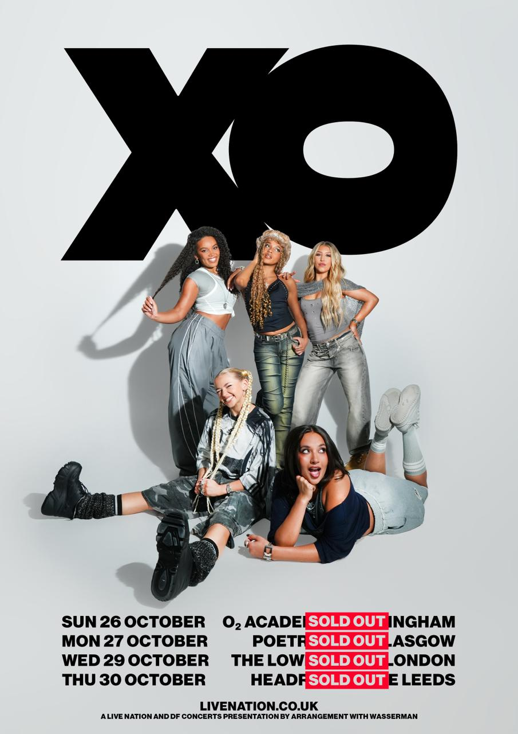

FOLLOW XO!
Instagram || Tiktok || Official Site || Youtube

For more on info contact warren@chuffmedia.com

