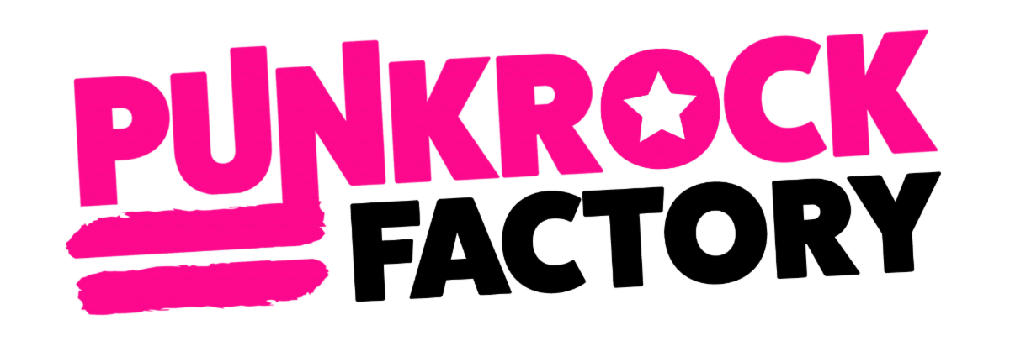

RELEASE ‘POOR UNFORTUNATE SOULS’ EP OUT NOW
FEATURING REIMAGINED SONGS FROM THE LITTLE MERMAID

NEW ALBUM ‘IT’S JUST A STAGE WE’RE GOING THROUGH’ OUT NOW FEATURING SINGLE “MAMMA MIA”

DOWNLOAD FESTIVAL IN JUNE
UK HEADLINE TOUR FROM OCTOBER
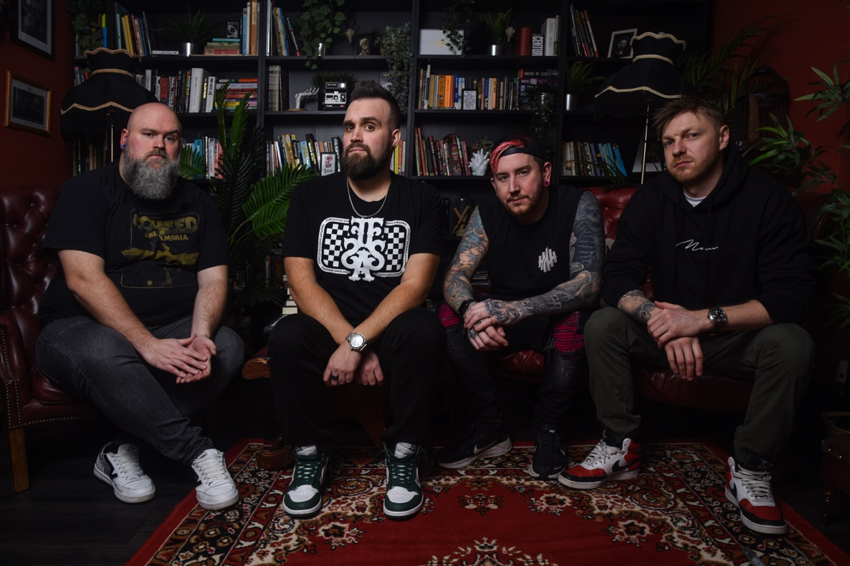

PUNK ROCK FACTORY HAVE RACKED UP 26 MILLION SPOTIFY STREAMS
5.1 MILLION LIKES ON TIKTOK
11 MILLION YOUTUBE VIEWS

PUNK ROCK FACTORY are the kings of turning any song into a pop punk masterpiece. The boisterous four piece from South Wales take all your favourite tracks and make them sound like you never quite imagined they could! No-one is immune - these four lads have adapted everything from Disney classics and assorted rock & pop hits to TV themes from across the decades.
Having played their first ever live show at the UK's Bloodstock Festival in 2021 they followed up with a sold-out UK tour and slots at Download and Slam Dunk in 2022. The band steamrolled into 2023, selling out every show again on their second UK tour, including their largest headline show to date at Nottingham's famous Rock City. With Download inviting them back for the second year running this month and their new dates in October/November 2023 already being upgraded and close to selling out, don't miss your opportunity to catch them on stage if you can!

The Welsh pop-punk upstarts have recently released their latest EP, Poor Unfortunate Souls, along with their album It's Just A Stage We're Going Through, both out now.

With a live action version of The Little Mermaid set to hit cinemas on May 26th, PUNK ROCK FACTORY decided to focus their attention under the sea. The EP's lead single, "Part Of Your World," features dazzling guest vocals from ALISSA WHITE-GLUZ, the powerhouse best known as the lead vocalist of the Swedish melodic death metal band ARCH ENEMY.
PUNK ROCK FACTORY add, "When we heard there was a new Little Mermaid film coming out, we knew we had to take a look at some of its hits, and put them together in a dedicated EP. After the success of our previous albums A Whole New Wurst 1 & 2 which were entirely Disney tracks, it had to be done!”
Their new album, It's Just A Stage We're Going Through, is self-released and features their single ‘Mamma Mia’. Their reimagined version of 'Mamma Mia' - streaming here - is just one of 10 high octane tunes from the new album. They also paid faithful homage to ABBA’s original video for the track – recreating it frame by frame, right down to the white boots and hair styles. Available to watch here.

The headline UK dates to catch PUNK ROCK FACTORY are:

Thu 19th Oct - BRISTOL SWX
Fri 20th Oct - GLASGOW O2 Academy
Sat 21st Oct - NEWCASTLE University
Sun 22nd Oct - SHEFFIELD O2 Academy 2
Tue 24th Oct - NORWICH Epic Studios
Wed 25th Oct - BRIGHTON Concorde 2
Fri 27th Oct - OXFORD O2 Academy
Sat 28th Oct - LEEDS Uni Stylus
Sun 29th Oct - LONDON O2 Academy Islington
Wed 1st Nov - SOUTHAMPTON 1865
Fri 3rd Nov - MANCHESTER O2 Ritz
Sat 4th Nov - BIRMINGHAM O2 Institute

To buy tickets and for a full list of all performances, including festivals already confirmed for 2023, please visit here.

For more information please contact
Warren@chuffmedia.com on 07762 130 510

