

DÉYYESS SHARES DELUXE VERSION OF
WOULD YOU GO DOWN ON A GIRL EP - OUT NOW

HEADLINE UK/EU TOUR BEGINS IN MARCH, INCLUDING
CAMDEN ASSEMBLY HEADLINE ON THE 25TH MARCH

TICKETS AVAILABLE HERE

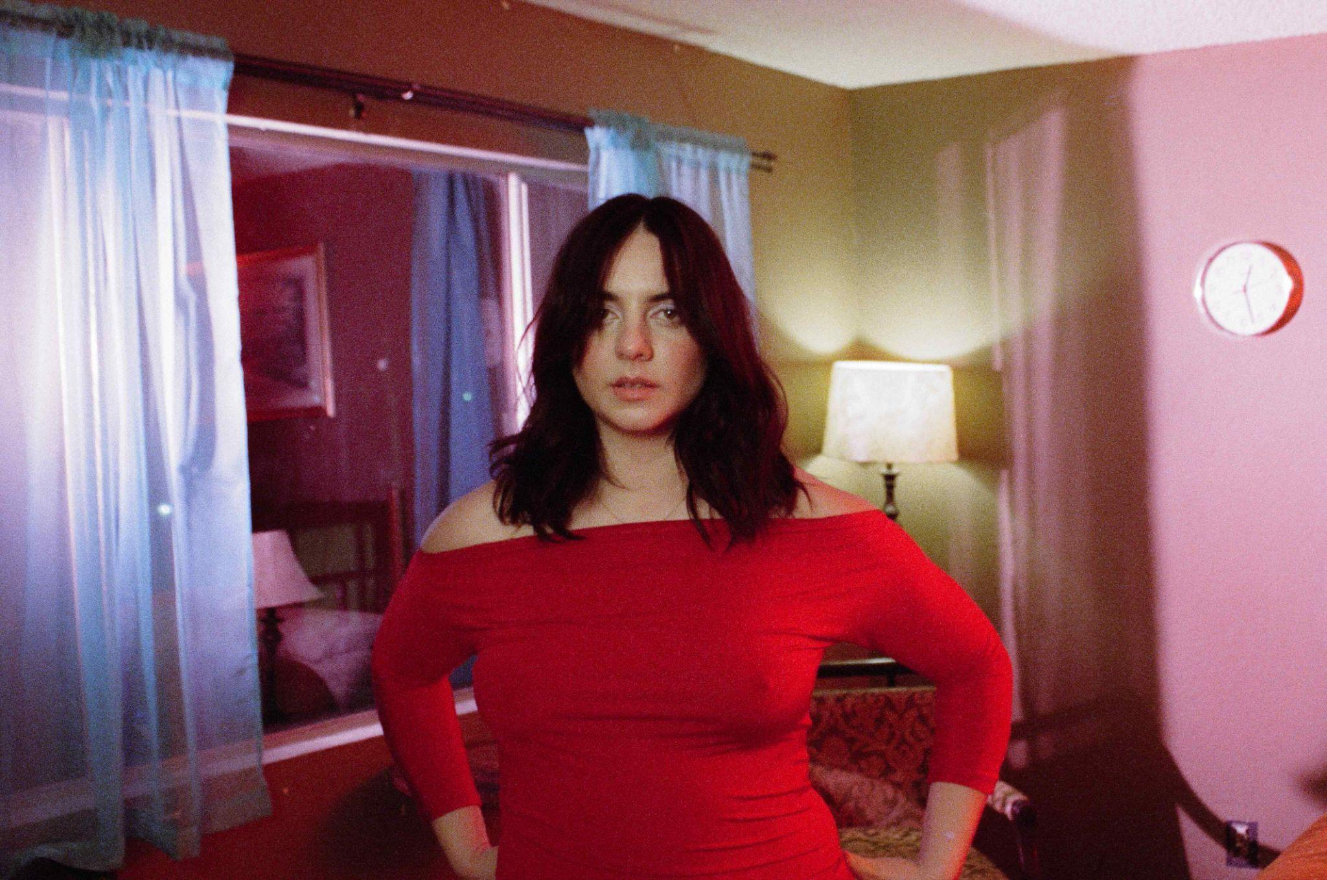
Credit: Samantha Monendo | Download press shot here

“An indie pop icon in the making” - The Line of Best Fit
“Every bit the alternative pop goddess” - DIY
“A hit away from massive growth” - Wonderland
“Glittering, gut-punch pop” - DORK

Alt-pop talent Déyyess today releases the deluxe version of her acclaimed EP Would You Go Down On A Girl via Polydor Records imprint ‘boys boys boys’. The new release sees her add two new tracks in the form of the soaring ‘Silverlake Baby’ and ‘Me, Oh My’ which she’s been road-testing on tour.

Déyyess says, “These songs and the time in my life that they came from was all about love - longing and yearning for a girl who had just come into my life, and suddenly she’s all I think about. I've been navigating the highs and lows of being in love with her; how to tell her, the fear of the unknown, was she even into girls? Does she like me like that? Is the tension in my head real, or am I being delusional? Would You Go Down On A Girl is essentially a lyrical love letter.”

Since bursting onto the scene with viral queer-love confessional ‘Claire’, Déyyess has established herself as a voice for WLW longing, identity, and joy, all delivered with sparkling production and earworm melodies. Following a huge UK and EU support tour at the end of last year with Alessi Rose which included two sold-out nights at Kentish Town Forum, Déyyess will also head out on her first ever headline UK and EU tour in March. Kicking off in Sheffield on the 20th, it takes in a date at Camden Assembly on the 25th March - full routing below, tickets available here.

Would You Go Down On A Girl perfectly captures the pain, longing and daydreaming of unrequited love, particularly between two women. Its themes span from a harmless crush, to becoming consumed by that person because all you can think about is them; it’s hopelessly romantic and yet simultaneously devastating. Inspired by the likes of The Cocteau Twins, The Sundays and The Cranberries as well as modern queer icons like Chappell Roan, Déyyess seamlessly blends nostalgia with a more contemporary sound.

Growing up in sleepy Canterbury, Déyyess has been aware of her queer sexuality from an early age, finding the confidence to come out thanks to Lady Gaga, whose fierce allyship empowered her to do so. Now, she hopes to offer that same visibility and empowerment to the next generation. “That’s my main goal – rebuilding what I needed when I was younger. I have fans in countries where it’s illegal to be gay; I want to create a community for them.” In 2025, queer representation in pop has never been stronger; artists like Doechii, Renée Rapp, Kehlani, Girl in Red, and 070 Shake are leading what some are calling a sapphic renaissance…and with the release of the deluxe version of her bold EP Would You Go Down On A Girl?, Déyyess proudly joins their ranks.

Would You Go Down On A Girl? Deluxe Tracklist
1) Lights Off
2) Lips Like Sugar
3) Interlude
4) She Knows
5) Would You Go Down On A Girl?
6) Me, Oh My
7) Silverlake Baby

UK & EU Headline Tour
20th March - Yellow Arch, Sheffield
21st March - SWG3 Poetry Club, Glasgow
22nd March - Deaf Institute The Lodge, Manchester
24th March - Exchange, Bristol
25th March - Camden Assembly, London

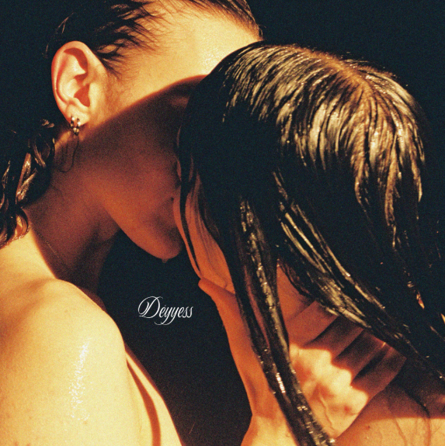
‘Would You Go Down On A Girl’ Artwork [Download Here]

For further information about Déyyess:
INSTAGRAM | YOUTUBE | TIKTOK | WEBSITE

For more information and press enquiries please contact

Warren & Harry
@chuffmedia.com

