Daisy the Great Announce UK and Europe Tour
Share “Tough Kid” From Forthcoming EP
Watch Accompanying Music Video HERE
EP Coming October 6
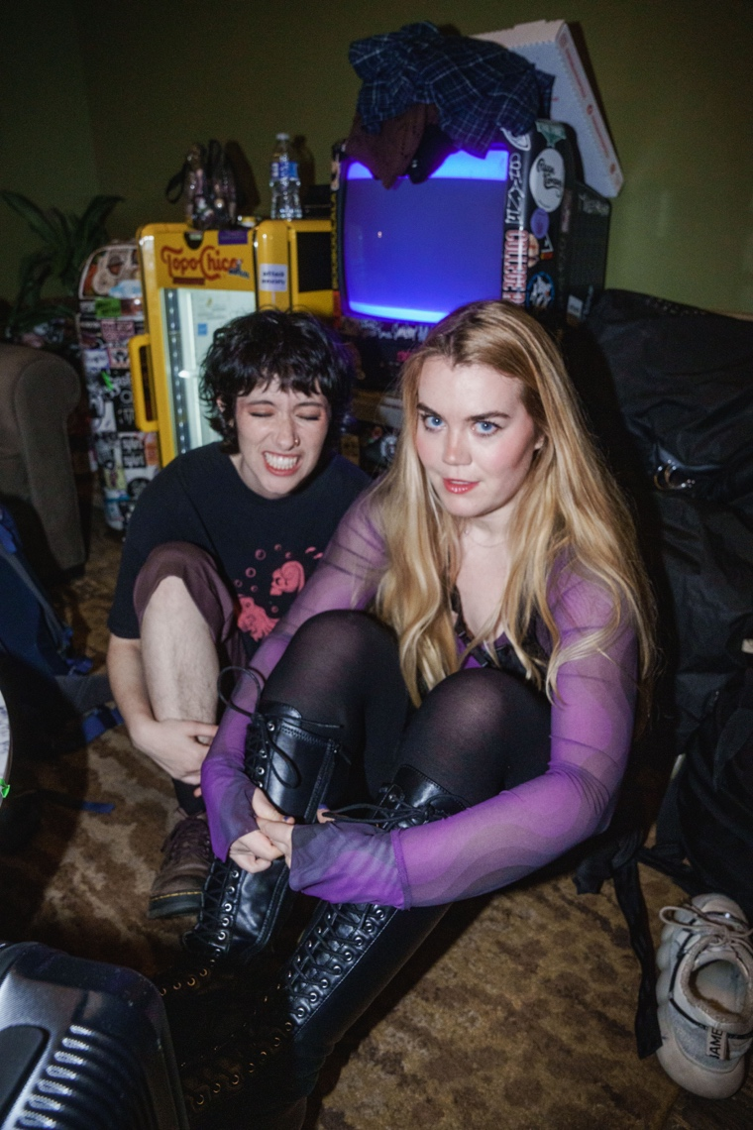

More images and info here

Indie pop band Daisy the Great’s sophomore album, ALL YOU NEED IS TIME, has surpassed 260 million global streams, and their five-week US tour was a smashing success, nearly selling out entirely. To continue the touring success and build up to the new EP, the band will embark on a European Tour which stops in the UK for a show in London and Manchester.

The band have also shared “Tough Kid,” the second song from their upcoming EP, which will be released October 6th. Stream the song here.

DAISY THE GREAT UK TOUR DATES

SEPTEMBER
12 – London, UK – Moth Club
13 – Manchester, UK – Yes

“There’s something breezy and refreshingly uncomplicated about the indie-pop sounds of Daisy the Great—even when the subject matter of their music delves into the complex.”
- FLOOD Magazine

# # #

Band Bio
As Daisy the Great, Kelley Nicole Dugan and Mina Walker make folk-inflected indie rock that spans a multitude of moods, capable of being clever, devastating, or both simultaneously, spanning harmony-laden pop to powerhouse balladry. The pair first met as acting majors at NYU’s Tisch School of the Arts where they began co-writing a musical about a fictional band before realizing they could make it happen in real life and set out as Daisy the Great.

2017 saw Daisy the Great make an auspicious debut with “The Record Player Song,” which quickly proved an immediate smash now boasting over 20M worldwide streams and multiple viral moments on TikTok. A full-length debut LP, I’m Not Getting Any Taller, arrived in 2019, followed in 2020 by the quarantine-born Soft Songs EP. In 2021, Daisy the Great teamed with acclaimed indie-pop trio AJR for “Record Player,” a brand new song inspired by their original 2017 hit, available at all DSPs and streaming services HERE. An official animated video now boasting close to 3M views is streaming via YouTube HERE.

Having now grown into a full six-piece band currently featuring Matt Lau on guitar, Bernardo Ochoa on bass, Matti Dunietz on drums, and Brie Archer on additional vocals, Daisy the Great first heralded ALL YOU NEED IS TIME with the dazzling “Glitter,” available for streaming and download HERE. Hailed by Atwood Magazine as “a dreamy, inspiring alternative anthem to let our light shine,” the track is joined by an official music video – directed and edited by Dugan and Walker – streaming now via YouTube HERE. An entrancing “Press Play” performance is viewable on the official Recording Academy/GRAMMYs YouTube channel HERE. The band also visited 90.9 The Bridge in KC for a session that NPR included in their 2022 “Sessions of The Year” list and appeared on The Late Show With Stephen Colbert’s “Late Show Me Music” series, available on the show’s Instagram, YouTube, and Facebook channels. 2023 saw the band releasing a new version of “Tell Me Have You Been Dancing” featuring vocals from indie pop artist Claud as well as a new acoustic lofi version of their album track “Glitter” called “Glitter 2”.

“Our music is generally pretty introspective, and we are often interested in the complexities or ironies we see within ourselves,” Dugan says. “That’s something we love about writing—you can say something small and delicate and true that maybe feels scary to say, but once you put it out there, it can turn into a comfort for anyone that might also be feeling that way.”

# # #

CONNECT WITH DAISY THE GREAT
OFFICIAL | FACEBOOK | INSTAGRAM | TIKTOK | TWITTER | YOUTUBE

For more on info contact warren@chuffmedia.com

