COVER ICONIC CHER TRACK, IF I COULD TURN BACK TIME EXCLUSIVELY FOR AMAZON MUSIC
LISTEN HERE
SET TO PLAY 2000 TREES IN JULY
UK HEADLINE TOUR KICKS OFF IN MARCH
BUY TICKETS HERE

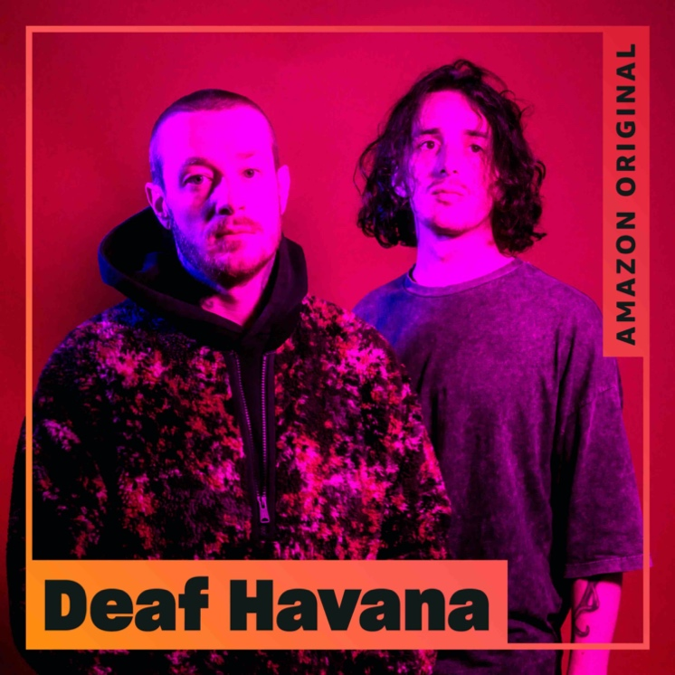
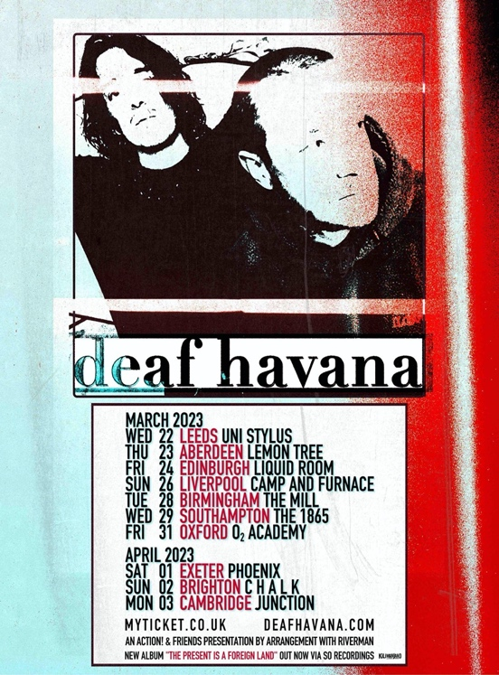

Press assets here

Deaf Havana have kicked off 2023 with a heartfelt Cher cover, exclusively for Amazon Music. Having been asked by Amazon personally to choose a song the duo would like to cover for their Amazon Original feature, they have put their own spin on the iconic, If I Could Turn Back Time. Teaming up with long-time producer Mike Horner, the cover features strings from the Parallax Orchestra who have performed live with the likes of Bring Me The Horizon and Eminem. Brothers James and Matty also worked on the programming of the track with Joe and Al of Hot Chip, in their studio. Listen here.

Deaf Havana have just been added to the already solid 2000 Trees festival line up, joining the likes of Frank Carter And The Rattlesnakes, Hundred Reasons, Bob Vylan and more. The band will play on Saturday 8th July, and tickets are on sale now here. Just ahead of 2000 Trees, the two-piece will return to Germany and play Hurricane Festival on 16th June, and Southside Festival on 17th June. Showing no signs of slowing down, Deaf Havana are currently gearing up for their UK headline tour in March. Kicking off in Leeds at Uni Stylus on 22nd March, the guys then hit Aberdeen, Edinburgh, Liverpool, Birmingham, Southampton, Oxford, Exeter and Brighton before wrapping up in Cambridge at the Junction, on 3rd April. Tickets are available to buy here.

Since the release of Deaf Havana’s hotly tipped album, The Present Is A Foreign Land which has racked up a whopping 10 million+ combined streams, the band have played a slew of live shows, including a string of instore shows, a UK headline tour and headline slots at Slam Dunk and Burn It Down Festival. They have also performed on Channel 4’s Sunday Brunch, and presented awards at the Kerrang! and Heavy Music Awards. Deaf Havana have also been continually writing and honing their craft, so watch this space for new music soon…

Deaf Havana have risen through the ranks during their time as a band, earning themselves coveted accolades including three Top 10 albums in the Official Charts with Rituals, All These Countless Nights, and Old Souls. 2018 saw them play their biggest headline show to date at Brixton Academy, alongside appearances at festivals such as Reading & Leeds, Mad Cool and Pukkelpop.

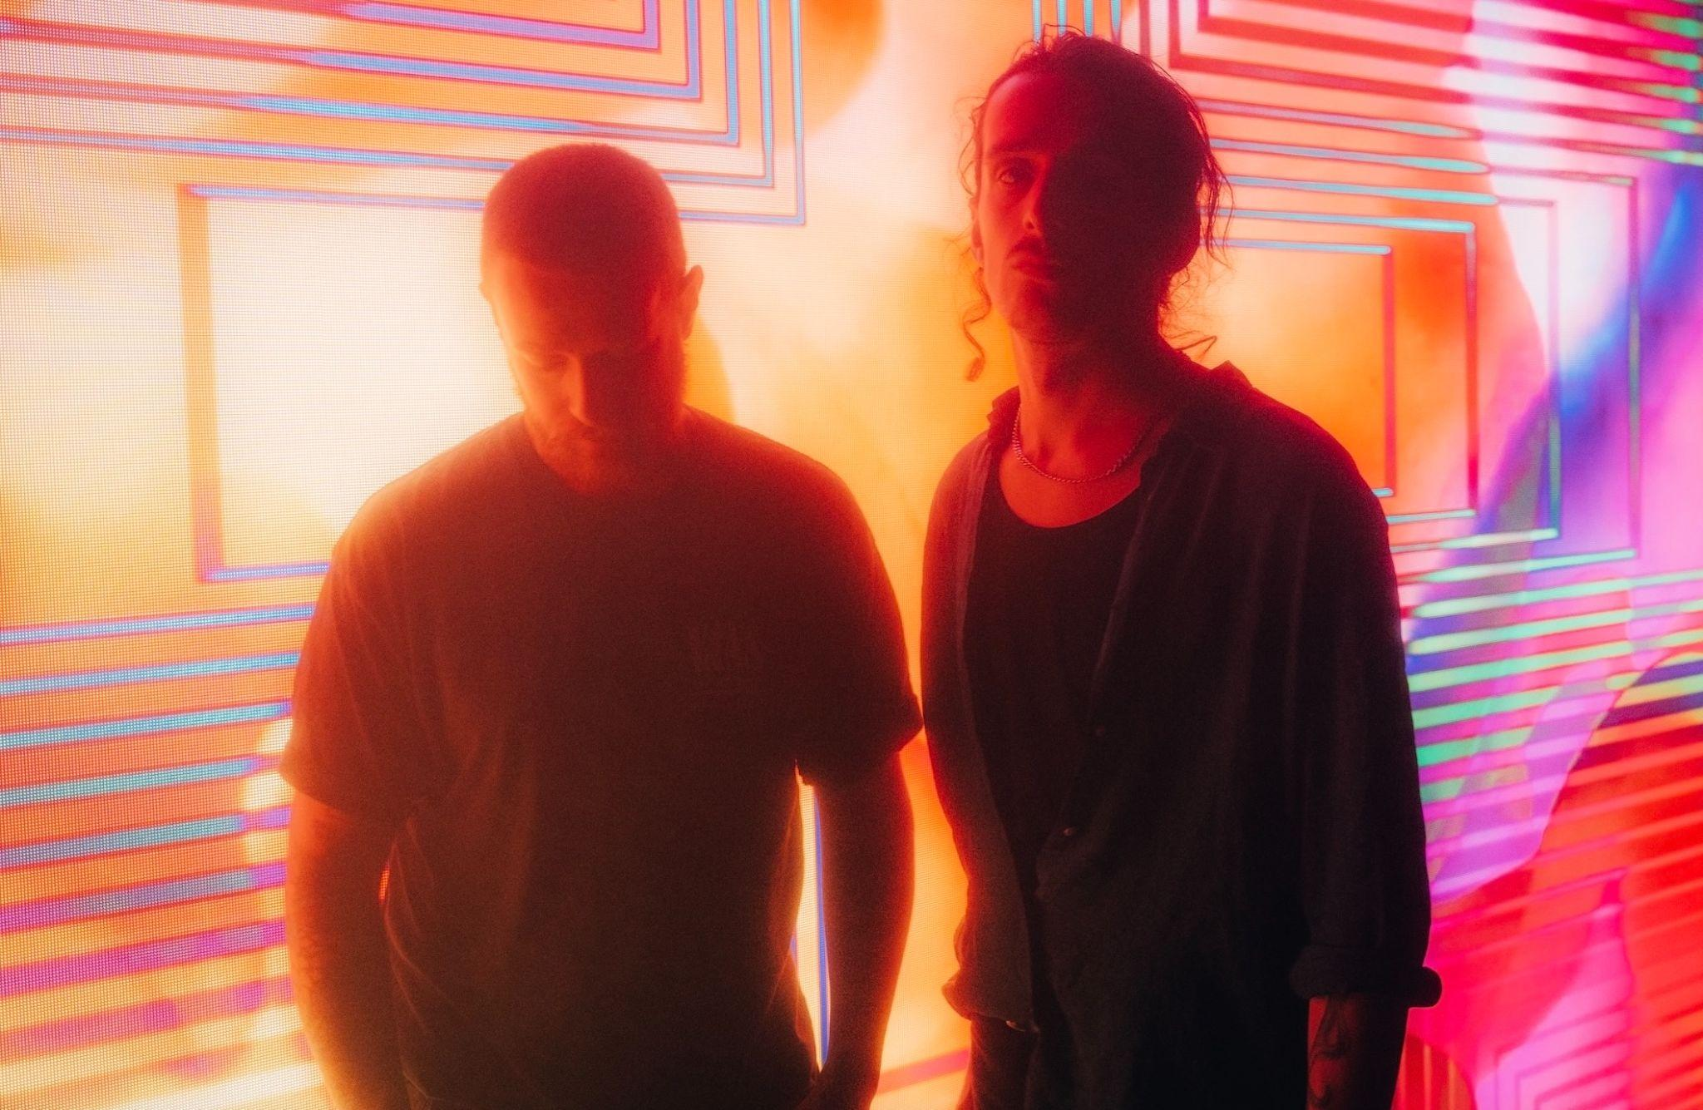
Credit: Jon Stone

Follow Deaf Havana:
Instagram
Twitter
Facebook
Spotify

For more information and press enquiries please contact

Jenny Entwistle
Jenny@chuffmedia.com

