
DECEMBER 10
DROP “ANGEL” AFTER THEIR RUN OF SOLD-OUT LIVE DATES ACROSS THE UK & IRELAND
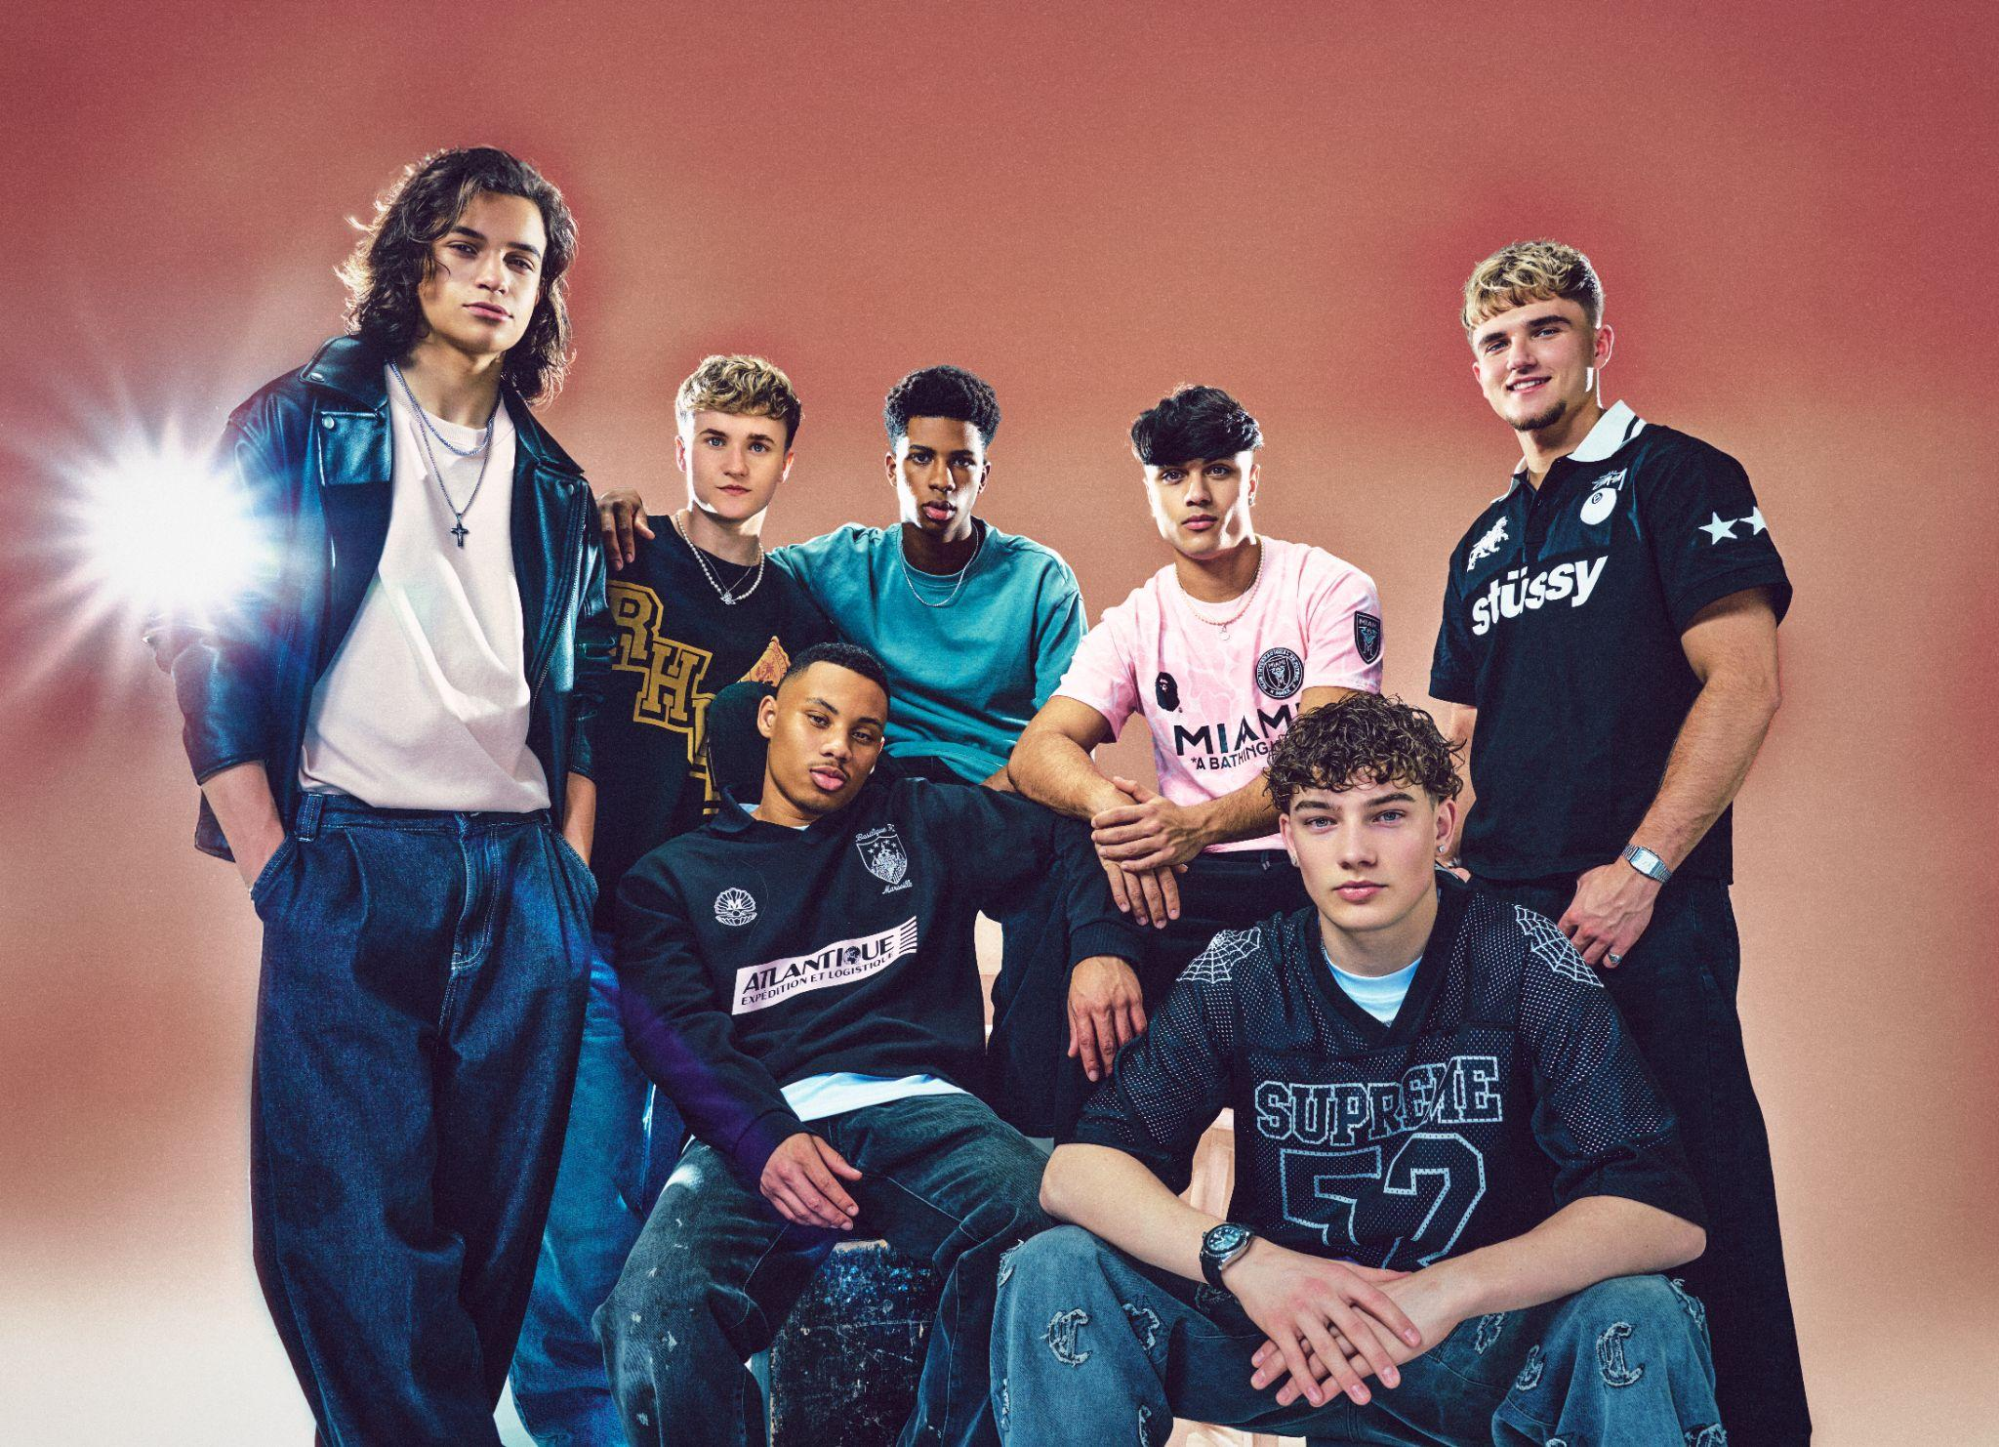Photo credit: Gracey&Co
DOWNLOAD IMAGERY HERE: Hi-Res Press Shots Artwork BTS Stills
LISTEN TO/ SHARE DECEMBER 10’S “ANGEL” HERE
WATCH DECEMBER 10’S STRIPPED- BACK PERFORMANCE VIDEO OF “ANGEL” FROM 4PM TODAY HERE

London, UK, 6 March 2026 – Britain’s brand-new boyband December 10 have released their highly anticipated debut single, “Angel”, today.
The release arrives hot on the heels of December 10 announcing an upcoming headline show at O2 Shepherd’s Bush on Wednesday 8 April, (full details here), and performing 13 sold-out live shows across the UK and Ireland. Their recent Introducing! run of live dates kicked off in Glasgow on 16 February and wrapped in Dublin on 22 February, drawing more than 7,500 fans. Extra shows were added twice in response to demand, with all dates selling out within minutes.
Less than 3 months on from their reveal on Netflix’s global series Simon Cowell: The Next Act, and newly signed to EMI Records, December 10 are moving at a relentless pace. They’ve already racked up millions of followers across socials and over half a million monthly Spotify listeners, with their debut single “Run My Way”, while the official music video for “Run My Way” and their stripped-back take on NSYNC’s “Bye, Bye, Bye” have tipped past 2.4 million and 1.9 million organic YouTube views respectively.

Written and produced by hitmakers Julian Bunetta (Sabrina Carpenter, Teddy Swims) and Savan Kotecha (Ariana Grande, The Weeknd), December 10’s “Angel” follows their rambunctious debut single “Run My Way” which has generated millions of streams to date, (including over 2 million on Spotify alone) and reached No.1 on the Official Physical and Vinyl Singles Charts.
A beautiful, lovestruck ballad, “Angel” is warm, intimate and melody-led, it leans into the dizzy rush of falling hard.
"We are so excited for our second single to be out in the world. Felt mind-blowing on tour to see everyone singing it back to us from when we teased it online!! Totally surreal.” - December 10
The accompanying stripped-back performance video for December 10’s “Angel” sees the band lay the track bare, trading spectacle for stark intimacy. Directed by Laurence Warder (Bring Me The Horizon, J Hus, Kasabian, Zara Larsson) and produced by Vicky Kanji-Smith for Bad Bones Films, the intimate session captures John on keys, alongside Seán and Hendrik on guitar and Josh on cajón, as the band reshape the song into a tender, slow-burning confessional. With its hushed dynamics and close-knit arrangement, the performance strips “Angel” back to its emotional core, allowing every lyric and lingering note to hit with quiet intensity.
Formed on camera during Netflix’s docuseries Simon Cowell: The Next Act, (released worldwide on 10th December 2025), December 10 have quickly built a devoted fanbase around their live shows and online following. The hugely fun, charismatic and high-energy septet consists of Cruz (19), Danny (17), Hendrik (19), John (17), Josh (17), Nicolas (17) and Seán (19).

They’re not just brilliant singers, but accomplished musicians too, playing 14 instruments between them: Cruz leads on percussion; Nicolas and Danny play guitar; Josh plays guitar and drums; Hendrik plays guitar, bass and piano; Seán plays guitar, piano and harmonica; while John was due to take Grade 8 Clarinet and Piano this year — until life got a bit busy.
December 10 is very much a boyband for our times: a truly inclusive group representing Chorley, Rochester, Dublin, London, Lisbon and Walsall, with Irish, Brazilian, Indian, Nigerian and Jamaican heritage between them. Their musical influences are just as expansive - from Fela Kuti, Daft Punk, Brent Faiyaz and Steve Lacy to Pearl Jam, Freddie Mercury, The Notorious B.I.G., Catfish and the Bottlemen, Sabrina Carpenter, Usher alongside Brazilian icons like Legião Urbana and Cazuza.
Fun, high-energy and utterly endearing, December 10 are rapidly carving out their place among Britain’s most talked-about new pop bands.
DECEMBER 10’S “ANGEL”, RELEASED VIA EMI RECORDS, IS AVAILABLE ACROSS ALL PLATFORMS NOW: https://december10.lnk.to/AngelListenNow

FOLLOW DECEMBER 10:
INSTAGRAM | TIKTOK | WEBSITE

For more information and press enquiries please contact

Warren Higgins
warren@chuffmedia.com

