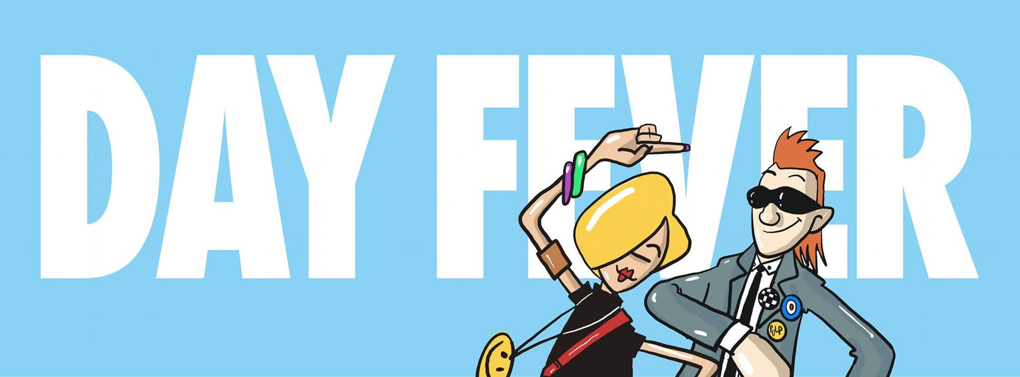

The day-time clubbing event from Vicky McClure, Jonny Owen
and Reverend & The Makers

Because life’s too short to save the dancing for after dark.

Media assets available here.

Forget feeling like your clubbing days are behind you. DAY FEVER is a revolution, a joyous celebration where people from all walks of life come together to dance, laugh, and relive the magic of those late nights out. There’s no dress code, no egos—just pure positivity.

Early in 2024, a bold idea was born between friends actress Vicky McClure, filmmaker and broadcaster Jonny Owen, and Jon McClure, frontman of Reverend & The Makers: a daytime clubbing experience that’s all about fun, freedom, and fabulous tunes. What started as a one-off event in Sheffield’s iconic City Hall Ballroom has exploded into a nationwide phenomenon with over 85,000 happy dancers to date!

Fast forward to today and from 3pm to 8pm, thousands of partygoers from every walk of life are hitting the dancefloor at iconic venues across the UK to dance the day away at the "disco that doesn’t ruin your Sunday," with tickets selling out in hours across cities like Nottingham, Sheffield, and Glasgow.

For many, Day Fever has redefined what it means to let loose. The event provides a safe, inclusive, and ego-free space where attendees can simply have a brilliant time. Ditching the late nights and dress codes – DAY FEVER is all about positivity and good vibes. Whether you're wearing glittery heels or comfy trainers, everyone’s welcome to join the party.

“Travelling up and down the country and seeing so many people enjoying themselves has been such a joy,” says co-founder Vicky McClure. “We’re thrilled that people feel comfortable at DAY FEVER. Hearing their stories has shown us how important it is to just take a break from life and have a bloody good dance!”.

UPCOMING CLUB DATES:

3-May-25 Leeds Project House
3-May-25 London Here @ OUTERNET
10-May-25 Exeter Lemon Grove
10-May-25 Manchester New Century Hall
10-May-25 Sheffield City Hall
17-May-25 Coventry Kasbah
17-May-25 Glasgow BAAD
24-May-25 Birmingham O2 Institute
24-May-25 Newcastle Boiler Shop
24-May-25 Norwich LCR UEA
24-May-25 Nottingham Rock City
31-May-25 Cardiff Tramshed
31-May-25 Edinburgh O2 Academy
7-Jun-25 London OUTERNET
7-Jun-25 Sheffield Sheffield City Hall
14-Jun-25 Glasgow BAAD
14-Jun-25 Leeds Project House
14-Jun-25 Leicester Athena
14-Jun-25 Liverpool Camp & Furnace
21-Jun-25 Bristol O2 Academy
21-Jun-25 Manchester New Century Hall
21-Jun-25 Middlesbrough Middlesbrough Town Hall
21-Jun-25 Norwich LCR UEA
28-Jun-25 Edinburgh O2 Academy
28-Jun-25 Newcastle Boiler Shop
28-Jun-25 Hull Asylum
28-Jun-25 Nottingham Rock City

Tickets are available at day-fever.com – but don’t wait too long, they’re selling fast!

Follow DAY FEVER on Facebook, Instagram, and X (@DAYFEVERUK)

For more information contact Warren@chuffmedia.com / 07762 130510

