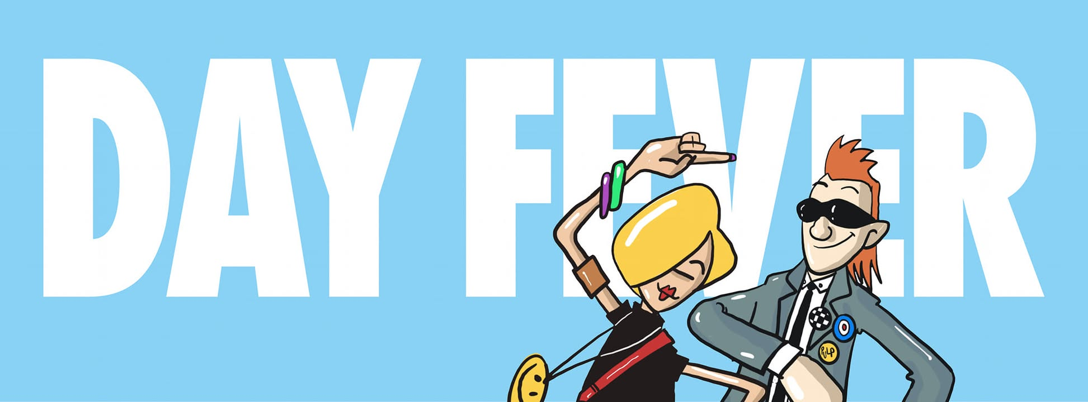

The day-time clubbing event from Vicky McClure, Jonny Owen
and Reverend & The Makers

Because life’s too short to save the dancing for after dark.

Forget feeling like your clubbing days are behind you. DAY FEVER is a revolution, a joyous celebration where people from all walks of life come together to dance, laugh, and relive the magic of those late nights out. There’s no dress code, no egos—just pure positivity.

Early in 2024, a bold idea was born between friends actress Vicky McClure, filmmaker and broadcaster Jonny Owen, and Jon McClure, frontman of Reverend & The Makers: a daytime clubbing experience that’s all about fun, freedom, and fabulous tunes. What started as a one-off event in Sheffield’s iconic City Hall Ballroom has exploded into a nationwide phenomenon with over 85,000 happy dancers to date!

Fast forward to today and from 3pm to 8pm, thousands of partygoers from every walk of life are hitting the dancefloor at iconic venues across the UK to dance the day away at the "disco that doesn’t ruin your Sunday," with tickets selling out in hours across cities like Nottingham, Sheffield, and Glasgow.

For many, Day Fever has redefined what it means to let loose. The event provides a safe, inclusive, and ego-free space where attendees can simply have a brilliant time. Ditching the late nights and dress codes – DAY FEVER is all about positivity and good vibes. Whether you're wearing glittery heels or comfy trainers, everyone’s welcome to join the party.

“Travelling up and down the country and seeing so many people enjoying themselves has been such a joy,” says co-founder Vicky McClure. “We’re thrilled that people feel comfortable at DAY FEVER. Hearing their stories has shown us how important it is to just take a break from life and have a bloody good dance!”.

UPCOMING CLUB DATES:

2024 NEW YEARS EVE (Daytime) PARTY!
31-Dec Edinburgh O2 Academy
31-Dec Manchester New Century Hall
31-Dec Nottingham Rock City

2025
18-Jan Newcastle Boiler Shop
25-Jan Manchester New Century Hall
25-Jan Glasgow BAad
1-Feb Birmingham O2 Institute
1-Feb London Outernet
1-Feb Cardiff Tramshed
1-Feb Sheffield City Hall
1-Feb Nottingham Rock City
8-Feb Bristol O2 Academy
8-Feb Hull Asylum
8-Feb Liverpool Camp & Furnace
8-Feb Southampton Guild Hall
15-Feb Oxford O2 Academy
15-Feb Norwich LCR UEA
15-Feb Exeter Lemon Grove
15-Feb Newcastle Boiler Shop
22-Feb Glasgow BAad

Tickets are available at day-fever.com – but don’t wait too long, they’re selling fast!

Follow DAY FEVER on Facebook, Instagram, and X (@DAYFEVERUK)

