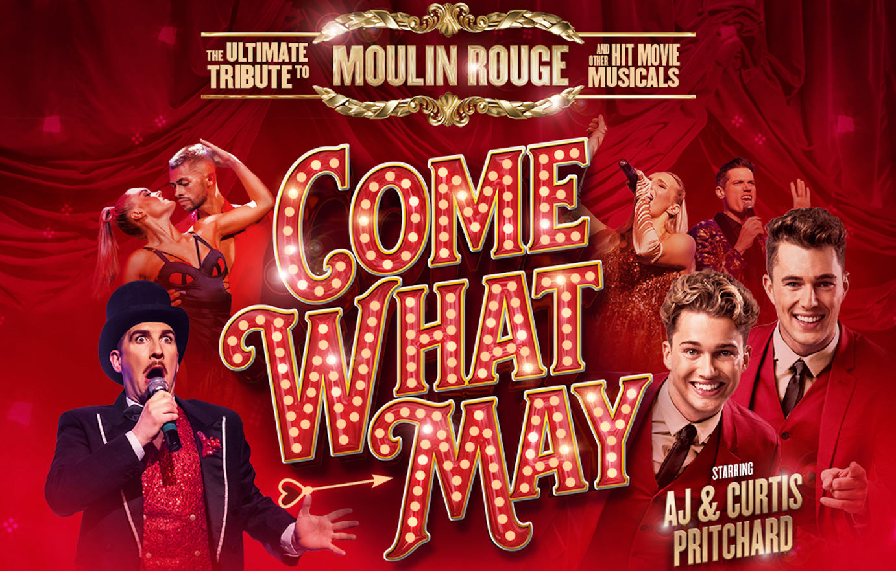

TOURING THE UK
20TH SEPTEMBER – 24TH OCTOBER 2024
Tickets on sale now
Media assets here

Leading producers Sisco Entertainment, and promoters Cuffe & Taylor and Live Nation are bringing the sultry, mysterious atmosphere of Paris to theatres across the UK with Come What May, an incredible show featuring all your favourite hits from the iconic movie-musical Moulin Rouge. Starring AJ and Curtis Pritchard (Strictly Come Dancing, Dancing With The Stars, Love Island) and a cast of West End performers, this is one show you don't want to miss.

Experience a night of pure entertainment as audiences are transported to the dazzling world of the Moulin Rouge as this incredible show features the classic songs you expect, including "Come What May," "Your Song," and "Diamonds Are a Girl's Best Friend." But that's not all - timeless hits from other modern movie musicals will really get your feet moving.

Looking forward to joining the production, AJ Pritchard says, “Come What May, is going to get myself and Curtis back onstage performing together and that is exactly what we love doing. This show embodies the big musical numbers we have all come to love with the dance routines are what I love to watch, but I much prefer being on stage which is exactly where I’ll be. Plus this tour really does cover the whole country so there is no excuse not to make it to one date and maybe more!!”

Curtis is equally as excited; "I’ve loved performing and entertaining an audience since my Ballroom and Latin dancing days, so this is the perfect tour for me - Singing & dancing! Having gone through the full show I know that you will be entertained start to finish. Come What May, is going to blow you away I guarantee it.”

Join our children of the revolution and be swept away by the sultry, mysterious atmosphere of Paris. From the sexy and disreputable underbelly of the city to the glamour and glitz of the Moulin Rouge, you'll be transported back in time to a place of dreams, adventure, and most importantly, love.

This high-energy musical extravaganza is a guaranteed hit with all audiences looking for a night of non-stop entertainment. So grab your friends and get ready to sing and dance the night away.

Get your tickets now and join us for a truly Spectacular, Spectacular evening of unforgettable entertainment!

Tickets are available from the theatre box office and CuffeandTaylor.com.

20-Sept-24 Loughborough Town Hall
21-Sept-24 Skegness The Embassy Theatre
22-Sept-24 Blackpool Opera House
23-Sept-24 Cardiff New Theatre
26-Sept-24 Sheffield City Hall
27-Sept-24 Stoke Victoria Hall
28-Sept-24 Leicester De Montfort Hall
29-Sept-24 York Barbican
2-Oct-24 Bath Forum
4-Oct-24 Cambridge Corn Exchange
5-Oct-24 Swindon The Wyvern Theatre
6-Oct-24 Ipswich Regent Theatre
7-Oct-24 Brighton Theatre Royal
9-Oct-24 Portsmouth Guildhall
10-Oct-24 Warwick Arts Centre
11-Oct-24 Reading The Hexagon
12-Oct-24 Salford The Lowry
15-Oct-24 Aberdeen Music Hall
16-Oct-24 Newcastle O2 City Hall
17-Oct-24 Edinburgh Usher Hall
20-Oct-24 Dartford The Orchard Theatre
21-Oct-24 Guildford G Live
23-Oct-24 Southend Cliffs Pavilion
24-Oct-24 Folkstone Leas Cliff Hall

For all media enquiries please contact
Warren@chuffmedia.com on 07762 130510

