CAROLS BY CANDLELIGHT

A classic celebration of Christmas coming to
Birmingham, Liverpool & London this December

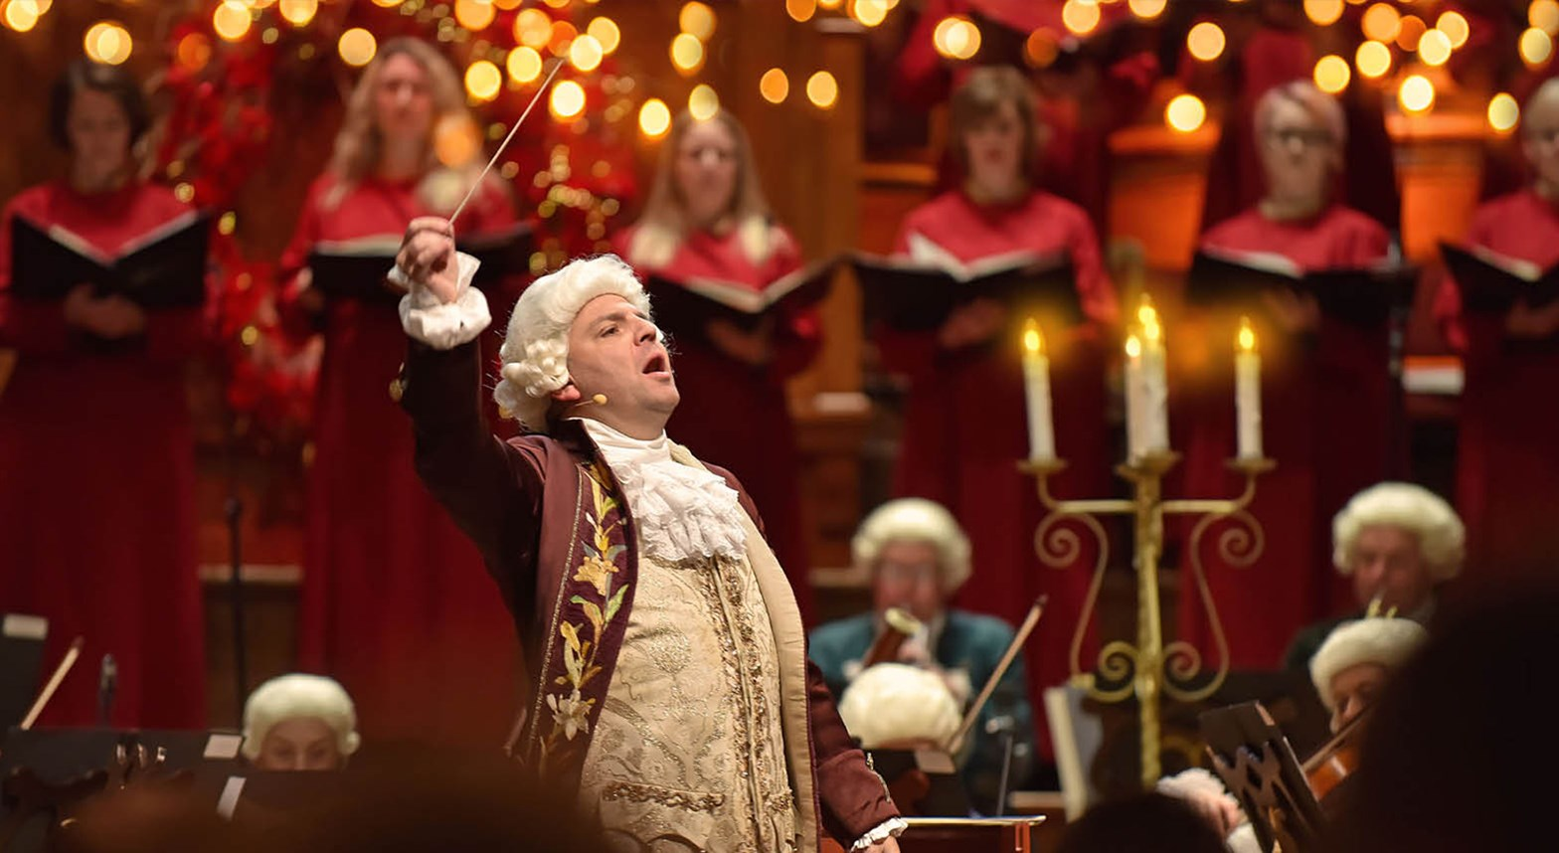

Featuring special guest readers Mark Williams & Peter Davison

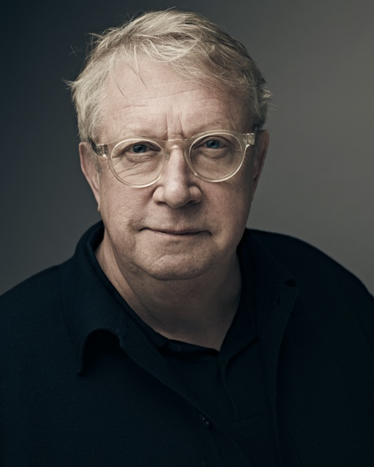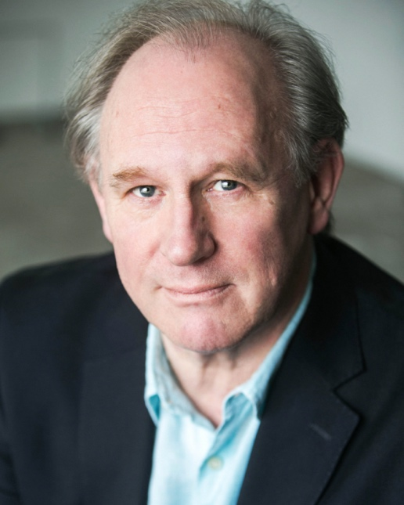

MEDIA ASSETS HERE

Travel back in time this Christmas with a sublime concert of carols and seasonal classics, staged in full 18th-century costume in an evocative candlelit-style setting. The concert includes readings by Mark Williams and features well known classical pieces from Cullen, Willcocks, Pearsall, Handel and Bach performed by the Mozart Festival Orchestra and an acclaimed choir and soloists.

The audience are invited to join in with the Christmas cheer with carols such as Good King Wenceslas, Hark! The Herald Angels Sing, O Little Town of Bethlehem, O Come All Ye Faithful, Once in Royal David’s City and many more being performed throughout the evening.

Featuring at all shows except those at Cadogan Hall, guest reader Mark Williams is best known to millions for his role as Arthur Weasley in one of the biggest film franchises of all time, Harry Potter. Having starred in the iconic Fast Show amongst numerous other appearances on our screens, since 2012 Mark has been delighting mystery fans playing the titular character in BBC One’s Father Brown.

Doctor Who legend, Peter Davison will be transporting us through time once again when taking on his latest role as guest reader at the Carol By Candlelight shows at the Cadogan Hall on the 23rd & 24th December. Peter has been a staple on British TV since All Creatures Great and Small made him a household name with recent roles on shows such as Midsomer Murders, Grantchester and Law & Order.

Tickets can be purchased from www.raymondgubbay.co.uk or via the venue.

Carols by Candlelight is appearing in venues around the country:

Saturday 11 December, 7.30pm – London, ROYAL FESTIVAL HALL
https://www.southbankcentre.co.uk/whats-on/classical-music/carols-candlelight
http://www.raymondgubbay.co.uk/whats-on/carols-by-candlelight-royal-festival-hall

Saturday 18 December, 7.30pm – Birmingham, SYMPHONY HALL
https://bmusic.co.uk/events/carols-by-candlelight
http://www.raymondgubbay.co.uk/whats-on/carols-by-candlelight-birmingham-1

Sunday 19 December, 2.30pm & 7.30pm – London, BARBICAN HALL
https://www.barbican.org.uk/whats-on/2021/event/carols-by-candlelight
http://www.raymondgubbay.co.uk/whats-on/barbican-christmas-festival-2021/carols-by-candlelight-barbican

Monday 20 December, 7:30pm – Liverpool, PHILHARMONIC HALL
https://www.liverpoolphil.com/whats-on/classical-music/carols-by-candlelight/3982
http://www.raymondgubbay.co.uk/whats-on/carols-by-candlelight-liverpool-2021

Thursday 23 December, 3.00pm & 7pm – London, CADOGAN HALL*
https://cadoganhall.com/whats-on/carols-by[1]candlelight-2021
http://www.raymondgubbay.co.uk/whats-on/carols-by-candlelight-cadogan-hall-2

Friday 24 December, 3.00pm – London, CADOGAN HALL*
https://cadoganhall.com/whats-on/carols-by[1]candlelight-2021
http://www.raymondgubbay.co.uk/whats-on/carols-by-candlelight-cadogan-hall-2

Friday 24 December, 2.30pm – Birmingham, SYMPHONY HALL
https://bmusic.co.uk/events/carols-by-candlelight
http://www.raymondgubbay.co.uk/whats-on/carols-by-candlelight-birmingham-1

*Please note, Peter Davison performs the readings at Cadogan Hall.

For all media enquiries please contact
warren@chuffmedia.com or jenny@chuffmedia.com on 07762 130510

