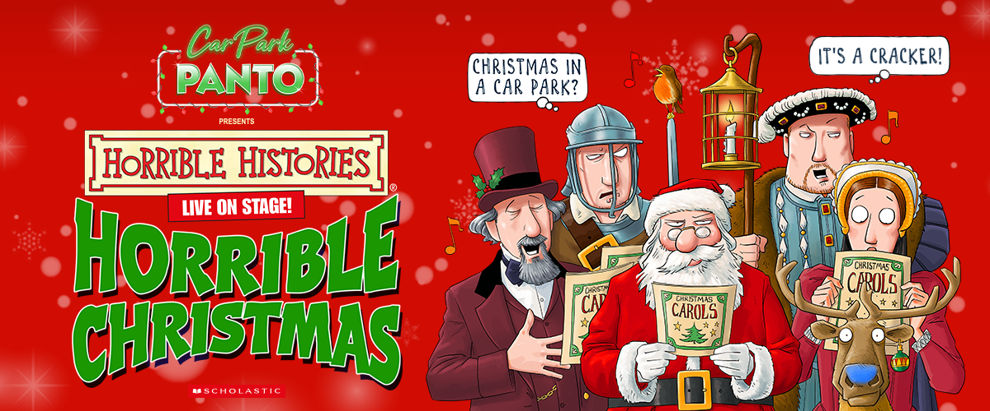

THE WORLD’S FIRST DRIVE-IN PANTOMIME
IS BACK FOR 2021!

Following a SOLD-OUT tour in 2020, rave reviews and overwhelming support for this new-fangled approach to live theatre, CAR PARK PANTO in partnership with Birmingham Stage Company are pleased to announce that Horrible Histories Horrible Christmas is coming back to a car park near you this December and January!

With the closing of theatres across the country in 2020, Birmingham Stage Company and Coalition Presents worked together to save Christmas for over 17,000 families by putting on the worlds first drive-in panto. Horrible Christmas is a unique Covid secure experience, where kids (& adults) are able to jump and down in their own seats, cheer and make as much noise as they like (beep those horns!). Not strictly speaking a typical panto, it will still get everyone into the festive spirit from the comfort and security of their own cars.

Christmas is often the first time a child experiences live theatre and sometimes the cost of taking a family can be prohibitive over the festive period, what with all the other expenses; CAR PARK PANTO is amazing value for money, with the price of ticket covering the car, not the number of family members you cram inside!

Neal Foster, Actor/Manager, Birmingham Stage Company says:
“We were amazed and thrilled how totally successful the Car Park Party productions proved to be during the last eighteen months – and we’re delighted to be back on tour again with our Horrible Histories production of Horrible Christmas! It turns live theatre into a truly unique and festive event!”

ABOUT HORRIBLE CHRISTMAS

When Christmas comes under threat from a jolly man dressed in red, it’s up to one young boy to save the day – but can he save Christmas? From Victorian villains to Medieval monks, Puritan parties to Tudor treats, join us on a hair-raising adventure through the history of Christmas in the company of Charles Dickens, Oliver Cromwell, King Henry VIII and St Nicholas as they all join forces to save the festive season!

It's a celebration of Christmas in the most wonderful, funny and moving way you'll ever see!

There are limited tickets for each show priced at £49.50 per sleigh car (£2.50 booking fee applies). Grab the reigns and secure your space for the best drive-in event of the season.

Tickets & T&C’s are available at carparkparty.com.

VENUES & DATES

Friday 17th December - Chelmsford City Racecourse - 4.30pm and 7pm
Saturday 18th December - IWM Duxford - 2pm and 5pm
Sunday 19th December - IWM Duxford - 2pm and 5pm
Tuesday 21st December - Cheltenham Racecourse - 11am, 2pm & 5pm
Wednesday 22nd December - Cardiff Airport - 2pm and 5pm
Thursday 23rd December - Cardiff Airport - 11am, 2pm & 5pm
Friday 24th December - Southampton Airport - 2pm and 5pm
Sunday 26th December – Newark Showground - 2pm and 5pm
Monday 27th December – Mallory Park Race Circuit, Leicestershire - 2pm & 5pm
Tuesday 28th December - Montgomery Waters Meadow, Shrewsbury - 2pm & 5pm
Wednesday 29th December - AJ Bell Stadium, Manchester - 2pm and 5pm
Thursday 30th December - AJ Bell Stadium, Manchester - 11am, 2pm & 5pm
Friday 31st December - Crewe Alexandra F.C. - 11am, 2pm & 5pm
Sunday 2nd January - Elvington Airfield, York - 11am, 2pm & 5pm

Twitter Instagram Facebook Website

For all media enquiries please contact
warren@chuffmedia.com or jenny@chuffmedia.com on 07762 130510

