Bastille Presents; “&” (Ampersand) live – the ‘Candlelight Original Sessions’ run across the UK this October

“&” (Ampersand) the album - A Collection Of Story Songs out 25th October
PRE-ORDER HERE

Muses: An Ampersand Podcast – Episode One Out Now
LISTEN HERE

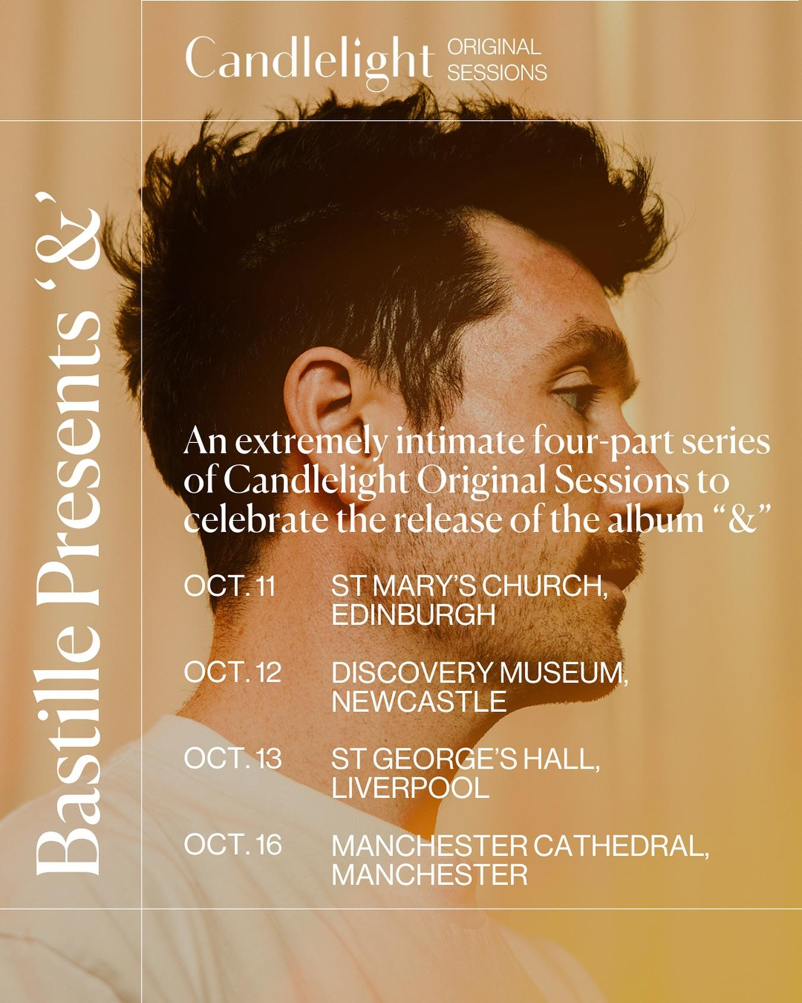
DOWNLOAD POSTER HERE
“Haunting strings and Dan Smith’s vulnerability make a lasting impact on this single about love and loss…” - The Times, (Leonard & Marianne)

To celebrate the release of “&” (Ampersand) - a beautiful new project from Bastille’s Dan Smith out on 25th October, Bastille Presents; “&” (Ampersand) live – the ‘Candlelight Original Sessions’ which run across the UK this October.

Held in beautiful and historic spaces across the UK, the unique dates will be an opportunity for fans to hear the new album “&” (Ampersand) played live in a truly enchanting setting. Fans attending the run of shows, which includes St Mary’s Episcopal Cathedral in Edinburgh and St George’s Hall in Liverpool, will experience a unique show with Smith performing alongside some of the extraordinary musicians he collaborated with on the record, the dates are set to be a truly magical musical experience.

Candlelight Original Sessions “&” Shows
11th October – St Mary’s Episcopal Cathedral, Edinburgh
12th October – Discovery Museum, Newcastle
13th October – St George’s Hall, Liverpool
16th October – Cathedral, Manchester

Tickets for the Candlelight Original Sessions will be on sale here. For further information on Candlelight Original Sessions, visit their website here.

“&” (Ampersand) is the beautiful new project from Bastille’s Dan Smith. A collection of story songs that explores the worlds of fascinating figures from history, mythology, and pop culture, fed by instinctive new collaborations with friends and family, dazzling arrangements and an infectious spirit of musical freedom. Watch Dan introduce the making of “&” here

Released last week, the new single Blue Sky & The Painter is inspired by the Norwegian expressionist painter, Edvard Munch and his relationship with his depression, and the difficult engine that allowed him to create. Uplifting and euphoric, the song is about seeing a crack of light in life after a long period of darkness. Watch Dan perform a stripped back version of the track in the middle of the Sargasso Sea, (one of the most important marine ecosystems on the planet) where he was invited by Greenpeace to raise awareness of protecting our oceans here.

Leonard & Marianne is a mesmerizing love song about longing and loss, inspired by the complex relationship between Leonard Cohen and Marianne Ihlen, it’s one of the first tracks that Smith wrote for the “&” project back in 2020.

“&” Part Two follows the recently released “&” Part One which includes the four tracks, Intros and Narrators, Eve & Her Paradise Lost, Seasons & Narcissus and Emily & Her Penthouse In The Sky. Listen Here

A deeper dive into the characters on the album can be heard on, ‘MUSES: An Ampersand Podcast’ - a new podcast blending music, history and storytelling which began last week. Smith and academic/podcaster Emma Nagouse (BBC Radio 4’s You’re Dead to Me and BBC Sounds’ Homeschool History) collaborate to uncover the lives of the poets, artists, anthropologists and trailblazers featured on the record and break down Dan’s journey of transforming their lives into songs for “&”. In the first episode, Dan and Emma look at the life of Eve, who inspired Dan's song Eve & Paradise Lost.
For more info visit https://shows.acast.com/muses/episodes/muses-an-ampersand-podcast

The run of Candlelight Original Sessions follows the announcement of the “&” live tour, which takes place in November with special one-off shows across seven global cities including Paris, Belgium, Amsterdam, Berlin, Los Angeles, New York and London.

“&” LIVE – 7 Special One-Off Shows
10th November – La Cigale, Paris
11th November – Cirque Royal, Belgium
13th November – Royal Theatre Carré, Amsterdam
14th November – Theatre Des Westens, Berlin
17th November – Shepherd’s Bush Empire, London
23rd November – United Theatre, LA
25th November – Town Hall, New York

Full “&” Album Track listing
Intros & Narrators
Eve & Paradise Lost
Emily & Her Penthouse In The Sky
Blue Sky & The Painter
Leonard & Marianne
Marie & Polonium
Red Wine & Wilde
Seasons & Narcissus
Drawbridge & The Baroness
The Soprano & Her Midnight Wonderings
Essie & Paul
Mademoiselle & The Nunnery Blaze
Zheng Yi Sao & Questions For Her
Telegraph Road 1977 & 2024

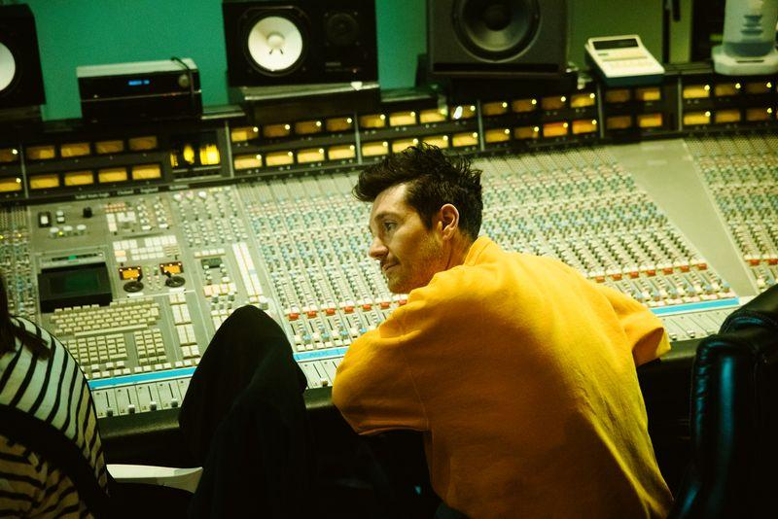

FOLLOW BASTILLE:
INSTAGRAM | TWITTER | FACEBOOK | TIKTOK | WEBSITE

For more information and press enquiries please contact:
Jenny Entwistle
jenny@chuffmedia.com

