

**CIAN DUCROT STARTS 2025 WITH A BANG WITH THE NEW SINGLE**

**‘WHO’S MAKING YOU FEEL IT’**

**LISTEN** [**HERE**](https://cianducrot.lnk.to/WMYFI) **/ WATCH THE VIDEO HERE**

**ANNOUNCED TO SUPPORT TEDDY SWIMS ON EUROPEAN/UK TOUR THIS FEBRUARY/MARCH INCLUDING OVO ARENA WEMBLEY**

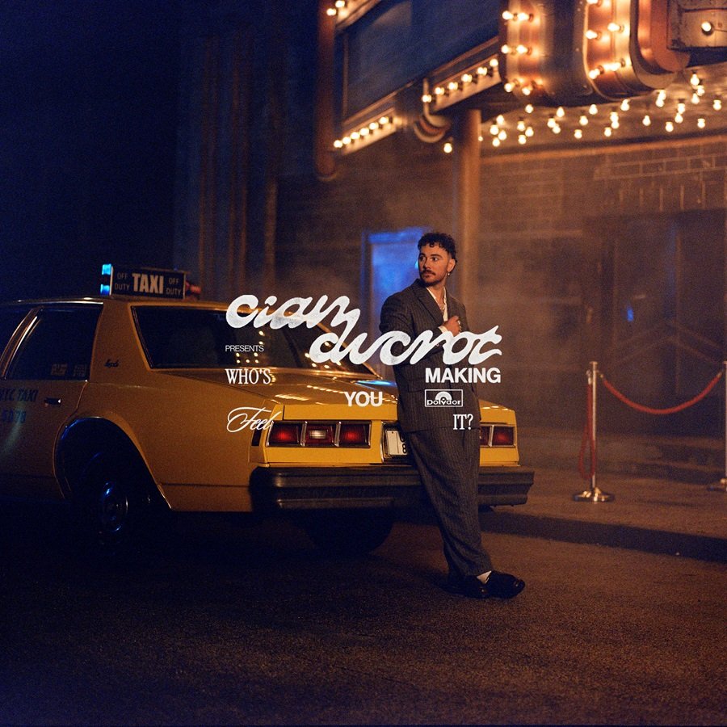 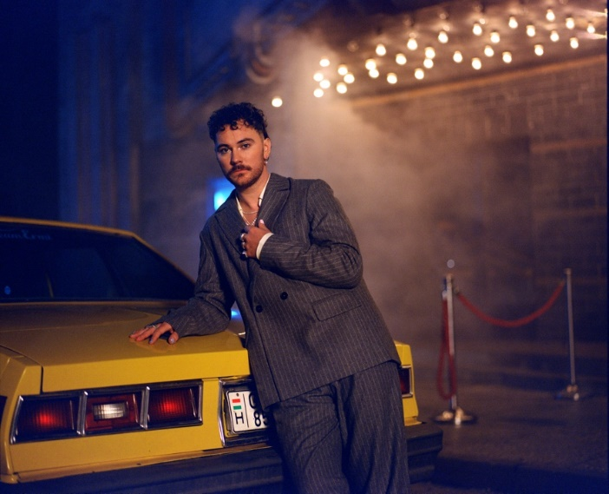

**Single Artwork / Press Photo Jasmine De Silva**

The first chapter of **Cian Ducrot’s** career took the then unknown newcomer to phenomenal success, with his debut album **‘Victory’** shooting to **#1** in the **UK** and **Ireland** as he amassed **over one billion** streams globally and played ever-bigger shows across the globe. Now an even more impactful era gets underway in **2025**, starting with today’s release of his new single **‘Who’s Making You Feel It’** and its equally ecstatic official video. It follows his recent first **Grammy** nomination as the co-writer of **SZA’s** smash hit **‘Saturn’**. Listen [HERE.](https://cianducrot.lnk.to/WMYFI) Watch the official video HERE.

Today also sees the announcement of Cian supporting Grammy-nominated **Teddy Swims** on his European and UK tour throughout February and March. The tour includes **Birmingham, London, Glasgow, Manch**ester and **Dublin.** The full list of dates are [HERE.](https://www.cianducrot.com/)

**‘Who’s Making You Feel It’** feels like an invigorating evolution in **Cian’s** style from his debut album. The bright, spacious piano melody that opens the song brings to mind the timelessness of early **Elton John**, but with a contemporary, radio-friendly twist when the flighty, punchy chorus soars to the stratosphere. Fans have come to love **Cian** for his emotionally-charged lyricism, but there’s a subtle evolution on that front too: where he would previously strike direct at the heart of the sentiment, now there’s a playfulness to his words which brings a fresh sense of character to his songwriting.

**Cian** says, *““The song is basically one big, ‘Tell me, is this new guy better than me?’” “It’s about how we all find ourselves stalking our exes even if we say we don’t. And when you inevitably notice them moving on, that feeling of jealousy and curiosity pops up and you just need to know, ‘Who is it? Who’s making you feel better than I did?’ Or, ‘I notice it looks like your life is amazing and you’re really making the most of it all, but also DO YOU MISS MEEEE?!’ It’s also a bit sarcastic in a way, asking this person if they got everything they dreamed of after leaving you and saying you ‘hope’ they did. It finally feels like the beginning of a new chapter I’ve been so eager to find and a part of me I’ve been so eager to express and discover! Creating music without walls or limits or any boundaries has allowed me to be so much more creative and to really create from a place of complete freedom! I hope you love this song and how it makes you feel as much as I do!”*

**Cian** first introduced **‘Who’s Making You Feel It’** on the biggest of stages. He debuted the song during his huge **New Year’s Eve** show at **Dublin Castle**, which was broadcast live across Ireland. **Cian** wrote the song with **Theo Hutchcraft** (**Calvin Harris**, **Louis Tomlinson**) and the **Grammy** winner **Lostboy** (**Calvin Harris** and **Ellie Goulding’s ‘Miracle’**, **Kylie Minogue’s ‘Padam Padam’**), who also produced it**.**

The uplifting charm of the song is complemented by a similar aesthetic in what is **Cian’s** most ambitious visual to date. It sees **Cian** embracing playful choreography and movement in a way that brings a touch of classic **Hollywood** glamour into his world. Filmed in **Hungary**, the video was directed by **Jasmine De Silva**, and was produced by **Rhory Danniells** for **Intergalactic Studios**. Watch the official video HERE.

**Cian’s** success with **‘Victory’** encompassed many more highlights, including two **UK Top 20** hits - the **Platinum**-certified **‘All For You’** and the **Gold**-certified **‘I’ll Be Waiting’** - winning the **RTÉ Choice Music Prize Irish Song of the Year**, and building tremendous engagement across socials with **4.5 million** followers at **TikTok** and another million at **Instagram**. The album’s impact continued long after its release, as **Cian** played to a total of 36,000 people across two headline shows in **Dublin** and **Cork** before touring **North America** as special guest to **Calum Scott**. He has also introduced a handful of new tracks in the shape of **‘Here It Is’**, **‘something i can’t afford’** and, most recently, **‘Can’t Even Hate You’**.

There will be much more to come on all fronts from **Cian Ducrot** as **2025** marches on - expect the statement that he made with **‘Victory’** to be amplified this time around.

**Follow Cian Ducrot:**

[**Instagram**](https://www.instagram.com/cianducrot/) **|** [**TikTok**](https://www.tiktok.com/@cianducrot?lang=en) **|** [**X**](https://twitter.com/Cian_ducrot) **|** [**YouTube**](https://www.youtube.com/user/cianducrot) **|** [**Spotify**](https://open.spotify.com/artist/49jTY62Cpw3RYo4dLuG43W?si=twClLke_Q-q_5wZD9j-Tmg) **|** [**Apple Music**](https://music.apple.com/gb/artist/cian-ducrot/1117495310)

**For more on information contact**

**Warren Higgins**

[**warren@chuffmedia.com**](mailto:warren@chuffmedia.com)