

**SHARES THE NEW SINGLE ‘CAN’T EVEN HATE YOU’**

**LISTEN / WATCH THE LYRIC VIDEO** [**HERE**](https://cianducrot.lnk.to/hateyou)

**CIAN BECAME THE FIRST ARTIST TO PERFORM AN INTERNATIONAL PORTALS SESSION**

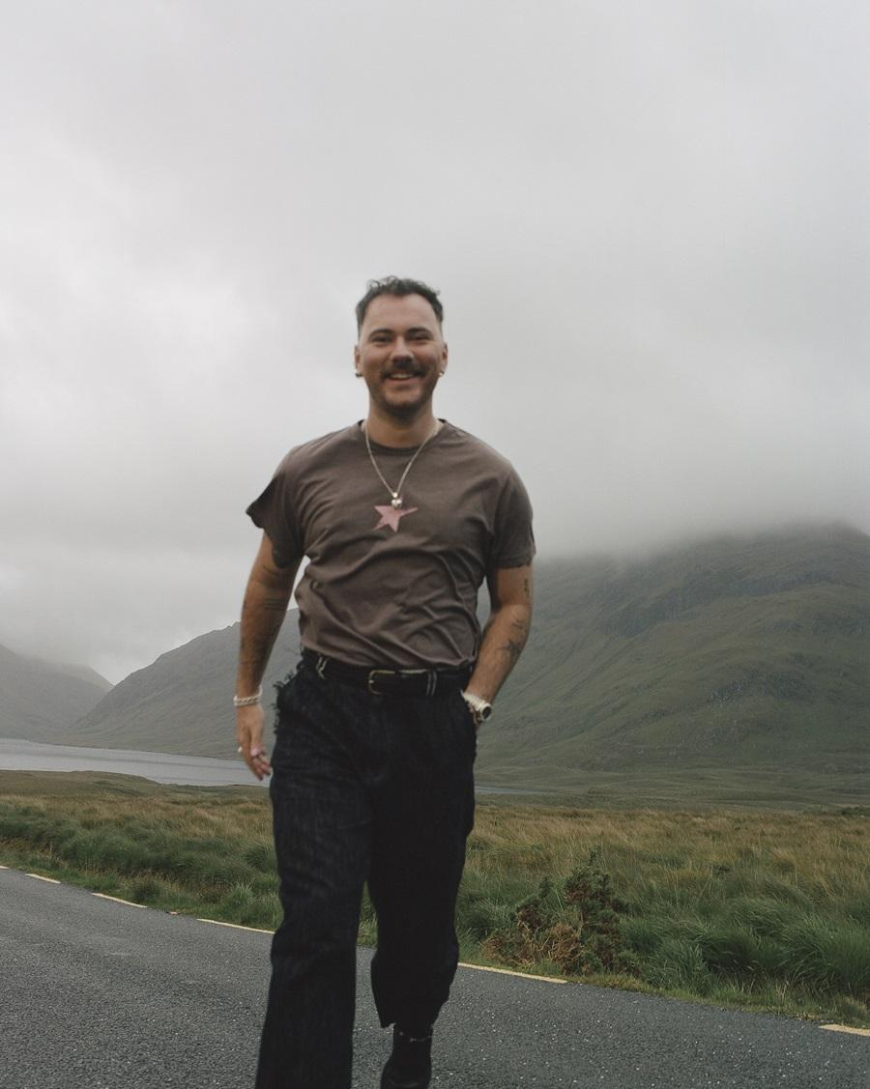 

**Cian Ducrot / single artwork**

This summer has seen **Cian Ducrot** follow his **UK** and **Ireland #1** album **‘Victory’** by embarking upon a tour consisting of huge outdoor shows including unforgettable nights in **Cork** and **Dublin**. The latter saw **Hot Press** summarise his appeal in the live arena as they stated, *“It can be difficult for artists to avoid looking as if they're on a pedestal, up there on stage, and yet this is exactly what Cian Ducrot manages to do, emphasising his own vulnerability and humanity.*” Now he shares his brand new single **‘Can’t Even Hate You’.**

That vulnerability and humanity is something that gives **Cian’s** songs a relatable surge of emotion, and that’s something that dominates **‘Can’t Even Hate You’**. A singer-songwriter with a gift for identifying the pains, joys and complications of love, **Cian** takes us into the heart of another romantic quandary: this time, wanting to hate someone after a break-up to alleviate your own pain, but having to accept that you just can’t do it. That raw emotion is wrapped within the kind of song that **Cian** does best, with heart-string pulling emotions flowing from his powerful, soulful voice with a surfeit of engaging songcraft.

**Cian** says, *“It’s one of those songs that just finds meaning as you write it. It starts as just an idea and something you relate to and with time you realise what it is you’re writing about and the song grows and becomes more and more about that one thing. It makes it an emotional process and also one that can be hard to share because no one will really understand it the way you do and the fear of it being judged when it’s so personal can be scary, but in the end that’s what sharing it is about. For people to connect and love it or hate it but hopefully it helps someone!"*

**‘Can’t Even Hate You’** emerges as **Cian** continues to work on his highly anticipated second album. Many artists may have capitalised on such a breakthrough (see also: **1.3** **billion** streams and still amassing another **3.2 million** streams each week, two **Top 20** hits and the **RTÉ Choice Music Prize Irish Song of the Year**) by rapidly completing a follow-up, but **Cian** vowed to take his time - not only to allow the new record to reach its full potential, but also to allow him to live in the present and to enjoy the rapturous receptions that he has received on tour.

Already renowned for his moving pop-up performances in all manner of imagination locations, **Cian** recently took the phenomenon into a new era as the first artist to perform through the international **Portals** initiative. Playing alongside a flash mob choir and a backing band, **Cian’s** performance was captured from the **Portal** sculpture in his home city of **Dublin** and essentially live-streamed to enthusiastic audiences via the other **Portals** in **New York City**, **Vilnius** and **Lublin**.

The **Portals** interactive technology sculptures were founded on the idea that offering people a window into the daily lives of others around the world can promote a broader sense of togetherness. Music similarly has the power to connect individuals across geography and circumstance, and **Cian** is an incredible ambassador for that phenomenon. From the start, his gift for channelling the pains, joys, and complexities of love has set him apart. Please see the [**Portals** website](https://www.portals.org/) for more information.

**Cian’s** extensive summer of touring is now in its final leg, with just **Rock ‘n’ Roll Circus** and **iMEP Music Festival** remaining. In addition to the **UK** dates, listed below, he will also play two shows in **Portugal** in **December**.

**AUGUST**

**30th - Sheffield, Rock ‘n’ Roll Circus (with Becky Hill)**

**SEPTEMBER**

**21st - Accrington, iMEP Music Festival (with Jess Glynne)**

**Follow Cian Ducrot:**

[**Instagram**](https://www.instagram.com/cianducrot/) **|** [**TikTok**](https://www.tiktok.com/@cianducrot?lang=en) **|** [**X**](https://twitter.com/Cian_ducrot) **|** [**YouTube**](https://www.youtube.com/user/cianducrot) **|** [**Spotify**](https://open.spotify.com/artist/49jTY62Cpw3RYo4dLuG43W?si=twClLke_Q-q_5wZD9j-Tmg) **|** [**Apple Music**](https://music.apple.com/gb/artist/cian-ducrot/1117495310)

**For more on info contact**

**Warren Higgins**

[**warren@chuffmedia.com**](mailto:warren@chuffmedia.com)