Brian Butterfield’s CALL OF NOW
UK & Ireland Tour 2024

“A triumphant transfer of a sketch character into a hilarious stage juggernaut” – Chortle

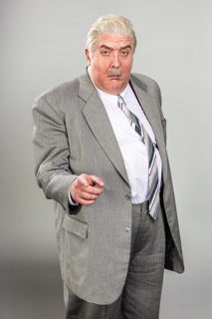
MEDIA ASSETS HERE

Businessman Entrepreneur Businessman
pronouns: business/man

Tickets on sale via www.brianbutterfield.co.uk

September (and a bit of October) 2023 was an important month in the world of business, as Brian Butterfield made his live stage debut, imparting all his business knowledge from his decades spent within the business world working as everything from Lord Mayor’s Croupier to Circus Horse Dentist. Over 10,000 people attended his sold-out wave of seminars from Exeter to Glasgow, keen to learn the secrets of success from one of the UK’s titans of business.
Demand for the return of Brian and his tell-all business seminar has been phenomenal, and alongside the previously announced show at the Eventim Apollo, London on 14th June 2024, Brian is once again heading out to reach the masses with his CALL OF NOW tour.
Brian says, “My CALL OF NOW tour is back in 2024! I will continue to impart all the key elements of business, including information on income tax, something I was unaware of until this morning. Please, please, please buy tickets before 31st January.”
Brian will be sharing his knowledge at the following venues:
Tue 21 May LIVERPOOL PHILHARMONIC HALL
Fri 31 May WEYMOUTH PAVILION
Tue 4 June DUBLIN LIBERTY HALL THEATRE
Wed 5 June BIRMINGHAM TOWN HALL
Fri 7 June CARDIFF NEW THEATRE
Sat 8 June MANCHESTER ALBERT HALL
Sun 9 June NOTTINGHAM THEATRE ROYAL
Wed 12 June SOUTHEND PALACE THEATRE
Fri 14 June LONDON EVENTIM APOLLO
Sun 16 June NORWICH THEATRE ROYAL
Mon 17 June CAMBRIDGE CORN EXCHANGE
Fri 21 June OXFORD NEW THEATRE
Sat 22 June BRISTOL BEACON
Sun 23 June EDINBURGH QUEENS HALL
Tue 25 June GLASGOW PAVILION THEATRE
Brian believes that every failure is just an opportunity to learn a new lesson. Having opened, and closed several businesses, Brian has learnt over 1000 lesson and counting.
This is a once in lifetime opportunity (for Brian).
Initially making his debut to the world through a series of spoof advertisements on BBC Two’s cult classic, Bafta nominated The Peter Serafinowicz Show, Brian Butterfield charmed viewers with his forever flawed business idea coupled with his eternal optimism. His popularity has grown considerably since, with clips notching up millions of views online. Brian has also built up a considerable online fanbase via his highly-engaged Twitter/X, Facebook and Instagram accounts, delivering commentary on politics, business, sport, and every episode of The Apprentice.
Tickets on sale via www.brianbutterfield.co.uk.
@mrbbutterfield
For all media enquiries please contact Warren@chuffmedia.com on 07762 130510

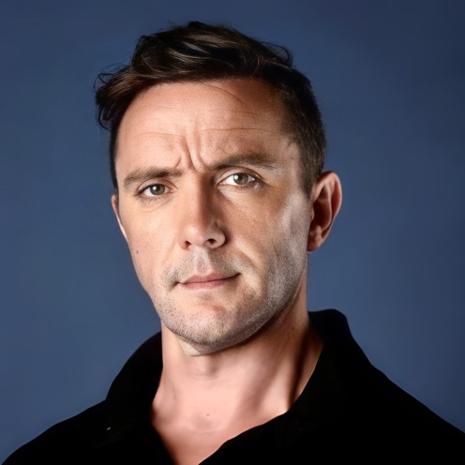
Peter Serafinowicz is an English actor, comedian, director and screenwriter, best known for his roles as the title character in the 2016 live-action series of The Tick, Denarian Saal in Guardians of the Galaxy (2014), Pete in Shaun of the Dead (2004) and as the voice of Darth Maul in Star Wars: Episode I - The Phantom Menace (1999). He has also appeared in many British and American comedy series, and received attention for political satire videos in which he dubs over videos of Donald Trump with various comedic voices. He has also directed music videos for acts such as Hot Chip.

