Rupert Gavin for Incidental Colman, Mallory Factor for Hill Street Productions
and Dan Colman Creative Present

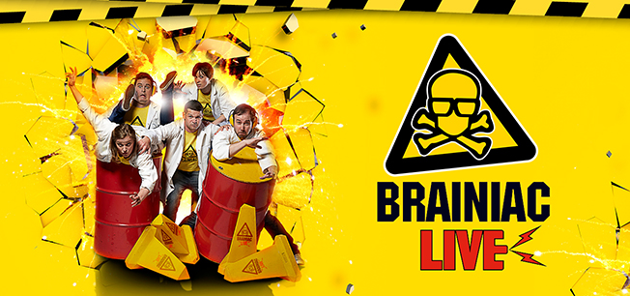

Strap on your safety goggles: BRAINIAC LIVE! IS BACK!!!

30TH JULY – 24TH AUGUST 2024
MARYLEBONE THEATRE, LONDON NW1

Tickets on sale Tuesday 14th May
Media assets here

Science’s greatest and most volatile live show is set to explode young (and old) minds when Brainiac Live! returns to London for the first time in five years. Taking you on a heady ride through the wild world of the weird and wonderful, watch from the safety of your seat as the Brainiacs delve fearlessly into the mysteries of science in a limited 4 week run at the Marylebone Theatre, starting on the 30th July.

More mischievous than ever before, Brainiac Live! will thrill audiences with a great range of experiments and demonstrations - think exploding dustbins, supercharged spinning chairs and live daredevil stunts, basically all those things that you’re not allowed to do at home or school!

Are you brave enough to sit through the UK’s original most outrageous live science show?

Based on the popular TV show owned by ITV Studios, since 2008 Brainiac Live! has played to packed houses across the UK, headlining top science festivals as well performing in theatres across the globe, entertaining and educating hundreds of thousands of children and their families.

Dan Colman, Producer says “After 16 explosive years of producing Brainiac Live! across the UK and everywhere from Dubai to Australia, we are so excited about bringing the show back to the heart of London at the Marylebone Theatre. I can’t wait to see the amazement on the children’s faces, when they see our daredevil experiments but remember DON’T DO THIS AT HOME!”

Nestled a short walk behind Baker Street tube station and 5 minutes from Marylebone train station, Marylebone Theatre is London’s newest cross-cultural performance space. Once known as the Steiner Hall, the theatre has undergone an extensive refurbishment and as a result is now a versatile, state-of-the-art space giving theatre goers an intimate experience. Families coming to watch the show, will be able to have a full family day out with Regents Park, Madame Tussauds and more all within a short walk of the theatre.

Jurian van der Meer, EVP Brand Licensing, Global Partnerships, ITV Studios: "Our partnership with Dan Colman Creative spans 15 years and this signifies an exciting development in extending the reach of our live experiences, developing new format and offering family-orientated edutainment events”.

Suitable for ages 5+ but great for all the family, it’s the perfect summer holiday treat!

TikTok: @brainiac / Facebook: brainiaclive / Instagram: @brainiaclive / Youtube: @Brainiac-TV

30th July – 24th August
Press performances: Thursday 1st August 11am & 1.15pm
Running time: 60 minutes (no interval)

Brainiac Live!
Marylebone Theatre
35 Park Road, London NW1 6XT

Tickets from £26.50 + Group rates available

Tickets are available from the Marylebone Theatre box office and Brainiaclive.com.

Tuesday 30-Jul-24 1.30pm & 4pm
Wednesday 31-Jul-24 11am & 1.15pm
Thursday 1-Aug-24 11am & 1.15pm Press shows
Friday 2-Aug-24 11am & 1.15pm
Saturday 3-Aug-24 11am & 1.15pm
Sunday 4-Aug-24 11am & 1.15pm
Tuesday 6-Aug-24 11am & 1.15pm
Wednesday 7-Aug-24 11am & 1.15pm
Thursday 8-Aug-24 11am & 1.15pm
Friday 9-Aug-24 11am & 1.15pm
Saturday 10-Aug-24 11am & 1.15pm
Sunday 11-Aug-24 11am & 1.15pm
Tuesday 13-Aug-24 11am & 1.15pm
Wednesday 14-Aug-24 11am & 1.15pm
Thursday 15-Aug-24 11am & 1.15pm
Friday 16-Aug-24 11am & 1.15pm
Saturday 17-Aug-24 11am & 1.15pm
Sunday 18-Aug-24 11am & 1.15pm
Tuesday 20-Aug-24 11am & 1.15pm
Wednesday 21-Aug-24 11am & 1.15pm
Thursday 22-Aug-24 11am & 1.15pm
Friday 23-Aug-24 11am & 1.15pm & 3.30pm
Saturday 24-Aug-24 11am & 1.15pm & 3.30pm

For all media enquiries please contact Warren@chuffmedia.com on 07762 130510

