**Brian Butterfield’s Debut Book**

***There’s No Business Like BUSINESS!***

**Available Exclusively At “The Call of Now”**

**UK & Ireland Tour 2024**

***“A triumphant transfer of a sketch character into a hilarious stage juggernaut” – Chortle***

**Nominated for Best Tour at 2024 Chortle Awards**

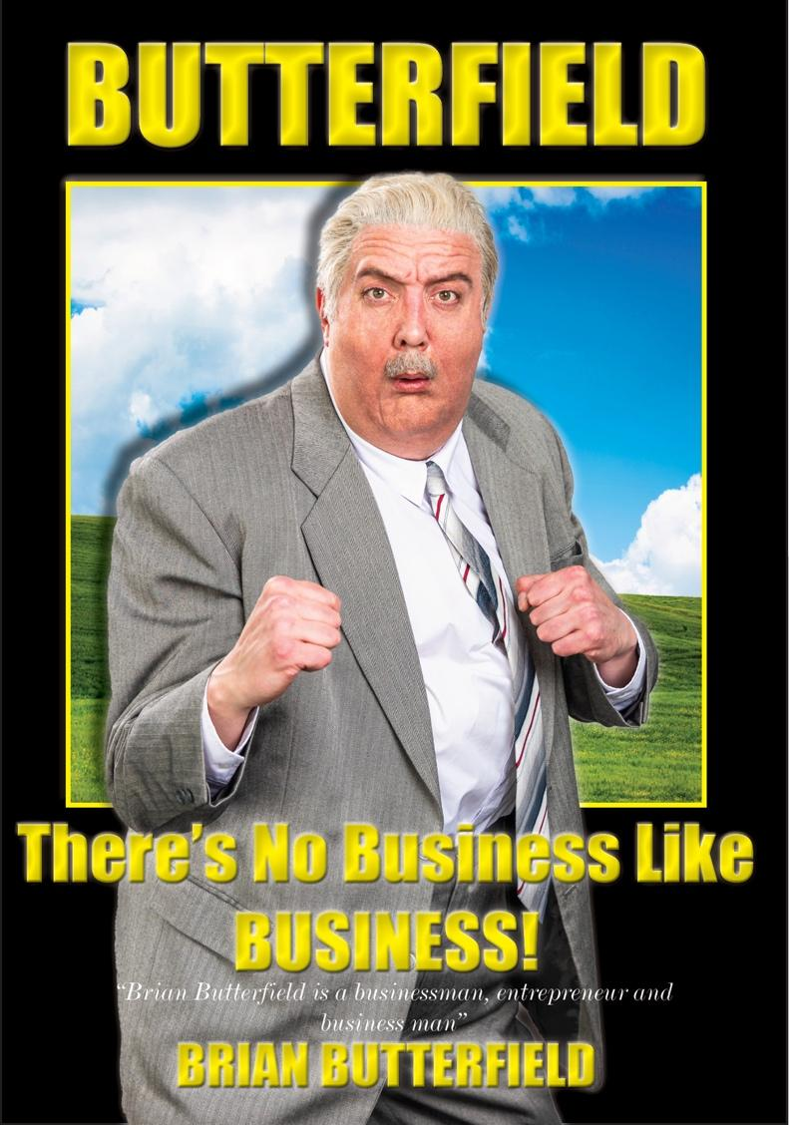

**MEDIA ASSETS** [**HERE**](https://chuffmedia.com/artists/brian-butterfield)

**Businessman** **Entrepreneur Businessman (and now author!)**

**pronouns: business/man**

Tickets on sale via [www.brianbutterfield.co.uk](http://www.brianbutterfield.co.uk)

Of his new book, Brian has admitted: *“I want to say that if you read this book, you will be guaranteed success in business and indeed in life. I want to say that, but sadly I’m legally not allowed to.”*

Brian believes that every failure is just an opportunity to learn a new lesson. Having opened, and closed several businesses, Brian has learnt over 1000 lessons and counting. To share these numerous lessons and business secrets further, the infamous businessman has written his debut book titled *There’s No Business Like BUSINESS!.* This masterpiece will be available to buy exclusively at the serial entrepreneur’s “The Call of Now” seminars, giving a complete business rundown including: ‘How To’ guides, self-help questionnaires, career tips, diary entries, adverts for Brian’s businesses, a couple of pages accidentally left blank and much, much more.

“Back in 1997, a man asked me to write a book containing all of my business knowledge. I remember it well as it was at his 91st birthday party. Well good news Algernon, I finally got round to writing it. Happy reading!” – Brian Butterfield

September (and a bit of October) 2023 was an important month in the world of business, as Brian Butterfield made his live stage debut, imparting all his business knowledge from his decades spent within the business world working as everything from Lord Mayor’s Croupier to Circus Horse Dentist. Over 10,000 people attended his sold-out wave of seminars from Exeter to Glasgow, keen to learn the secrets of success from one of the UK’s titans of business.

Demand for the return of Brian and his tell-all business seminar ***Call Of Now*** has been phenomenal, with sold out shows at the Eventim Apollo, London and Manchester’s Albert Hall part of the 15-date tour.

Brian says, *“My* ***CALL OF NOW*** *tour is back in 2024! I will continue to impart all the key elements of business, including information on income tax, something I was unaware of until this morning. Please, please, please buy tickets.”*

Brian will be sharing his knowledge at the following venues:

Tue 21 May **LIVERPOOL** PHILHARMONIC HALL

Fri 31 May **WEYMOUTH** PAVILION

Tue 4 June **DUBLIN** LIBERTY HALL THEATRE

Wed 5 June **BIRMINGHAM** TOWN HALL

Fri 7 June **CARDIFF** NEW THEATRE

Sat 8 June **MANCHESTER** ALBERT HALL **SOLD OUT**

Sun 9 June **NOTTINGHAM** THEATRE ROYAL

Wed 12 June **SOUTHEND** PALACE THEATRE

Fri 14 June **LONDON** EVENTIM APOLLO **SOLD OUT**

Sun 16 June **NORWICH** THEATRE ROYAL

Mon 17 June **CAMBRIDGE** CORN EXCHANGE

Fri 21 June **OXFORD** NEW THEATRE

Sat 22 June **BRISTOL** BEACON

Sun 23 June **EDINBURGH** QUEENS HALL

Tue 25 June **GLASGOW** PAVILION THEATRE

This is a once in lifetime opportunity (for Brian).

Initially making his debut to the world through a series of spoof advertisements on BBC Two’s cult classic, Bafta nominated The Peter Serafinowicz Show, Brian Butterfield charmed viewers with his forever flawed business idea coupled with his eternal optimism. His popularity has grown considerably since, with clips notching up millions of views online. Brian has built up a considerable online fanbase via his highly-engaged Twitter/X, Facebook and Instagram accounts, delivering commentary on politics, business, sport, and every episode of The Apprentice.

**Tickets on sale via** [**www.brianbutterfield.co.uk**](http://www.brianbutterfield.co.uk) **& *@mrbbutterfield***

**For all media enquiries please contact** [**Warren@chuffmedia.com**](mailto:Warren@chuffmedia.com) **on 07762 130510**

Peter Serafinowicz is an English actor, comedian, director and screenwriter, best known for his roles as the title character in the 2016 live-action series of The Tick, Denarian Saal in Guardians of the Galaxy (2014), Pete in Shaun of the Dead (2004) and as the voice of Darth Maul in Star Wars: Episode I - The Phantom Menace (1999). He has also appeared in many British and American comedy series, and received attention for political satire videos in which he dubs over videos of Donald Trump with various comedic voices. He has also directed music videos for acts such as Hot Chip.A person in a black shirt
