**Bellah Mae Bio**

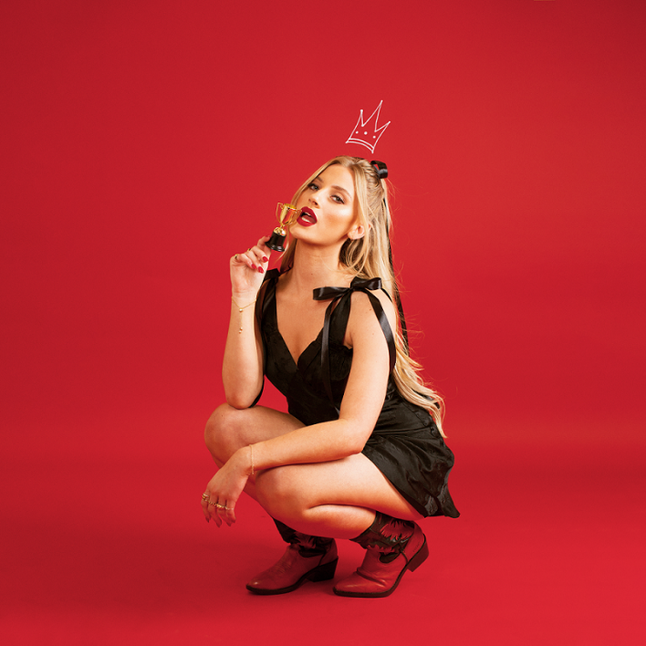

When Bellah Mae uploaded a snippet of her debut single, the grungy pop punk stomper ‘Boyfriend Of The Year’, to TikTok, she had a feeling that the song would pop off. The 21-year-old had spent years writing over 100 songs and nearly 12 months sharing covers on TikTok, but she was reluctant to upload any original material. Then she wrote ‘Boyfriend Of The Year’ and immediately knew that it was the right song to kick everything off. “It was one of those songs that just writes itself,” she says. “It was written in an hour. In fact, I actually sent my dad a message the night it was written saying, ‘I just wrote a career launching song.’ And we had.”

Bellah isn’t exaggerating. Shortly after she teased the song on TikTok, the video racked up over 1 million views. Comments began pouring in about how the song’s deeply relatable lyrics – about watching a toxic ex-boyfriend treat their new partner with the respect they never showed you – resonated, the internet’s many broken-hearted people recording their own videos using the song to express their own relationship woes. “I wrote it from my personal experiences, but the number of messages I’ve had from girls and guys sending me paragraphs about their own situations is incredible,” Bellah says. “As a songwriter, it’s confirmation that I’m doing something right.”

It also points towards Bellah’s innate understanding of music and its ability to connect people. Such instincts point towards a life spent surrounded by music, something Bellah knows a thing or two about. Her grandfather was in a rock’n’roll band and she was raised on a diet of Jerry Lee Lewis and Chuck Berry. Meanwhile, her father was also musical, their house filled with instruments. “I know people love to be like, ‘I picked up a mic and learned guitar when I was two days old,’” she jokes, “but I think because my family was in music, it really was just around me. I’m grateful for that, because my introduction to music was so pure. I’ve only ever wanted to be a musician because I love music. It’s home to me.”

She recalls one of her dad’s favourite stories, which involves him coming home from a night out to find his daughter, aged 11, playing Guns N’ Roses ‘Sweet Child O’ Mine’. “He didn’t even know I could play,” she laughs.

“And obviously it's such a rogue song for an 11-year-old in the 21st Century to be singing as their first song.”

Despite growing up in Solihull, a town just outside of Birmingham, Bellah’s early influences skewed towards rock, Americana and, later, country. She was also obsessed with Miley Cyrus and her fictional alter-ego, Hannah Montana: “I was, like, a die-hard fan,” she says, clearly still deadly serious. She recalls how, at eight years old, she would force her mother and older sister to pretend to be fans at a concert as she took on the role of pop star. “I would make my mum and sister put their hands through the bannisters and I would run touching their hands, while wearing a wig, like I was Hannah Montana on stage touching the hands of her fans on stage.”

She would also perform at any given opportunity. She says that she brought her guitar, which she’s fondly named Theo, everywhere with her. “He’s like a member of the family,” she says. “We would never travel without him because wherever we were in the world, if there was an opportunity for me to perform, we would take it. We just got the guitar out.”

Songwriting was constant, too. As a child she would write songs about her day-to-day life (one such track, called ‘Rope Swing’, was literally about a rope swing her father put up for her), but by the time she was in her late teens, things had solidified. Aged 17, Bellah released a song independently, which found its way into the hands of Dolly Parton’s manager, Danny Nozell. “He’s been a huge mentor to me and is a really good friend of mine,” Bellah says.

Nozell invited Bellah to take part in a concert series his management company organises called Song Suffragettes, which focuses on spotlighting up-and-coming female country artists. Bellah performed at Song Suffragettes concerts in the UK, before flying out to join them for an anniversary show in Nashville, where the Song Suffragettes host weekly acoustic showcases. While visiting the home of country music, Bellah took the opportunity to soak up the city’s rich musical culture and scope out collaborators. “It's so easy to make friends in the music industry there because anybody who's trying to get into that area of the industry moves to Nashville,” she says. “We managed to do a bunch of writing, which is cool.”

Nevertheless, Bellah says she’s an artist who prefers to work with the same people consistently. She found one such partner in Scottish songwriter and producer Josh Breaks, who she connected with on social media and with whom she has written the majority of her upcoming music with, including ‘Boyfriend Of The Year.’ “We ended up doing one session together and it was like we were twin flames,” she says. “I’m very chaotic and have 100 thoughts a minute, but Josh is able to bat all the bad ideas away. He’s incredible.”

Bellah connected with Josh during a period when her sound was developing. Initially rooted in country, she had begun expanding her sonic touchstones, pulling in her rock’n’roll roots, modern pop and pop punk to create something that feels wholly unique. She retained country music’s penchant for storytelling, though, her songs peppered with colourful specificity, from the type of pasta an ex-boyfriend cooked on ‘Boyfriend Of The Year’ to finding another girl’s hair on her lover’s bedroom floor on recently recorded track, the glitchy and scornful ‘Game Over’.

“I definitely picked up a lot of my writing style from that tradition,” Bellah explains. “But then I put that into a pop format, which I feel is sometimes lacking in that space. I just get very, very honest and trust the fact that as a human being, and as a young woman, a lot of people will relate to that honesty. I think today, being honest is sometimes hard to do. I don’t know if it’s a generational or societal thing, but we’re trained to cover things up

and curate our lives. But I would say the more raw, deeper and specific you go, the more relatable your songs become.”

The response online to ‘Boyfriend Of The Year’ proves the effectiveness of this approach, which is the bedrock of Bellah’s music. Her songs also bite: filled with sharp observations, prickly kiss offs to bad boyfriends (“Had to convince myself I was attracted to you,” she sings on the Tony Basil-esque ‘Out Of Your League’), sarcasm and exasperated eyerolls, and fiery lashings of righteous anger, they provide the sort of sing-a-long catharsis found in early Alanis Morrisette and, more recently, Olivia Rodrigo’s ‘Good 4 U’.

“I don’t journal, but I do take a concept or an idea for a song and write that down,” Bellah says of her songwriting approach. “I just try not to think about it terms of lyrics, but rather focus on the emotions. I might have a verse idea but no chorus and leave it for a couple of months. It’s almost like I have to live in those emotions for a little bit longer in order to properly document them. Also, sometimes I don’t know how to feel. For example, if I’m still going back to a toxic relationship, I obviously don’t know what I’m doing enough to put that into a song. But what happens is there’s a sweet spot where I can finally write about it. You still care about what happened and are still hurting, but you’re over the initial trauma phase. I tend to write when I’m on that curve.”

While mining these experiences has helped Bellah develop an ever-growing catalogue of bangers, she says she’s “of the mentality that my best songs aren’t written yet. I always want to level up,” she continues. “I don’t think my music will ever stop progressing because I’m constantly trying to push boundaries. My favourite genre to write is pop punk, but I don’t want to be put in a box.

Paired with this passion for music is Bellah’s desire to connect with people. “My job as a songwriter is to execute an emotion that we're all feeling into something that is specific but that also hits home to people,” she says. “I just think about all the tears that go into a song like ‘Boyfriend Of The Year’ and how amazing it is that there are people who care about that song and relate to it.  Now I just can’t wait to start performing the songs live. It’s one thing having people message you on social media to say they like your song, but it's another to hear your lyrics sung back to you. That is just going to be incredible.”

**For more information please contact**

**Warren Higgins** [**warren@chuffmedia.com**](mailto:warren@chuffmedia.com)