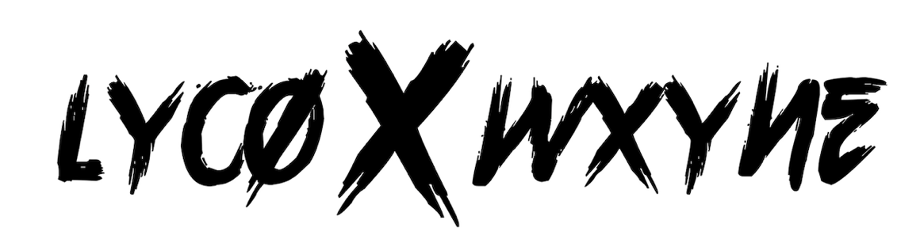
Biography
From throwing parties in their university dorms to gaining viral success, the East Midlands duo LYCO x WXYNE are set to heat up summer with their highly awaited return!
Over the last few years more cities across the nation have been piercing through the music scene, more specifically British Rap, with a flurry of unquestionable talent; many notable budding rappers have been putting their ends on the map and pushing the capital aside. For many it has become a fight to get noticed and “breakthrough” when located outside of London, but for Birmingham’s rising duo LYCO and WXYNE that isn’t in the question.
Posing as one of the most exciting and fresh acts to emerge from the East Midlands, the pair have amassed over 212,000 independent views on their latest “Midlands” single, not to mention the 1.2 million views and 212,000 likes on imjustbait’s page for their impressive talent – it’s safe to say the pair are gearing up for what is due to be another successful year ahead!
What has been referred to as a “terror-dome” of a year, 2020 bought many challenges to the music industry and its musicians but there’s always a silver lining to any challenge; using this time of self-reflection to further their style, “There has been positives and negatives, it’s allowed us to focus on the music and experiment with different things”, the pair commented.
Having both taken an interest to music from a youthful age, each playing a selection of instruments from piano, drums, and guitar, both LYCO and WXYNE were heavily influenced by their cultural backgrounds [Nigerian and Jamaican] and surrounding environment; from attending Church to playing Westlife in the car, as they stepped toward their teenage years, they found themselves leaning towards British Rap, Dancehall and Bashment which eventually contributed to them making their own music.
Juggling commitments with University and their life-long dreams, the pair first connected on Instagram a few years ago, “LYCO DM’d me. At the time, we both had a song we released roughly at same time, and we had mutual friends. He saw my music go around and vice versa, I gave him a follow and then a few minutes later he sent me a DM asking to collab. We linked up the week after and continued to do so every Wednesday”. Taking influence from UK hit-makers Tion Wayne, NSG, Yxng Bane and international sensation Burna Boy – not to mention Birmingham’s very own Lotto Boyzz, “Lotto Boyzz were a big influence at the beginning”, both LYCO and WXYNE have managed to establish a sound of their own. From throwing parties at their Uni dorm and surrounding areas (pre-covid), the pair began building a name for themselves before stepping into the world of TikTok and capturing worldwide success through various viral moments; further accumulating over 431,000 views and 101,000 likes.
Breaking onto the scene back in 2019 with “Summertime” that swiftly followed through with string of successful singles, the East Midlands duo are on their way back with a variety of summer smashes! Following on from their track named “Midlands” back in Spring last year [2020], the boys have been working on new music, “In between the time we’ve not released and now, there’s been a lot of grinding and making as much music as we can”, WXYNE commented.
Like any successful artist there are always comparisons being thrown around, having previously been compared to the likes of Young T & Bugsey and Lotto Boyzz, when speaking on their new music, LYCO stated, “The main difference between last time and now; before we got a lot of comparisons but as we’ve progressed, we sound like LYCO and WXYNE now which is very important. We’re getting to that place now where a LYCO and WXYNE type-beat on YouTube will exist”.
“I think it’s a compliment to be fair. Who doesn’t take inspiration from anyone really? No one would be here otherwise. You have to start somewhere and gradually break off and become your own thing, I don’t think it’s a bad thing at all. I don’t see it is as criticism”, WXYNE added.
Through taking influence from a variety of different genres, it’s hard to box the duo into one particular sound, having already proved their versatility through various singles that are enriched with bouncing flows, infectious melodies and feel-good energy, when asked to describe their sound LYCO said, “It’s a blend really. If I were to put it into one phrase or genre, I would say it’s more Afro-Bashment, but there is still room to add a lot of hyphens to that because of the music we’ve been creating recently”.
As we gear up for the release of their highly awaited single “Birkin Price”, this summer-drenched track is the perfect re-introduction to the pair following their short hiatus. “We were in London with one of my guys from Birmingham and it was just a vibe! The session was fun, it wasn’t strictly music, and everyone was enjoying themselves, we took influence from everyone in the room – it was a fun song to make. We started with creating the chorus first, the vibes were right, and it helped to bring the song to where it is now”, WXYNE added.
Flicking between home set ups and going to the studio in both their home city and London, LYCO and WXYNE have set their sights high, “I defo seeing us branching outside of the UK in the next couple of years. We have the potential to do that. We are from different backgrounds and connected to our roots, I don’t see any reason why we can’t branch out to different sides of the world. I see us having an award or two under the belt and becoming a household name in the UK and in Birmingham”.
With the aim to eventually become international stars and collaborate with the likes of Popcaan, Tion Wayne, Young T & Bugsey, Burna Boy, WizKid, Tems and Dave, although the pair are at the start of their journey, it’s evident that their hunger to succeed and musical chemistry will take them far – we’re sure this isn’t the last you’ll hear of LYCO x WXYNE!
FOLLOW LYCO
INSTAGRAM | TIK TOK | TWITTER

FOLLOW WXYNE
INSTAGRAM | TIK TOK | TWITTER

For more information please contact warren@chuffmedia.com on 07762 130510

