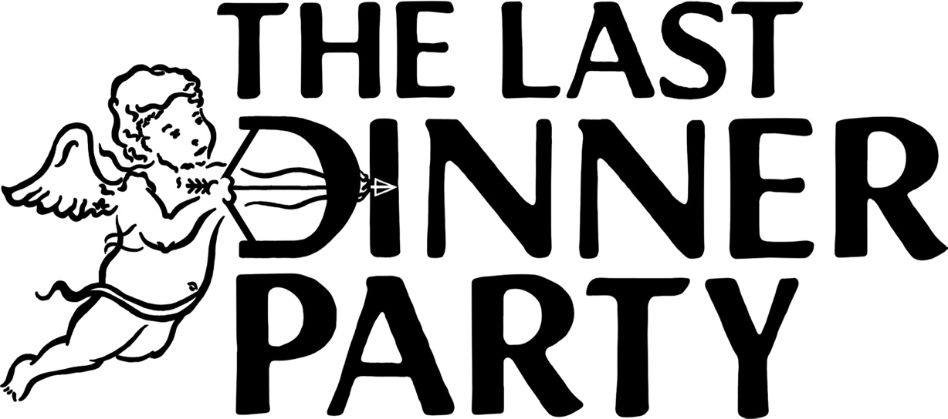

Biography 2025
From The Pyre

Although it has only been a year since our debut album, Prelude to Ecstasy, was released, we had been playing many of those songs since our very first rehearsals in the stagnant summer of 2020. Nothing Matters, our first single, has been a feature of every setlist since our first ever gig at the George Tavern in 2021. We have held, nurtured and fed these first songs for a long time, and in return they have flown us to heights and guided us on journeys once totally incomprehensible. While it may seem to an outsider that we have moved quickly on to a second album, this timing felt like a natural progression to us. We’re not closing the book or beginning a new ‘era’, but transforming and shapeshifting, vibrating with the experience and inspiration that these last few years have given us.

It is our absolute delight to present our new album From The Pyre to the world. This record is a collection of stories, and the concept of album-as-mythos binds them. ‘The Pyre’ itself is an allegorical place in which these tales originate, a place of violence and destruction but also regeneration, passion and light. The songs are character driven but still deeply personal, a commonplace life event pushed to pathological extreme. Being ghosted becomes a Western dance with a killer, and heartbreak laughs into the face of the apocalypse. Lyrics invoke rifles, scythes, sailors, saints, cowboys, floods, Mother Earth, Joan of Arc, and blazing infernos. We found this kind of evocative imagery to be the most honest and truthful way to discuss the way our experiences felt, giving each the emotional weight it deserves. This record feels a little darker, more raw and more earthy; it takes place looking out at a sublime landscape rather than seated an opulent table. It also feels metatextual and cheeky in places, like a knowing look reflected back at ourselves. For the album’s artwork, we imagine each song as its own character and story set within a travelling medieval mystery play, and ourselves as its cast. This frame narrative of a theatrical production which is both nomadic and fable-making felt like a way of visually representing our lives as a band, once again mythologising the everyday.

To mythologise the self is to attempt to understand it, and we gained an even deeper understanding of ourselves and each other through this writing and recording period. Recorded in the spring of 2025 in London with producer Markus Dravs, these songs were created against the backdrop of our changed lives as musicians. We have felt the bizarre omnipresence of our own image on billboards and hearing our song played at the airport duty-free, as well as the intense emotional highs and lows of being a topic of discussion in the public eye. In particular, Inferno, Agnus Dei and This is the Killer Speaking all contend in some way with the different impacts our career has had on our individual lives and the people in them. In light of this shift from an unknown band to full-time touring musicians, From The Pyre did not have the same gift of anonymity in its inception as our first album, and most of its songs hadn’t been played live before we went into the studio to record them. We played From The Pyre’s lead single, This is The Killer Speaking, to a relatively small crowd, under a decoy name (Yeehaw Interlude), during a thunderstorm at a festival in Prague in 2024. Moments later, forums and social media was already abuzz with fans trying to transcribe the lyrics, discern the title, and posit a connection to other unreleased material. It was one of those moments that demonstrated to us how much things had changed since the band’s beginning, and what a dedicated community we had cultivated.

Where we’d once had years to repeat and polish each song, we now had to figure it out mostly without the audience’s reception to guide us. It was a learning curve to not have every second of each part meticulously planned out as we did with Prelude, as writing it came in brief windows between tours last year. While the process was different and challenged us as artists, we are so proud of what we were able to do together. We certainly feel a sense of nervous anticipation as the record’s release date draws closer, and some sense of expectation following our initial rise. Strangely, none of this energy permeated into the recording studio and we only ever wrote to excite ourselves, just like we did all those years ago before we’d ever played a gig. Our admiration of each other as artists and friends has always been our strongest asset and the force which continues to compel us through sunshine or storm.

Thank you for listening, we hope you enjoy it,

The Last Dinner Party

From The Pyre is released 17th October 2025

For more information contact warren@chuffmedia.com

