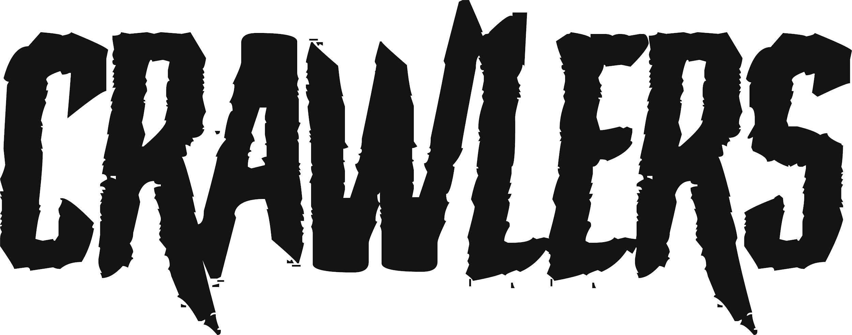
CRAWLERS BIO, SEPTEMBER 2023 — JENESSA WILLIAMS

To become a great rock band, you often need to begin with a certain alchemy. There needs to be talent, determination, a solid friendship which can withstand the rigours of creative difference or public critique. But you also need a sizable dose of ambition, the kind of unapologetic belief that your voice is one which needs to be heard. Such was already the case for Crawlers way back in 2018, where Amy Woodall, Liv May and Holly Minto were at uni together in Liverpool, attending a guest lecture on the music industry by the then-head of Polydor Records. Watching in awe as he described the ways in which they helped bands to build multi-faceted worlds, Minto decided to seize the moment and introduce herself, drawing from a confidence she didn’t quite realise she had.

“I just went straight up there, shook his hand and said ‘I will see you again soon’. I don’t know where these big balls came from, but when we did eventually walk in to get signed, it was the fucking coolest moment to be like …’ Remember me?!’”

This five-year transition may seem like a fairytale, but in Crawlers land, nothing happens without a hefty degree of hard work. Gigging around the Liverpool scene, Amy, Holly and Liv were already polishing their grunge-rock sound when they recruited drummer Harry Breen, a blogger who had written a (favourable) review of their early track ‘Hush’. Newly solidified as a four, their formidable live reputation was already encouraging the kind of organic fanbase that would help them become the UK’s next big crossover alternative act. But then COVID hit, and amidst its turmoil, any sense of momentum threatened to fall out of grasp.

“It was almost like the universe saying, you’re not ready yet,” says Holly. “We had to work from being a band that played great shows to being a band that worked on our individual songwriting, our marketing strategies, our everything else. Basically, we had to think like a business.”

Game faces on, all four members set about levelling up their craft. Holly learnt how to use Logic and improved her guitar skills; Amy began working with sound engineers, taking notes on how to boost the clarity of their trademark heavy-delicate rock blend in a live environment. Liv purchased a six-string bass; an initial point of humour to their bandmates quickly silenced when they realised how much cinematic gravitas it would bring to their recordings. Harry, meanwhile, had turned his writing skills to the band’s mailouts, fostering a much-needed sense of pandemic connection. “How everyone’s playing and knowledge both just grew…it was amazing to watch,” says Holly. “The full Crawlers glow up has been real.”

To the group's unanimous admission, this DIY ‘glow up’ also involved a fair bit of drunken play. As lockdown eased, they found themselves holed up at Liv’s house, hammering shots of Kraken and challenging each other to make up songs from lucky-dip paper prompts. One hungover morning, Holly was still messing around with chords when she realised that she actually had something serious — the opening verses of ‘Come Over’, a raw depiction of a toxic relationship. What started out as a joke exercise for the band quickly became a realisation: in lowering any sense of guard or ego between them, they had unlocked their biggest strength as a unit — total emotional transparency.

“If I went in by myself and did these songs, it would have just become one big soppy piano ballad: says Holly. “But having four other people seeing your inward struggles, and then opening up their own to create music which illustrates that, it’s just phenomenal.”

Becoming a viral hit in 2021, ‘Come Over’ song was the falling domino in a string of serious bucket-list achievements — support slots for My Chemical Romance and YungBlud, the release of two acclaimed mixtapes and what Harry describes as the biggest pinch-me moment of all; “being able to write a note to work saying 'I'm handing my notice because I'm going to be a full-time musician’”. While Crawlers remain deeply grateful for the song’s runaway success, they wanted to take their time on their debut album, proving that they could transcend a TikTok moment.

“It definitely wasn’t right for us to go to superstardom at that time,” says Holly. “This album debut comes from us honing our craft, being vulnerable with each other, finding our sound and saying exactly what we wanted to. I think that's a lot of what the Crawlers sound is, being honest with each other about how to get the correct emotions out — trying, failing, and pushing each other to keep playing and writing to the limits.”

With The Mess We Seem To Make Crawlers have certainly proven their sticking power. Digging deeper into what fans already know and love about their eclectic alt-rock sound, it builds on the relationship of trust they have with producer Pete Robinson and engineer Tom Roach at Liverpool’s Coastal Studios, crafting anthemic rock songs where each member's playing personality can truly thrive. “He gets the coolest sound by getting the best out of us individually,” says Harry. “In doing that, he's really cultivated the collective Crawlers sound.”

Rather than forcing themselves in any one sonic direction, Amy says they maintained the free-wheeling spirit of 2021’s mixtape ‘Loud Without Noise’, unafraid to “throw loads of ideas at the wall to see what sticks”. “We just wrote loads and loads of songs until we could see the best ones and pick out the emerging themes. We've never intentionally been like 'oh, our album needs to be a mix of this or that’ - it just happens.”

True to their word, The Mess We Seem To Make takes on a whole range of challenging topics; trauma, sexual politics, mental health, the general goings on in a young person’s life. Across the record, feelings of loneliness, insecurity and toxic forms of dependence are held up to the light and examined in close context: ‘Hit It Again’ hears Minto sing of “a childhood spent in locked bathrooms”, while “What I Know Is What I Love’ gets open with old romantic habits: “There’s a part of me that needs to think for myself/but it feels so comfortable to feel that I know you so well”.

Having had a chance to step back, Holly observes a clear theme of depression, distrust and vulnerability, but also one of recovery — not providing perfect solutions, but learning to be okay with the journey, to find glimmers of hope in the dark.

“The last song on the album, ‘Nighttime Affair’, was originally written from a stance of upset, of self-hate and anxiety,” she says. “But when we recorded it together, I just thought, I don't want the album to end like this. I wanted this record to acknowledge that things can be fine — I’m fine, and we're all fine together. That doesn't mean we're amazing, or the best we've ever been, but it means we're okay. Once that we kind of unlocked that, I think the whole album just made sense.”

It is also an album which allows them to deepen their ongoing relationship with an LGBTQIA+ audience. As a group where three members openly identify as queer (“plus Harry, our favourite ally”), they are proud to have created music that speaks authentically to both their own identities and a wider need for inclusive environments, offering up social spaces where young people feel truly heard and understood. “We didn't have an awful lot of safe queer spaces when we were growing up, so being able to create an environment where people can be themselves without question or fear is really important,” says Liv.

“More than anything, it’s just about openness; vulnerability and openness is what creates a community,” Minto concludes. “It's why we've gone back to this kind of 2012 Tumblr-grunge way of presenting the album, because that was our sanctuary. That part of the internet was where we could be unapologetically ourselves, whether it was in our queerness, our alternative musical spaces, whatever. It was a wild feeling, and I think this album has very much been about healing that inner child for all of us — whether that’s the music, the lyrics, or how we hope to share it with our audience through live and visuals.”

As they prepare to embark on those next stages of audience connection, the Crawlers community spirit is one that all four members hope will continue to see them right. Life may throw its curveballs, but with clear principles of honesty, commitment and matter-of-fact self-belief, Crawlers remain every bit as indomitable as that day when Holly marched up to Polydor and told them that their name would be one worth remembering.

“It’s not always been easy — we've all seen each other's meltdowns,’ she says. “We're constantly talking and singing about heavy stuff, touring heavy material. But I truly believe everyone in this band is very special, and to find hard-working people who come from where we have and succeed is rare as shit. We’re very lucky that we’ve been able to make this happen together.”

For more information and press enquiries please contact

Jenny Entwistle
Jenny@chuffmedia.com

