**POP STORYTELLER BELLAH MAE**

**ANNOUNCES UK HEADLINE TOUR**

**+ NEW SINGLE ‘COMPATIBLE’ OUT NOW**

**+ ‘*NEVER WASTE A HEARTBREAK*’ EP OUT MAY 3RD**

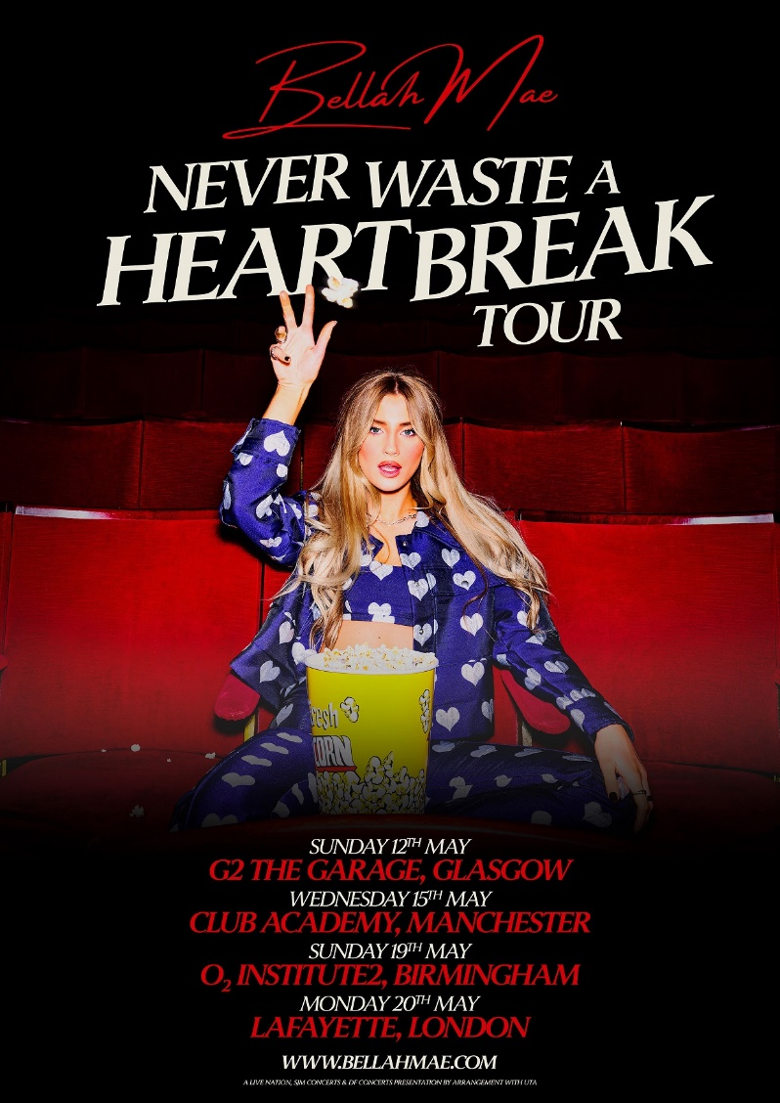

[**HI-RES IMAGE / ARTWORK**](https://umusic.box.com/s/gq8k2r1e0z95slgupec22y6dg0p07p2i)

“*The pop rebel is making her own rules*” – **CLASH**

“*Bellah Mae is the full pop-star package*” – **The Forty Five**

“*Saving Gen-Z’s broken hearted with her tales of toxic relationships*” – **Notion**

“*Bellah is the powerhouse hitmaker the whole world is destined to discover*” – **Dork**

Hot on the heels of her newest release ‘[Compatible](https://bellahmae.lnk.to/CompatibleStream)’, pop storyteller **Bellah Mae** announces her *Never Waste A Heartbreak Tour* kicking off this May. The string of shows follows on from last year’s entirely sold-out tour and will see Bellah perform new songs from her upcoming second EP *Never Waste A Heartbreak* out May 3rd.

“*I’m gonna take the heartbreak era straight on tour so we can all scream and cry together! I can’t wait to see as many of you there as possible, I love you so much and I’ll see you soon!*”

Taking to Instagram to [announce](https://www.instagram.com/p/C3UnwefIaWY/) the tour, Bellah shared comments from her Hot Ex Girlfriend community who have been eagerly asking for new live dates to be announced, and the wait is now over!

Dates for the *Never Waste A Heartbreak Tour* can be found below:

Sunday 12th May – G2 The Garage, Glasgow

Wednesday 15th May – Club Academy, Manchester

Sunday 19th May – O2 Institute2, Birmingham

Monday 20th May – Lafayette, London

Tickets are on sale this Friday, with O2 pre-sale happening now.

2023 witnessed rising singer-songwriter Bellah Mae reach new heights, taking her meticulously crafted anthems on the road as part of her first ever **sold-out UK tour** and connecting with fans across the country, all whilst ranking up an impressive **40 million streams** across releases. Now firmly poised to make 2024 her biggest year so far, Bellah shares ‘Compatible’, her most honest track to date – listen [**HERE**](https://bellahmae.lnk.to/CompatibleStream).

“*Compatible encapsulates the feeling of not feeling chosen or wanted by the person you’re with and worry they’re too comfortable,*” she explains.

“*And although being comfortable can be good, you don’t want it at the sacrifice of feeling so loved and appreciated. As a songwriter and storyteller, I often take from multiple inspiration around me for writing a song, yet I still didn’t quite expect this one to resonate with so many people.*”

A track that was self-written entirely on piano, ‘Compatible’ spotlights Bellah in her most vulnerable nature, with stripped back chords placing her unguarded vocal at the forefront of the track. We’re entering new territories with Bellah’s songwriting, a “sad girl era” encapsulated by reflection, honesty, and empowerment. ‘Compatible’ is just the first of many tracks that’ll make up her second EP ***Never Waste A Heartbreak*** out 3rd May.

“*The title of this new EP means a lot to me as it enforces that no matter what happens there’s always a positive. If you’re in a heartbreak, you have so much opportunity to become such an empowered version of yourself, learning that you can move past anything and grow even stronger from it.*” – Bellah Mae

The storyteller has been recently sharing a collection of self-written demos and late night covers to tease fans across her social media, doubling her Instagram following and gaining over **10 million video views** in the process. To help mend this broken heart of hers, Bellah has enlisted the Hot Ex Girlfriend community to sculpt the tracklisting for *Never Waste A Heartbreak* – asking them to choose their favourites which’ll soon form the personalised project they can proudly say they were part of.

Bellah’s debut EP *With All Due Respect* released last year showcased her intimate brand of song writing, making use of a winning combination of “big feelings, little details” that charmed the likes of **Daily Star**, **Wonderland** and **House of Solo** with her vivid writing that places her among her Gen-Z contemporaries like Olivia Rodrigo or Sabrina Carpenter, carving relatable and honest stories to be screamed back to her by crowds of her peers.

Bellah Mae’s writing style incorporates her influences ranging from Dolly Parton to Avril Lavigne and Miley Cyrus. In the tradition of other Gen Z artists her music defies categorisation, incorporating ever expending sonic touchstones to create something that feels wholly unique.

Plenty more is in store for Bellah Mae in 2024, including supporting **Caity Baser** at her hotly tipped shows this spring - find dates and tickets [**HERE**](https://www.caitybaser.com/#lets-dance).

**Bellah Mae has her sights set on making 2024 her biggest year yet! Follow her journey:**

[TikTok](https://www.tiktok.com/@bellah.mae) // [Instagram](https://www.instagram.com/bellah.mae) // [YouTube](https://www.youtube.com/@BellahMae)

**For more information please contact**

**Warren Higgins** [**warren@chuffmedia.com**](mailto:warren@chuffmedia.com)