**BELLAH MAE SHARES NEW SINGLE ‘2053’**

**AHEAD OF ‘*NEVER WASTE A HEARTBREAK*’ EP OUT MAY 3RD**

**+ UK HEADLINE TOUR IN MAY**

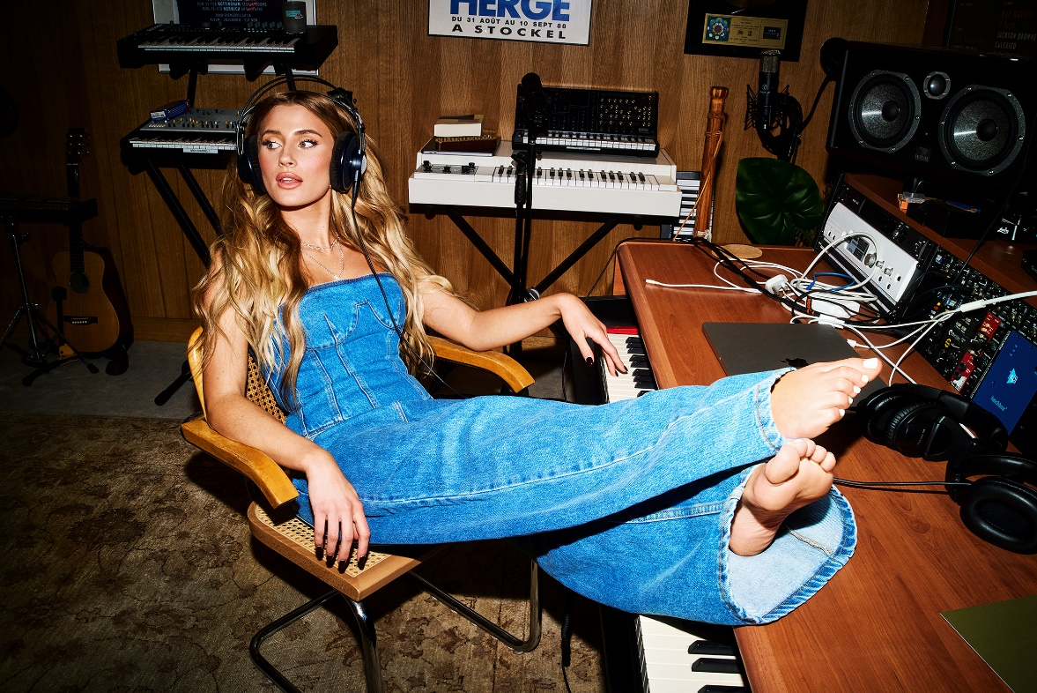

[**HI-RES IMAGE / ARTWORK**](https://umusic.box.com/s/4j9veapiks3yx7z6bnyjza3gfmsfq5gc)

“*The pop rebel is making her own rules* blending future-facing production, excellent ear-worm melodies, and odd country and rock inflection,” – **CLASH**

“*Bellah Mae is the full pop-star package*” – **The Forty-Five**

“*Saving Gen-Z’s broken hearted with her tales of toxic relationships*” – **Notion**

“*Bellah is the powerhouse hitmaker the whole world is destined to discover*” – **Dork**

Singular pop storyteller and lyricist, **Bellah Mae** reaches further depths of her Sad Girl Era diving into ‘the one that got away’ with captivating new single ‘2053’ – listen [**HERE**](https://bellahmae.lnk.to/2053PR).

“*Everybody will always tell you ‘it’ll be okay’ and ‘there’s plenty of fish in the sea’ but sometimes you wonder if they’ll always be a part of you that reflects on a particular person that’s no longer in your life anymore,*” Bellah explains. “*As for writing the lyrics, I really wanted to tell a story of how strange it is for that person to not be aware of big changes or things happening within your life now.*”

Always seeking new narratives to help conceptualise her songwriting, the fast-rising popstar finds this approach is a way in which she can connect the dots to unveil her most emotive side. “*I never really switch off from thinking in lyrics, if I’m having any conversation and someone says a little thing it can spark a whole line in my head.*”

Surrounded by music from a young age, instilling a love for both performing and songwriting, Bellah’s introduction to music came from her grandad who dedicated his time to his own rock’n’roll band alongside playing as a pianist for county and southern style musicians. *“I feel so closely connected to country lyricism and southern music arrangements, it was just what I was raised listening to and learning to play, so it feels a very homely genre to me.*” Picking up a guitar aged 9, it was Bellah’s Grandad that would push her into becoming the best version of a musician, continuously asking her to practice a song just “one more time” to reach that point of perfection – this tenacity and persistence is something Bellah still teaches herself today.

There’s also nothing more special to Bellah than a song telling a story, in words so specific that they feel like they were written exactly about you and your life. ‘2053’s hyper specific lyrics are already resonating with the Hot Ex Girlfriend community across [social teasers](https://www.instagram.com/p/C33L1UOrZlS/), forging tighter bonds between fans through shared experiences and emotions.

‘2053’ follows the release of ‘[Compatible](https://bellahmae.lnk.to/CompatibleStream)’ and the announcement of the *Never Waste A Heartbreak Tour* kicking off this May. The string of new shows arrives after last year’s sold-out tour and will see Bellah perform new songs from her upcoming second EP *Never Waste A Heartbreak* out May 3rd.

“*The title of this new EP means a lot to me as it enforces that no matter what happens there’s always a positive. If you’re in a heartbreak, you have so much opportunity to become such an empowered version of yourself, learning that you can move past anything and grow even stronger from it.*”

Dates for the *Never Waste A Heartbreak Tour* can be found below. Tickets [**HERE**](https://bellahmae.lnk.to/NeverWasteAHeartbreakTour).

Sunday 12th May – G2 The Garage, Glasgow

Wednesday 15th May – Club Academy, Manchester

Sunday 19th May – O2 Institute2, Birmingham

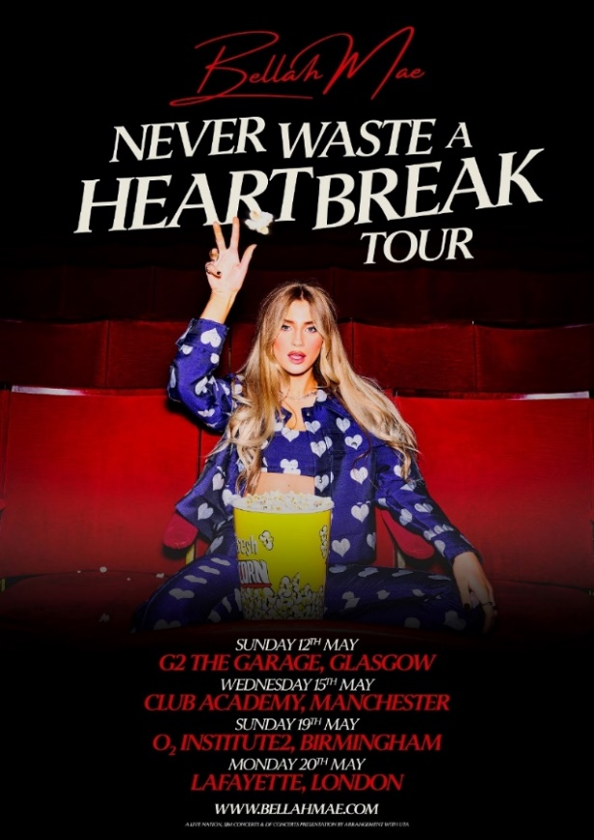Monday 20th May – Lafayette, London

**Bellah Mae has her sights set on making 2024 her biggest year yet! Follow her journey:**

[TikTok](https://www.tiktok.com/@bellah.mae) // [Instagram](https://www.instagram.com/bellah.mae) // [YouTube](https://www.youtube.com/@BellahMae)

**For more information please contact**

**Warren Higgins** [**warren@chuffmedia.com**](mailto:warren@chuffmedia.com)