

SHARES THE NEW MK REWORKING OF FAN FAVOURITE ‘SWIM’
LISTEN HERE

THE ORIGINAL FEATURES ON HER ACCLAIMED UK #3 ALBUM ‘BELIEVE ME NOW?’

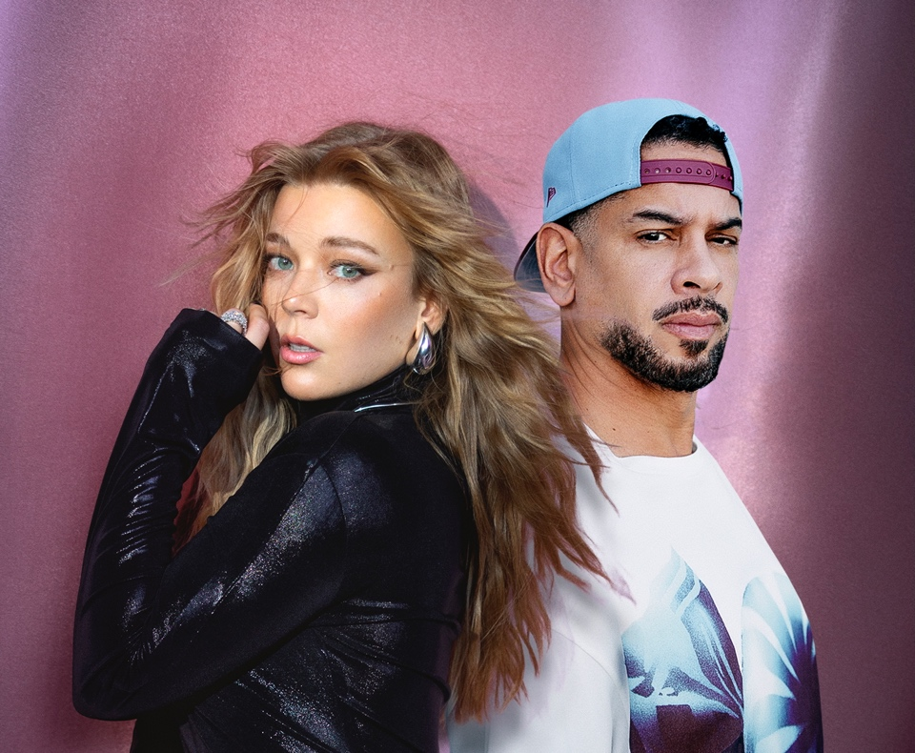

Becky Hill has had a phenomenal year. The two-time BRIT Award winner landed a #3 chart position for her acclaimed album ‘Believe Me Now?’ and stepped up to become an arena-conquering headliner during her recent sold-out UK tour. Having just completed a run of US shows - most of which also sold-out – Becky puts the finishing touches to 2024 by sharing the new MK reworking of album standout track, ‘Swim’.

Already both a fan favourite and Becky’s own personal highlight from her recent shows and hit album, the original ‘Swim’ is an anthemic trance banger in which Becky vocalises the pain of changing relationship dynamics. Dance music icon MK now takes it to another level, with every element bigger than before, from its pounding beat to its addictive 90’s piano house keys. But the superstar touch comes from Becky as the new reworking provides the space for her to pour infinite passion and power into her phenomenal vocal performance.

MK said, “Becky Hill; that’s my homie. We got history!! When she reached out over the summer to make 'Swim' into a club banger, I jumped at it."

The creative alliance between Becky and MK goes back to early in her career. They first collaborated on the 2016 single ‘Piece of Me’, which has since been certified double-Platinum in the UK with 1.2million+ domestic sales, and 175 million streams at Spotify alone. They reunited in 2018, this time boosted by Jonas Blue, for ‘Back & Forth’, another Platinum hit which reached #12 on the UK Official Singles Chart.

Hailing from Detroit, MK (real name Marc Kinchen) is a producer and DJ who became one of the first superstars of house music with 2 billion career streams to date. Bringing a deeper shade to US house, he stormed the charts and made a mainstream breakthrough in 2013 when his rework of Storm Queen’s ‘Look Right Through’ went to #1 in the UK, while sandwiched between his two Becky Hill collaborations, ‘17’ became his biggest solo track. His headline shows continue to sell out across the globe, with notable performances at Coachella, Glastonbury, Bonnaroo, Reading, Leeds, Longitude and Creamfields over the last year. He also embarked upon a season-long residency alongside Calvin Harris at Ushuaia Ibiza.

Becky will see in the New Year at the Wildlands Festival in Brisbane, before playing further shows in Australia and New Zealand in January.

Follow Becky Hill:
Spotify | Apple Music | YouTube | TikTok | Instagram | Facebook | X | Website

Follow MK:
Spotify | Apple Music | YouTube| TikTok | Instagram

For more info contact warren@chuffmedia.com

