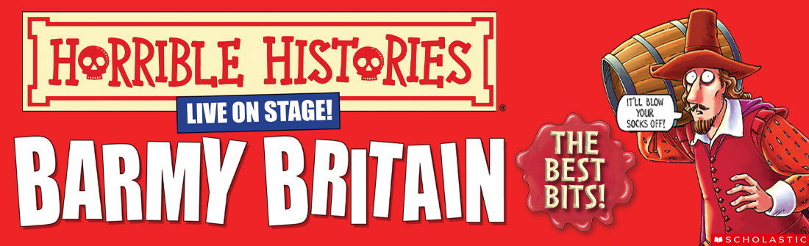
RETURNS TO THE WEST END FOR A SECOND SUMMER SEASON BY POPULAR DEMAND

The most beloved Horrible Histories stage spectacular is back playing the greatest hits!

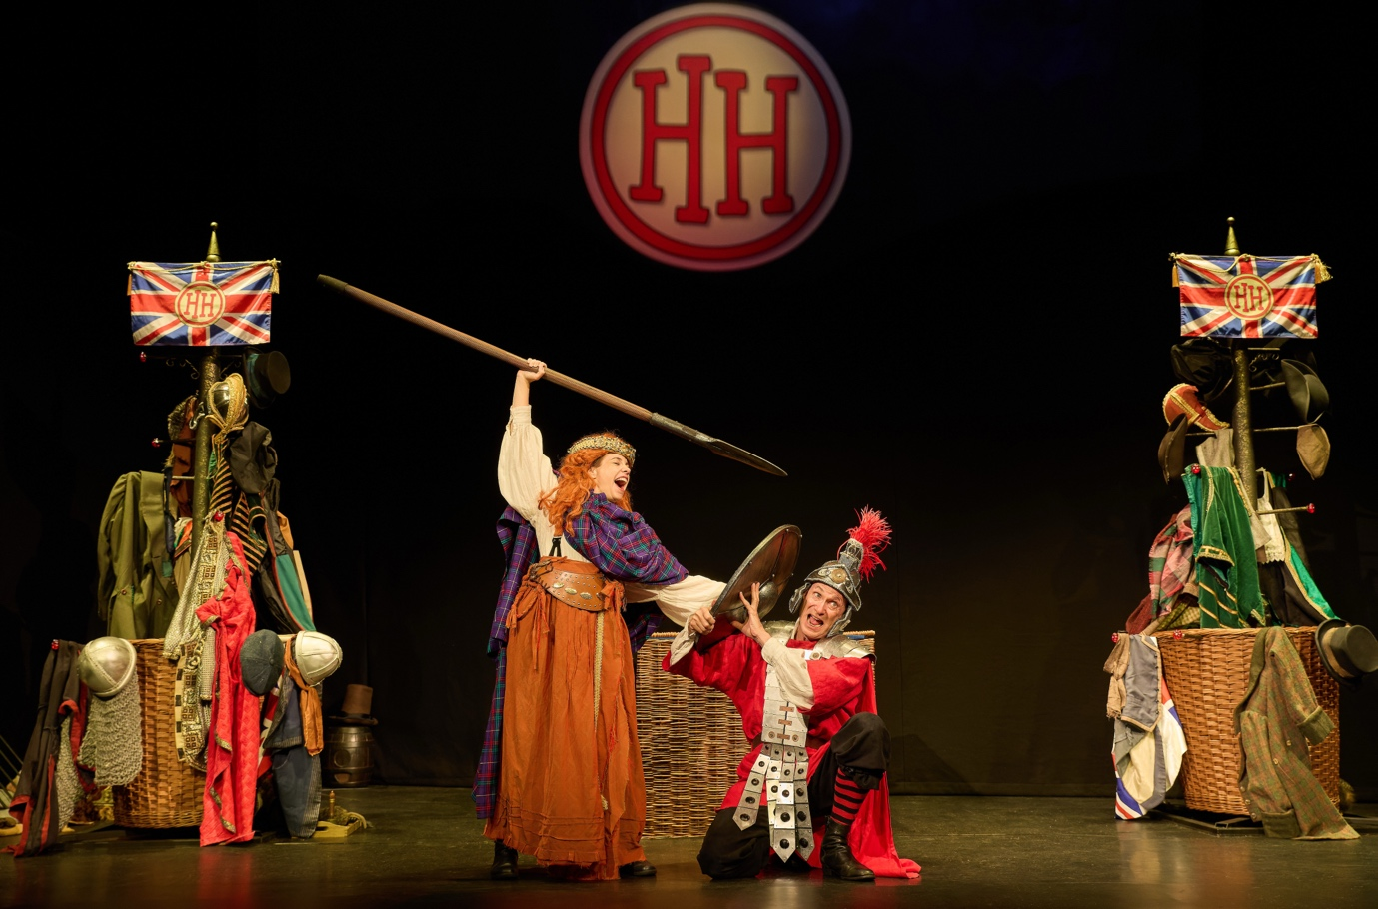
Apollo Theatre, Shaftesbury Avenue, London
30 July – 31 August 2026

Press performances: 11am Saturday 1st & 12pm & 3pm Sunday 2st August

Media assets here

“The Horrible Histories stage shows have become a bit of a British institution” The Guardian
***** “History’s never been more gruesome or full of fun!” London Theatre 1
**** “A fun, fact-filled summer treat – it’s a scream!” Broadway World

This summer, Birmingham Stage Company returns to London’s West End with the funniest, fearsome and most farcical facts from British history in Horrible Histories: Barmy Britain - The Best Bits! a non-stop romp through our nation’s remarkable past.

Celebrating 21 years of Horrible Histories Live on Stage and an incredible 15 years in the West End, this special anniversary production brings together the greatest hits from the legendary Barmy Britain series for a riotous month-long run at the Apollo Theatre.

From Thursday 30 July to Monday 31 August, it’s the perfect treat for families looking to make the most of the school summer holidays before school sneaks back in!

Audiences can expect all the glorious gory highlights: from gunpowder Guy to the notorious Nightsoil Men. Will you survive the putrid plague? Dare you stand up to cruel King John? Or escape the clutches of villainous Burke and Hare? It’s a wild ride through Britain’s barmiest moments, packed with facts, fun and fabulous figures!

A perfect first theatre trip for young audiences and a treat for grown-ups who love their history horrible, the show is recommended for ages 5 to 105 (please note 106-year-olds may not like it)!

Horrible Histories: Barmy Britain - The Best Bits! is directed by Neal Foster, featuring Emma Swan and Neal Foster, designed by Jacqueline Trousdale, with lighting by Jason Taylor, sound by Nick Sagar, music by Matthew Scott and choreography by Kenn Oldfield.

Based on the bestselling books by Terry Deary – the world’s top-selling non-fiction author for children – Horrible Histories has sold over 36 million copies in 45 languages. Deary’s delightfully dreadful stories have come alive on stage thanks to the Birmingham Stage Company, one of the world’s top theatre companies for families. They have produced all the Horrible Histories live stage shows since 2005 both in the UK and worldwide, including Australia, New Zealand, Singapore, Hong Kong, Dubai and Abu Dhabi. They are currently touring their acclaimed production of Horrible Histories – The Concert.

X: @HHLiveOnStage / Facebook: birminghamstage / Instagram: @HHLiveOnStage

Horrible Histories: Barmy Britain - The Best Bits!
Apollo Theatre
Shaftesbury Avenue, London W1D 7EZ
Box Office: 0330 333 4809
barmybritain.com

Tickets from £19.50 (excluding fees), Premium & Family tickets available

30 July – 31 August 2026
Press performances: 11am Saturday 1st & 12pm & 3pm Sunday 2st August
Running time: 70 minutes (no interval)

For all media enquiries contact Warren Higgins at Chuff Media
warren@chuffmedia.com / 07762 130510

