BIG SPECIAL announce debut album

POSTINDUSTRIAL HOMETOWN BLUES out 10th May via SO Recordings

Watch the video for lead single 'DUST OFF / START AGAIN' HERE

+ UK headline tour dates & summer festivals

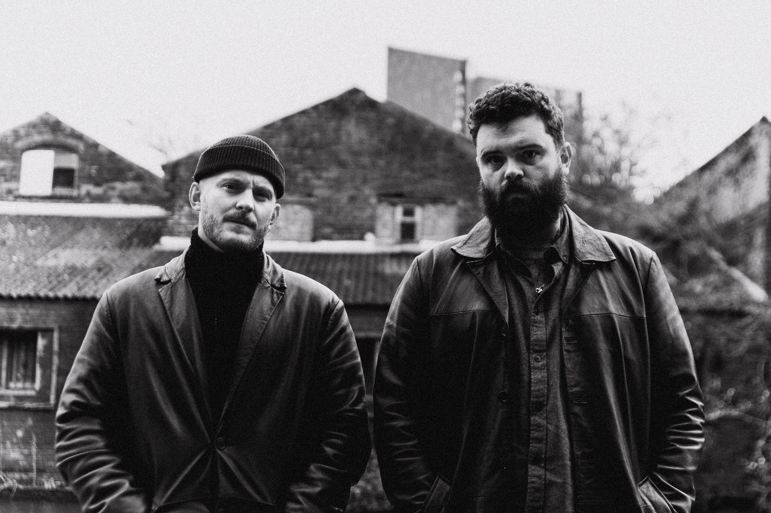

BIG SPECIAL | Photo credit: Isaac Watson | Download image here

////

BIG SPECIAL are today announcing their highly-anticipated debut album POSTINDUSTRIAL HOMETOWN BLUES for release on 10th May via SO Recordings. The Black Country duo are also sharing their first new music of 2024, in the shape of huge new single ‘DUST OFF / START AGAIN’, along with more UK / EU headline shows and festival appearances.

The band’s first new music arrives in the wake of a sold-out winter UK headline tour, multiple playlisted singles on BBC 6 Music, and their presence as a hotly-tipped prospect for 2024 in a number of Ones To Watch lists.

‘DUST OFF / START AGAIN’ is BIG SPECIAL at their most towering and imposing. Barrages of biting spoken word, striking soulful vocals and hulking guitars coalesce around a song that catalogues the metal health impact of failed government policy on a generation with a dwindling sense of ownership and corroded autonomy. It works around the central idea that there’ll always be hope of starting again after a fall, but rallies against the very premise that life shouldn’t be a cycle of building yourself up only to be knocked down again.

Lead singer Joe Hicklin had the following to say:

“’DUST OFF / START AGAIN’ is a bolt of cursed vomit, spewed into a stewpot of English class issues regarding housing, ownership, mental illness, appropriation and human rights. It’s about the disregard for the common man. And how it is expected of anyone, regardless of their situation, to carry on, struggle through and go to work. It’s about how the privileged and powerful attempt to define, debate and justify the social positions of all whilst the ideals of our governing systems are pressed upon the working-class youth, so that they quietly accept their role as a commodity and place blame on each other, as they wave the flag that keeps them down.”

Continuing about the album he says: “POSTINDUSTRIAL HOMETOWN BLUES is an album about depression. It's about the different shapes it takes; personal, social, generational... and it's about coming face to face with those ghosts and what we do or how we feel when that happens.

The album offers no answers, it is just an honest expression of a working-class experience in modern England through the eyes of ill mental health, a pursuit of art and political disenchantment; a story of rumination, realisation and reaction.

POSTINDUSTRIAL HOMETOWN BLUES is about learning that we are connected by our common struggles and though dark and rageful, the album holds a quiet sentiment of love and hope. It's about laughing at the face of the void, recognising its oppressive weight, holding hands and moving forward.”

Pre-order debut album POSTINDUSTRIAL HOMETOWN BLUES here.

Listen to ‘DUST OFF / START AGAIN’ on streaming services here and watch the video here.

////

BIG SPECIAL 2024 TOUR DATES

Tickets on sale now here.

03 Apr - Clwb Ifor Bach, Cardiff, UK (DIY Now & Next tour)
04 Apr - Bullingdon, Oxford, UK (DIY Now & Next tour)
05 Apr - Yellow Arch Studio, Sheffield, UK (DIY Now & Next tour)
06 Apr - Green Door Store, Brighton, UK (DIY Now & Next tour)
07 Apr - Joiners, Southampton, UK (DIY Now & Next tour)
12 Apr – New Century Hall, Manchester, UK (supp. Antony Szmierek)
13 Apr – Lafayette, London, UK (supp. Antony Szmierek)
07 May – District, Liverpool, UK
08 May – The Key Club, Leeds, UK
09 May – XOYO, Birmingham, UK
10 May – King Tuts, Glasgow, UK
12 May – Strange Brew, Bristol, UK
16 May – Jazz Café, London, UK
17 May – Horatio’s, Brighton, UK (The Great Escape 2024)
18 May – Deaf Institute, Manchester, UK
20 May – Kasbah Club, Limerick, Ireland
21 May – Workman’s Cellar, Dublin, Ireland
22 May – Ulster Sports Bar, Belfast, Norther Ireland
24 May - Netherlands, Den Haag, Zwarte Ruiter (Sniester Festival)
26 May – Bearded Theory Festival, Derbyshire, UK
27 May – Paradiso Upstairs, Amsterdam, Netherlands
28 May – Effenaar, Eindhoven, Netherlands
30 May – Block Party Festival, Paris, France
31 May – Vestrock, Hulst, Netherlands
01 Jun - Dauwpop Festival, Hellendoorn, Netherlands
26 Jul – Low Festival, Benidorm, Spain
28 Jul – Latitude Festival, Suffolk, UK
23 Aug – Reading Festival, Reading, UK
24 Aug – Leeds Festival, Leeds, UK

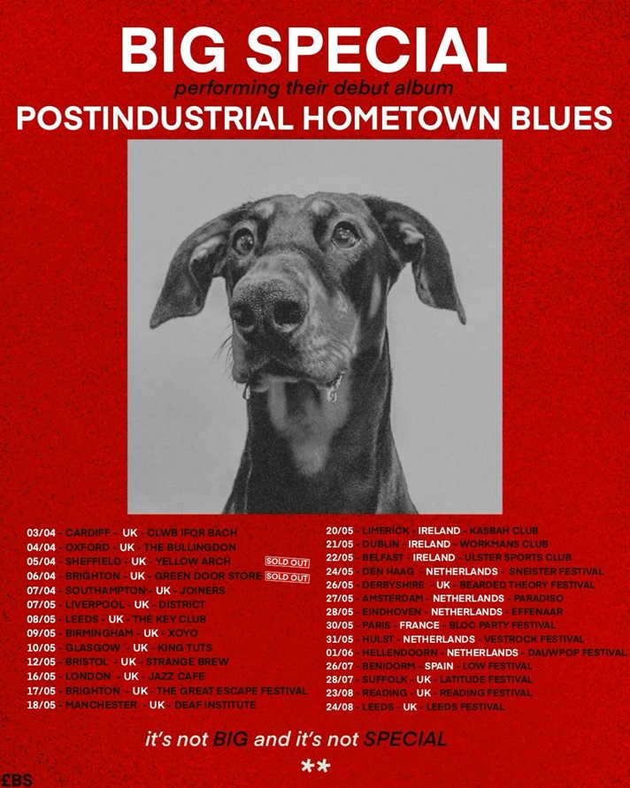

BIG SPECIAL - 2024 live poster | Download image here

More about BIG SPECIAL and debut album POSTINDUSTRIAL HOMETOWN BLUES

Words are not to be taken for granted. Especially when they’re being bellowed, full blast, by a broad-shouldered poet with the brimstone fire of a preacher and the honesty and wisdom of a layman, over ground-shaking live beats and between anthemic blasts of melody and rousing riffage.

Words matter. History matters. People matter. And BIG SPECIAL matter.

For BIG SPECIAL - Joe Hicklin (vocals) and Callum Moloney (drums) - their sound is one that comes from vital, frustrated young working-class voices that don’t always get heard on the scale they should do. It’s a frustration that comes to the fore through a voice that is at times coarse and raw, but sensitive, desperate and soulful at others. Hicklin's brimstone-fired voice marches from guttural punk barks and serrated spoken word to soaring soul and back again, arriving siphoned from their forebears, crushed under the weight of history, and retooled for a new generation. It’s wrought, raw and angry at a world lacking options, the thinning of the common understanding between the social classes of England, exasperation at repeating cycles, and the feeling that you’re watching your own life unfold from the outside.

These are songs that channel that voice you hear when you look in the mirror and see your true self – fight songs for a world gone wrong.

Download the band's latest biography here.

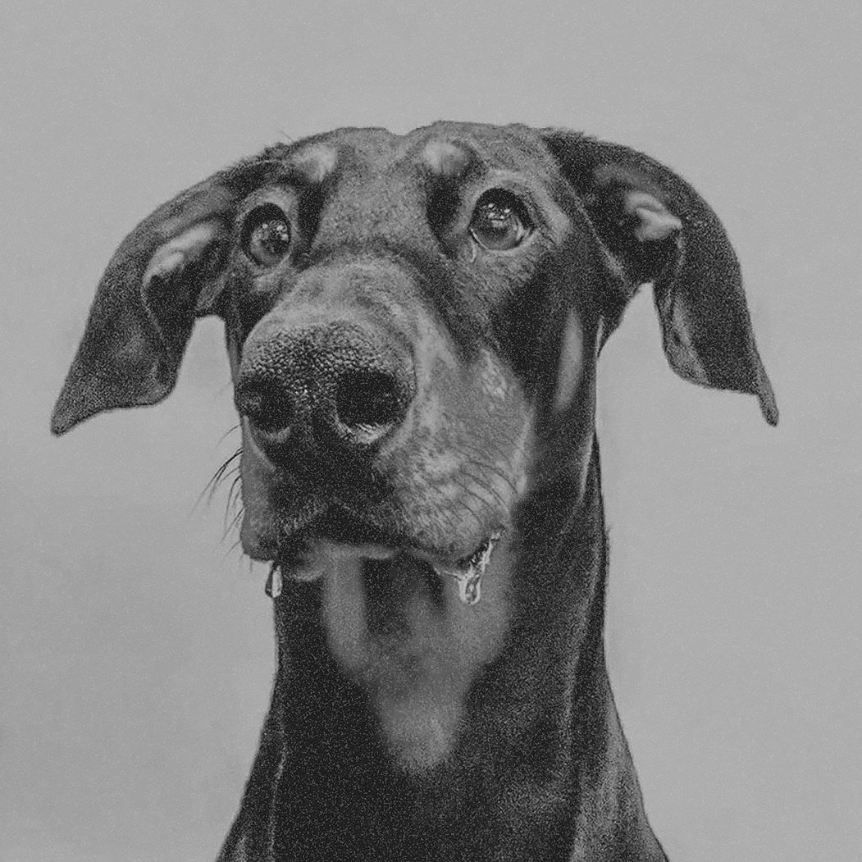

BIG SPECIAL - POSTINDUSTRIAL HOMETOWN BLUES album artwork | Download image here

BIG SPECIAL - POSTINDUSTRIAL HOMETOWN BLUES tracklisting

1. BLACK COUNTRY GOTHIC
2. I MOCK JOGGERS
3. DESPERATE BREAKFAST
4. SHITHOUSE
5. THIS HERE AIN’T WATER
6. MY SHAPE (BLOCKING THE LIGHT)
7. BLACK DOG / WHITE HORSE
8. BROADCAST: TIME AWAY
9. iLL.
10. MONGREL
11. BUTCHER’S BIN
12. DUST OFF / START AGAIN
13. TREES
14. FOR THE BIRDS
15. DiG!

Follow BIG SPECIAL: Website | Facebook | Instagram | Spotify | Twitter | YouTube

For more information & media enquiries, please contact Warren
warren@chuffmedia.com

