NEW ALBUM ‘BELIEVE ME NOW?’ TO BE RELEASED ON MAY 31ST
PRE-ORDER / PRE-SAVE HERE

FEATURING THE MASSIVE HITS ‘DISCONNECT’, ‘SIDE EFFECTS’ AND ‘NEVER BE ALONE

NOMINATED FOR HER THIRD CONSECUTIVE BRIT AWARD FOR BEST DANCE ACT

ALSO CONFIRMED TO HEADLINE MANCHESTER’S PARKLIFE FESTIVAL

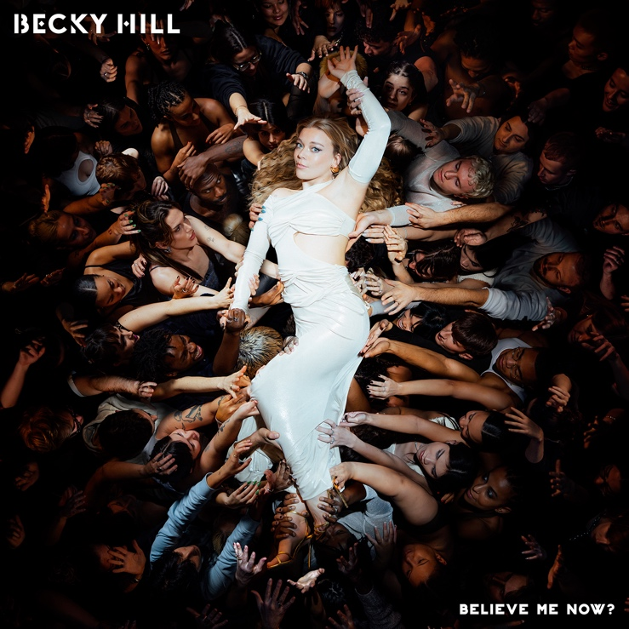

Fresh from earning her third consecutive BRIT Award nomination for Best Dance Act, Becky Hill today confirms the release of her eagerly anticipated second album ‘Believe Me Now?’, out on May 31st through Polydor Records/Eko Records. It’s a record which will cement her status as one of dance music’s biggest influential voices and the genre’s leading boundary-breaking female artist. And it’s impossible to deny that status for the two-time BRIT Award (2022 & 2023) winning artist who recently announced a huge UK and Ireland arena headline tour, and who has exceeded 10 billion career streams to date plus six UK Top 10 smash hits.

‘Believe Me Now?’ is Becky’s most authentic, career defining body of work to date. An album which sees her digging even deeper into her life-long passion for underground dance music and club culture. Whether she’s drawing on influences from the worlds of drum ‘n’ bass, anthemic house, techno or atmospheric trance, Becky’s flair for blending the heart of such genres with her soaring powerhouse vocal has produced an album that’s rich with credibility and personal integrity, yet with immense global appeal.

The album will feature the #1 US airplay hit ‘Side Effects; ‘Disconnect’ (featuring Chase & Status) which peaked at #6 on the UK charts and was certified Gold; and the current single ‘Never Be Alone’, which features Sonny Fodera and is Becky’s 22nd Top 40 track to date. The album also sees Becky working with an array of top tier and next wave producers including PARISI, Mark Ralph, Toddla T, Maur, Solardo, MJ Cole, Jax Jones and Franky Wah.

Becky says, “This album has been a joy to make! it’s come at a point in my life where I’m leaving my turbulent twenties behind me and entering my thirties as a more confident, knowledgeable & self-assured woman and this album really reflects that. I wanted this body of work to be deep rooted in dance music but have my story telling song writing flowing throughout, describing tales of loneliness, togetherness, love and betrayal. I can’t wait to share it with the world.”

Recent release ‘Never Be Alone’ follows a remarkable 2023 for Becky. The year was bookended with two prestigious music awards: the BRIT Award for Best Dance Act (her second year in a row) and Best Vocalist at the Drum & Bass Arena Awards. And in-between, the year delivered highlight-after-highlight: a killer Glastonbury set, a summer YOU/ME/US residency in Ibiza, exceeding a billion domestic career streams and winning Attitude Magazine's Music Award. She also kickstarted the second series of her critically acclaimed podcast The Art of Rave with dream guest Fatboy Slim, after its initial series had featured influential names such as Roni Size, Fabio & Grooverider, Sister Bliss, Andy C and Pete Tong.

On the live front, immense demand for Becky’s autumn UK and Ireland arena tour saw 80,000 of its 130,000 tickets sell-out in just three days, leading to the addition of a series of outdoor summer shows alongside select festival dates which include a headline slot at Manchester’s Parklife Festival. Currently on tour in Australia and New Zealand, she will also play her debut headline tour of mainland Europe in April, which hits seven countries. Her upcoming UK and Ireland shows are listed below, please see HERE for remaining tickets and a list of all scheduled international dates.

JUNE
8th - Manchester, Parklife (headline)
13th - Cheshire, Delamere Forest
14th - Cork, Musgrave Park
15th - Belfast, Belsonic

JULY
12th - Derby, Summer Sessions

AUGUST
7th-11th - Newquay, Boardmasters
9th - Newmarket, Racecourse
16th - Durham, Hardwick Festival
18th - Edinburgh, Summer Sessions
23rd – Oxfordshire, Big Feastival (headline)
24th - Cardiff, The Bay Series
25th - Portsmouth, Victorious Festival
29th - Scarborough, Open Air Theatre
30th - Sheffield, Rock ‘n’ Roll Circus
31st - Margate, Dreamland

OCTOBER
12th - Glasgow, OVO Hydro
13th - Newcastle, Utilita Arena
15th - Nottingham, Motorpoint Arena
16th - Leeds, First Direct Arena
18th - Exeter, Westpoint Arena (SOLD OUT)
19th - Birmingham, Utilita Arena (SOLD OUT)
20th - Manchester, AO Arena (SOLD OUT)
22nd - Cardiff, Utilita Arena (SOLD OUT)
24th - London, OVO Arena Wembley

Follow Becky Hill:
Spotify | Apple Music | YouTube | TikTok | Instagram | Facebook | Twitter | Website

For more info contact warren@chuffmedia.com

