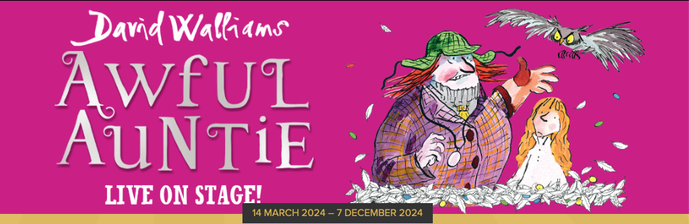

DAVID WALLIAMS’ AWFUL AUNTIE
EXCITING FAMILY ADVENTURE TOURS THE UK
14TH MARCH – 7TH DECEMBER

The bestselling children’s author David Walliams and the award-winning Birmingham Stage Company have teamed up for a brand-new production of the family adventure Awful Auntie. This is their latest collaboration in a series of shows which includes the Oliver Award-nominated Gangsta Granny and Billionaire Boy.
When Stella sets off to visit London with her parents, she has no idea her life is in danger! When Stella wakes up three months later, only her Aunt Alberta can tell her what has happened. But not everything Alberta tells her turns out to be true and Stella quickly discovers she’s in for the fight of her life against her very own awful Auntie!
David Walliams said: “The BSC’s live shows of my books are always brilliant. I can’t wait for the fun to begin again – it’s going to be a hoot!”
David Walliams is one of Britain’s best-loved comedians. LITTLE BRITAIN, his creation with Matt Lucas, won numerous international awards including three BAFTAs, and played in over 100 countries. It was followed by one of the most watched comedies of all time, COME FLY WITH ME. David was a judge on BRITAIN’S GOT TALENT for ten years and won numerous National TV Awards for Best TV Judge. A best-selling children’s author, David began writing books in 2008. His books have been translated into 55 languages, selling over 53 million copies worldwide.
Neal Foster is the adapter and director of Awful Auntie, and for the very first time he is also appearing in the title role. He is the Actor/Manager of The Birmingham Stage Company, which celebrated its 30th anniversary in 2022. Since its foundation in 1992 has staged over one hundred productions and the company has become one of the world’s leading producers of theatre for children and their families. Productions include Horrible Histories Live on Stage for eighteen years in the UK, Dubai, Abu Dhabi, Qatar, Bahrain, Hong Kong, Singapore, New Zealand and Australia. Neal has written and directed all of the most recent Horrible Histories shows including the Barmy Britain series seen in the West End, across the UK, and internationally. Awful Auntie is his latest David Walliams stage adaptation after Gangsta Granny, Billionaire Boy and Demon Dentist. He also directed the world premiere of Tom Gates which he co-wrote with the author of the book series, Liz Pichon.

Awful Auntie is adapted and directed by Neal Foster, Assistant Director/Movement Director is Richard J Hinds, the Designer is Jackie Trousdale, lighting is by Jason Taylor, sound is by Nick Sagar and the music is by Jak Poore.

Awful Auntie is suitable for ages 5 +

14 Mar 24 to 17 Mar 24 The Capitol Horsham

21 Mar 24 to 24 Mar 24 Lighthouse Poole

28 Mar 24 to 31 Mar 24 Wolverhampton Grand Theatre

04 Apr 24 to 07 Apr 24 Sunderland Empire

10 Apr 24 to 13 Apr 24 New Theatre, Cardiff

18 Apr 24 to 21 Apr 24 Opera House Manchester

25 Apr 24 to 27 Apr 24 Grand Opera House, Belfast

09 May 24 to 12 May 24 Richmond Theatre

16 May 24 to 19 May 24 Venue Cymru, Llandudno

23 May 24 to 25 May 24 The Alhambra Theatre, Bradford

29 May 24 to 02 Jun 24 Cambridge Arts Theatre

06 Jun 24 to 09 Jun 24 King's Theatre, Glasgow

13 Jun 24 to 16 Jun 24 Liverpool Empire
20 Jun 24 to 23 Jun 24 Theatre Royal Nottingham

27 Jun 24 to 30 Jun 24 Hall for Cornwall, Truro

04 Jul 24 to 06 Jul 24 New Victoria Theatre, Woking

11 Jul 24 to 14 Jul 24 Darlington Hippodrome

18 Jul 24 to 21 Jul 24 Hull New Theatre

25 Jul 24 to 27 Jul 24 Everyman Theatre, Cheltenham

12 Sep 24 to 15 Sep 24 Gaiety Theatre, Dublin

19 Sep 24 to 22 Sep 24 Waterside Theatre, Aylesbury

26 Sep 24 to 29 Sep 24 Grand Opera House York

T10 Oct 24 to 12 Oct 24 Theatre Royal, Brighton

17 Oct 24 to 19 Oct 24 The Alexandra Theatre, Birmingham

31 Oct 24 to 02 Nov 24 Milton Keynes Theatre

07 Nov 24 to 10 Nov 24 New Wimbledon Theatre

27 Nov 24 to 30 Nov 24 MAST, Southampton

Tickets are available from the theatre box office and via Birminghamstage.com.

For all media enquiries please contact
Warren@chuffmedia.com on 07762 130510

