ANNOUNCE 24 DATE TOUR
PREORDER THE NEW ALBUM
All Quiet On The Eastern Esplanade
(released 5th April)
from the official store to get pre-sale access

ARTWORK & PHOTOS

“They’re still able to channel an almost Dickensian parallel universe of lowlife, crime and violence into something poetic and romantic.”
THE GUARDIAN

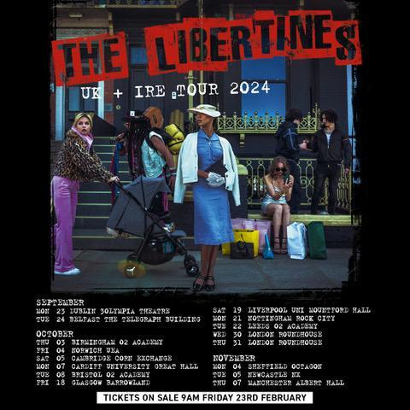

The last gang in town The Libertines, who release their hotly anticipated new album All Quiet On The Eastern Esplanade on April 5th, have announced a UK & Irish tour commencing in Dublin on 23rd September and taking in two shows at The Roundhouse in London and culminating at Bournemouth O2 Academy on the 17th November.

The Libertines’ once-seen-never-forgotten live shows are here to save humanity from holograms, virtual reality and AI auto-tuned bullshit, so switch off your pocket-held marketing machine and come and experience raw analogue euphoria at the hands of these delirious musical chaos-mongers.

The full dates for the All Quiet On The Esplanade Tour are:

SEPTEMBER
23rd MON Dublin 3Olympia Theatre SOLD OUT
24th TUE Belfast The Telegraph Building SOLD OUT

OCTOBER
3rd THU Birmingham O2 Academy SOLD OUT
4th FRI Norwich UEA SOLD OUT
5th SAT Cambridge The Corn Exchange SOLD OUT
7th MON Cardiff Great Hall SOLD OUT
8th TUE Bristol O2 Academy SOLD OUT
17th THU Glasgow Barrowland Ballroom SOLD OUT
18th FRI Glasgow Barrowland Ballroom SOLD OUT
19th Sat Liverpool Mountford Hall SOLD OUT
21st Mon Nottingham Rock City SOLD OUT
22nd TUE Leeds O2 Academy SOLD OUT
30th WED London Roundhouse SOLD OUT
31st THU London Roundhouse SOLD OUT

NOVEMBER
1st FRI London Roundhouse SOLD OUT
4th MON Sheffield The Octagon SOLD OUT
5th TUE Newcastle NX SOLD OUT
7th THU Manchester Albert Hall SOLD OUT
8th FRI Manchester Albert Hall SOLD OUT
9th SAT Manchester Albert Hall SOLD OUT
17th SUN Lincoln Engine Shed
18th MON Stockton Globe
20th WED Bath Forum
21st THU Bournemouth O2 Academy

The Libertines released a fabulous new single (quite possibly the most Libertines single ever!) on Wednesday 6th March. Entitled Oh Shit it is an earworm anthem for these economically challenging times. Written by Carl Barat and Peter Doherty, Oh Shit is the fourth single to be lifted from All Quiet On The Eastern Esplanade, following the release of Run, Run, Run VIDEO, Night Of The Hunter VIDEO and Shiver VIDEO You can preorder the new album here: TheLibertines.lnk.to/AQOTEEPR

The Libertines will be playing the following in/out-store shows on the week of release of the new album with a special Q&A happening at Rough Trade East.

APRIL IN/OUT-STORES:
5th FRI Coventry HMV Empire
6th SAT Birmingham Acoustic
Manchester Academy w/ Crash Records
8th MON Rough Trade East Q&A w/ Rough Trade
9th TUE Pryzm Kingston w/ Banquet Records

As previously announced The Libertines will headline ‘On The Beach Festival’ in Brighton on Sunday, July 28th.

The Libertines are Peter Doherty – vocals/guitar, Carl Barât – vocals/guitar, John Hassall – bass guitar and Gary Powell– drums. The band have released three albums: Up The Bracket (2002); The Libertines (2004); and Anthems For Doomed Youth (2015).

X Instagram Facebook Threads YouTube TikTok

For more information & media enquiries, please contact Warren
warren@chuffmedia.com / 07762 130510

